Alabama Congressional Delegation Contact Listing

 | Member of Congress | Phone | Address | Contact Information
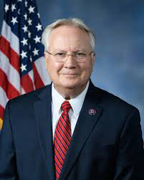 | Jerry Carl (AL-1) | (202) 225-4931 | 1330 Longworth HOB  Washington, DC 20515 | Email Jerry Carl
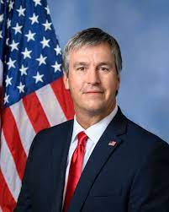 | Barry Moore (AL-2) | (202) 225-2901 | 1504 Cannon House Office Building  Washington, DC 20510 | Email Barry Moore
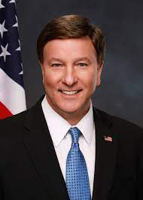 | Mike Rogers (AL-3) | (202) 225-3261 | 2184 Rayburn HOB  Washington, DC 20515 | Email Mike Rogers
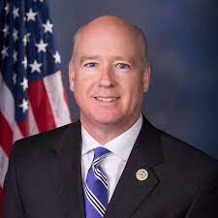 | Robert Aderholt (AL-4) | (202) 225-4876 | 1203 Longworth HOB  Washington, DC 20515 | Email Robert Aderholt
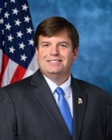 | Dale Strong (AL-5) | (202) 225-4801 | 1337 Longworth House Office Building Washington, DC 20515 | Email Dale Strong
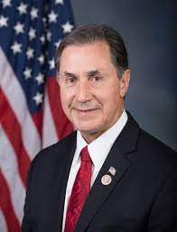 | Gary Palmer (AL-6) | (202) 225-4921 | 207 Cannon HOB  Washington, DC 20515 | Email Gary Palmer
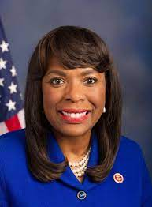 | Terri Sewell (AL-7) | (202) 225-2665 | 2201 Rayburn HOB  Washington, DC 20515 | Email Terri Sewell
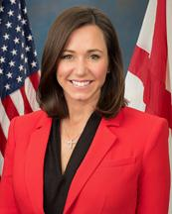 | Senator Katie Britt | (202) 224-5744 | SD-B40A Dirksen Senate Office Building  Washington, DC 20510 | Email Senator Britt
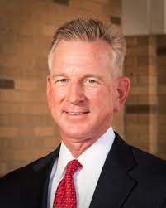 | Senator Tommy Tuberville | (202) 224-4124 | B40 A Dirksen Senate Office Building  Washington, DC 20510 | Email Senator Tuberville

