AL House Economic Development and Tourism Committee Contact List

 | Member of Committee | Phone | Address | Email
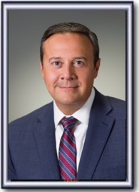 | Andy Whitt  (Chair) | (334) 261-0404 | 11 South Union Street  Suite 522 C  Montgomery AL 36130 | andy.whitt@alhouse.gov
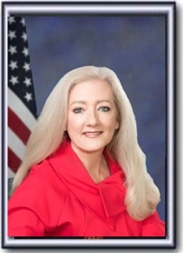 | Ginny Shaver  (Vice Chair) | (334) 261-0413 | 11 South Union Street  Suite 527 D  Montgomery AL 36130 | ginny.shaver@alhouse.gov
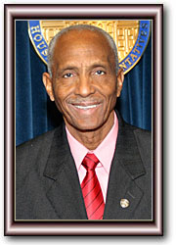 | Berry Forte  (Ranking Minority Member) | (334) 261-0566 | 11 South Union Street  Suite 540-D  Montgomery AL 36130 | berry.forte@alhouse.gov
 | Cynthia Almond | (334) 261-0558 | 11 South Union Street  Suite 528-A  Montgomery AL 36130 | cynthia.almond@alhouse.gov
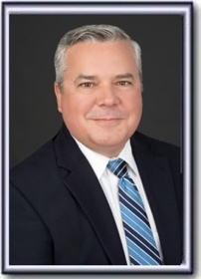 | Chip Brown | (334) 261-0447 | 11 South Union Street  Suite 524-F  Montgomery AL 36130 | chip@chipbrown105.com
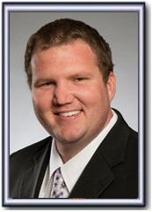 | Corey Harbison | (256) 385-5510 | 11 South Union Street  Suite 526-F  Montgomery AL 36130 | corey_harbison@yahoo.com
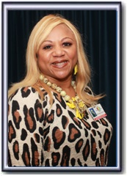 | Rolanda Hollis | (334) 261-9520 | 11 South Union Street  Suite 536-D  Montgomery AL 36130 | rolanda.hollis@alhouse.gov
 | Gil Isbell | (334) 261-0490 | 11 South Union Street  Suite 526 B  Montgomery AL 36130 | gfisbell@gmail.com
 | Neil Rafferty | (334) 261-0543 | 11 South Union Street  Suite 539 E  Montgomery AL  36130 | reprafferty@gmail.com
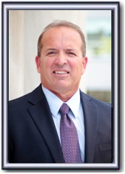 | Ritchie Whorton | (334) 261-0553 | 11 South Union Street  Suite 427 J  Montgomery AL 36130 | ritchiewhorton@gmail.com
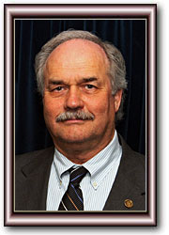 | Randy Wood | (334) 261-0552 | 11 South Union Street  Suite 417 H  Montgomery AL 36130 | strep36@gmail.com
 | Teresa Evans (Clerk) | (334) 261-0550 |  | Teresa.evans@alhouse.gov

