AL Senate Tourism Committee Contact List

 | Member of Committee | Phone | Address | Email
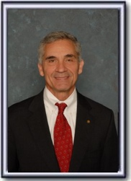 | Del Marsh  (Chair) | (334) 261-0712 | 11 South Union Street  Suite 722  Montgomery AL 36130 | del.marsh@alsenate.gov
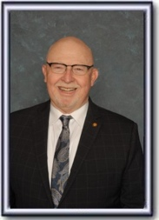 | Randy Price  (Vice Chair) | (334) 261-0874 | 11 South Union Street  Suite 733  Montgomery AL 36130 | randyprice.sd13@gmail.com
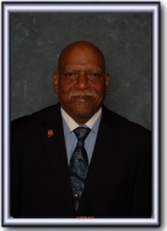 | Rodger M. Smitherman  (Ranking Minority Member) | (334) 261-0870 | 11 South Union Street  Suite 736  Montgomery AL 36130 | rodger.smitherman@alsenate.gov
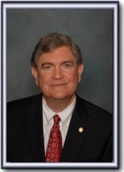 | William M. Beasley | (334) 261-0868 | 11 South Union Street  Suite 737  Montgomery AL 36130 | billy.beasley@alsenate.gov
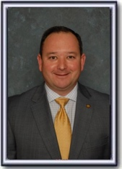 | Chris Elliott | (334) 261-0897 | 11 South Union Street  Suite 735  Montgomery AL 36130 | chris.elliott@alsenate.gov
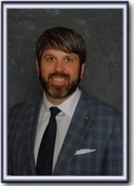 | Garlan Gudger | (334) 261-0855 | 11 South Union Street  Suite 733  Montgomery AL 36130 | garlan.gudger@alsenate.gov
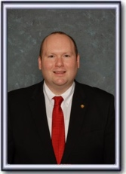 | Andrew Jones | (334) 261-0857 | 11 South Union Street  Suite 737  Montgomery AL 36130 | andrew.jones@alsenate.gov
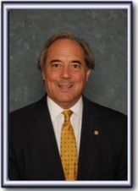 | Steve Livingston | (334) 261-0858 | 11 South Union Street  Suite 731  Montgomery AL 36130 | steve.livingston@alsenate.gov
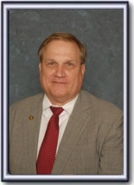 | Tim Melson | (334) 261-0773 | 11 South Union Street  Suite 732  Montgomery AL 36130 | tim.melson@alsenate.gov
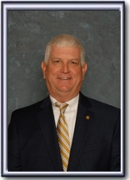 | David Sessions | (334) 261-0882 | 11 South Union Street  Suite 734  Montgomery AL 36130 | d.r.sessions@att.net
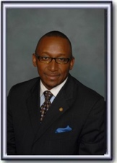 | Bobby D. Singleton | (334) 261-0335 | 11 South Union Street  Suite 740  Montgomery AL 36130 | bsingle362@gmail.com
 | Asia Franklin (Clerk) | (334) 261-0712 |  | asia.franklin@alsenate.gov

