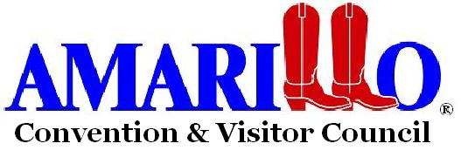

MARKETING ASSISTANCE FUNDING REQUEST

Organization ______________________________________________________

□ Non-Profit, Please enclose copy of 501[C][3] or [c][6] status

Contact name ______________________________________________________

Address __________________________________________________________

_________________________________________________________________

Phone ___________________Email____________________________________

Event Title ________________________________________________________

Event Dates _______________________________________________________

Describe event _____________________________________________________

_________________________________________________________________

_________________________________________________________________

Location of event ___________________________________________________

On-going event or one time activity? ___________________________________

Estimated attendance ________________
Is there an audience focus? (families, seniors, youth, etc.)__________________

Funding request (dollar amount) $ ________

List other event sponsors ____________________________________________

_________________________________________________________________
Will additional CVC services be needed for this event? (non-arts)____________
________________________________________________________________

The following are requirements to receive funding from the Arts Committee:

- Place logo on programs and all promotional activity, including social media. How will you promote your event? (Include marketing plan for funding request only, which includes how promotion will assist the CVC’s marketing efforts to bring overnighting tourism to Amarillo)

- Provide marketing financial income/expense statements.

- CVC will receive a full-page complimentary ad in your program.

- Provide a CVC link on your website.

- Use the CVC Arts Committee logo on your website and other appropriate materials.

- If this is a request with the arts, you will participate in the Golden Nail Awards by sending in nominations and attending the annual gala.

- Use the CVC link to put your season and events information on the CVC Website Calendar of Events.

- CVC will be granted free access and use of all event photo’s

This is what you can receive from the Amarillo Convention and Visitor Council:

- Participating arts groups will be involved in our “No Co-op Co-op”, where we run your message or upcoming activities with our logo on digital billboards in Amarillo. There is no cost to you. It is only available to those who allow the CVC Arts Committee logo on your advertising and promotional activities.

Include a copy of proposed event budget and marketing plan.

All Amarillo Convention and Visitor Council funding is subject to appropriation by the Amarillo City Council.

Thank you for your application!
----------------------------------------------------------------------------------------------
Amarillo Arts Committee recommendation:
Yes ______ No_____
Amount of funding recommended___________________
Additional Comments:

