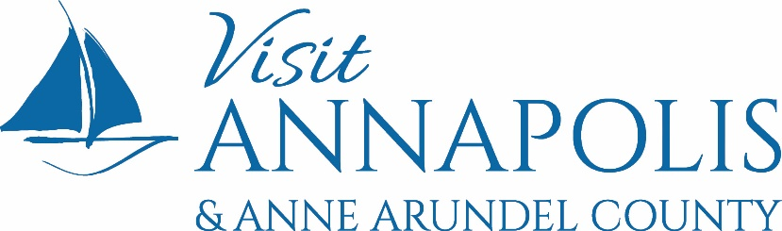

NEWS RELEASE

For Immediate Release
Contact: Susan Seifried, sseifried@visitannapolis.org, 410-280-0445
Date: April 21, 2022

Job Fairs provide Support to Maryland
Hospitality & Tourism Industry Employers

ANNAPOLIS, MARYLAND — In what is believed to be the first statewide tourism and hospitality job fair in Maryland’s history, destination marketing and tourism organizations from across the State and their workforce system counterparts are teaming up to address one of the travel and hospitality industry’s biggest challenges – filling thousands of open positions and retaining talent to welcome back visitors for what is expected to be a robust summer travel season. A statewide virtual job fair and a regional in-person job fair to benefit the future of the travel industry in Maryland will take place during National Travel & Tourism Week (NTTW) May 1 – 7, 2022.

Individuals seeking employment in Maryland’s hospitality and tourism industry will have the opportunity to meet virtually with employers from 19 Maryland counties, as well as Annapolis, the City of Baltimore, and Ocean City, on Wednesday, May 4, from 9:00 a.m. until noon.

Employers and job seekers who prefer the option of an in-person meeting will have the opportunity to meet during a Greater Baltimore and Annapolis Hospitality & Tourism Job Fair sponsored by Visit Annapolis & Anne Arundel County (VAAAC) and Anne Arundel Workforce Development Corporation (AAWDC) at the BWI Airport Marriott in Linthicum Heights, Maryland on Monday, May 2, from 9:00 a.m. until noon.

VAAAC Executive Director Kristen Pironis says what began as a conversation about hosting a regional job fair morphed into the creation of the May 4 statewide virtual job fair being presented by Maryland Association of Destination Marketing Organizations, the Maryland Tourism Coalition, and their workforce system partners to assist the hospitality industry statewide.
According to a Tourism Economics report, the pandemic resulted in a net loss of more than 45,600 Maryland jobs that directly interact with visitors in 2020. That’s more than 30 percent of all jobs directly supported by visitor activity. Even with those losses, visitor activity in Maryland continued to directly support 104,328 jobs, or 2.9 percent of all jobs in the state.
“For there to be a full economic recovery of the travel and hospitality industry in Maryland, our hotels, restaurants, attractions, and tourist venues need staff to meet the expectations of our visitors,” says Pironis. “We want to do what we can to help ensure that a Maryland vacation or getaway is enjoyable from start to finish and is 100% dependent upon the workforce being in place this summer to create lifelong memories,” she adds.

AAWDC President and CEO Kirkland J. Murray says the upcoming job fairs provide an excellent opportunity to share the message that jobs in the hospitality and tourism industry are vehicles for growth. “Yesterday’s entry level tourism and hospitality workers are today’s innovative leaders who are entrepreneurial, rising in the ranks, and shaping the future of the industry. For many individuals, accepting a position in the travel and tourism industry is the first step toward a stable and rewarding life with major opportunities for career and wage growth,” says Murray.
About the Virtual Statewide Job Fair on Wednesday, May 4, 2022:
- In addition to Annapolis, Ocean City and Baltimore City, employers from the following counties will be recruiting travel and hospitality talent during the virtual job fair: Allegany, Anne Arundel, Baltimore, Calvert, Charles, Dorchester, Frederick, Garrett, Harford, Howard, Kent, Montgomery, Queen Anne’s, Saint Mary’s, Somerset, Talbot, Washington, Wicomico, and Worcester.

- Employers who are recruiting talent for positions within the 22 participating counties/cities are invited to register at: https://pvapi.premiervirtual.com/s/d7aZrW.

- Individuals seeking employment in the participating jurisdictions are invited to register for the virtual job fair at: https://pvapi.premiervirtual.com/s/81rNrd.

About the In-Person Greater Baltimore & Annapolis Job Fair on Monday, May 2, 2022:
- VAAAC and AAWDC will kick off NTTW observances in Annapolis and Anne Arundel County with a complimentary in-person Hospitality & Tourism Job Fair at the BWI Airport Marriott, 1743 West Nursery Road, Linthicum, MD 21090, on Monday, May 2, from 9:00 a.m. until noon.

- Hospitality and tourism industry employers, including restaurants, tourist attractions, hotels, motels, inns, retail establishments, entertainment venues, and more, will have the opportunity to meet face-to-face with prospective job seekers at the no cost event.

- According to a Tourism Economics report, 15,297 individuals were directly employed by the travel and tourism industry in Annapolis and Anne Arundel County in 2020. This was down 30.4% from the 21,974 individuals who were directly employed by the industry in 2019.

- Employers who are interested in recruiting talent at the in-person Hospitality & Tourism Job Fair on Monday, May 2, can register at: https://www.visitannapolis.org/jobfair2022.

- Individuals who would like to attend the in-person Hospitality & Tourism Job Fair on Monday, May 2, can register at: https://visitannapolisjobfair.eventbrite.com.

XXX
About National Travel & Tourism Week: National Travel and Tourism Week 2022 (May 1-7) is an annual industry tradition celebrating the value travel holds for our economy, businesses, personal well-being and more. For more information, visit: https://www.ustravel.org/toolkit/national-travel-and-tourism-week.

About Visit Annapolis & Anne Arundel County: Visit Annapolis and Anne Arundel County (VAAAC) is a nonprofit, membership-based Destination Marketing Organization (DMO) that generates revenues for the local economy by promoting Annapolis and Anne Arundel County to business and leisure travelers across the country and around the world. Anne Arundel County’s official DMO executes strategic marketing, sales, and media campaigns that position the destination’s portfolio of brands in key markets to bolster the economy and enhance employment opportunities.

About Anne Arundel Workforce Development Corporation: Anne Arundel Workforce Development Corporation (AAWDC) is a nonprofit organization that enhances the vitality of Anne Arundel County by developing and implementing workforce solutions. AAWDC builds and maintains a pipeline of skilled talent to meet the demand of businesses and prepares residents with the in-demand skills that lead to family-sustaining employment.

