Arriving in Belfast Access Guide

Welcome! This guide will help you plan your journey to Belfast and find accessible transport, facilities and support during your visit.

Quick Tips
Book accessible parking in advance if required.
Allow extra time when travelling during busy periods.
There will be lots of volunteers from Volunteer Now in yellow T-shirts if you need assistance.
Visit the Accessibility Hub at CastleCourt for access information and support.
Accessible toilets and Changing Place facilities are available at key locations.

Arriving in Belfast Access Guide
This guide provides information to help you plan your journey and key accessibility features throughout the city centre.
Belfast has three railway stations and two main bus arrival points. Details of each of them are below.

Grand Central Station
Grand Central Station is the city’s main train and bus station, it also serves coach operators, including Aircoach and Dublin Express. The station is a 10-minute walk or wheel to Belfast City Hall and provides easy access to city-centre Fleadh venues.

Accessibility Overview
Step-free entrance
Navilens (technology that supports independent navigation for blind and visually impaired people, further information on Navilens is available on Translink’s website)
Internal tactile walkway
Sensory packs on request
Accessible toilets
Changing Place

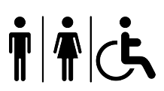

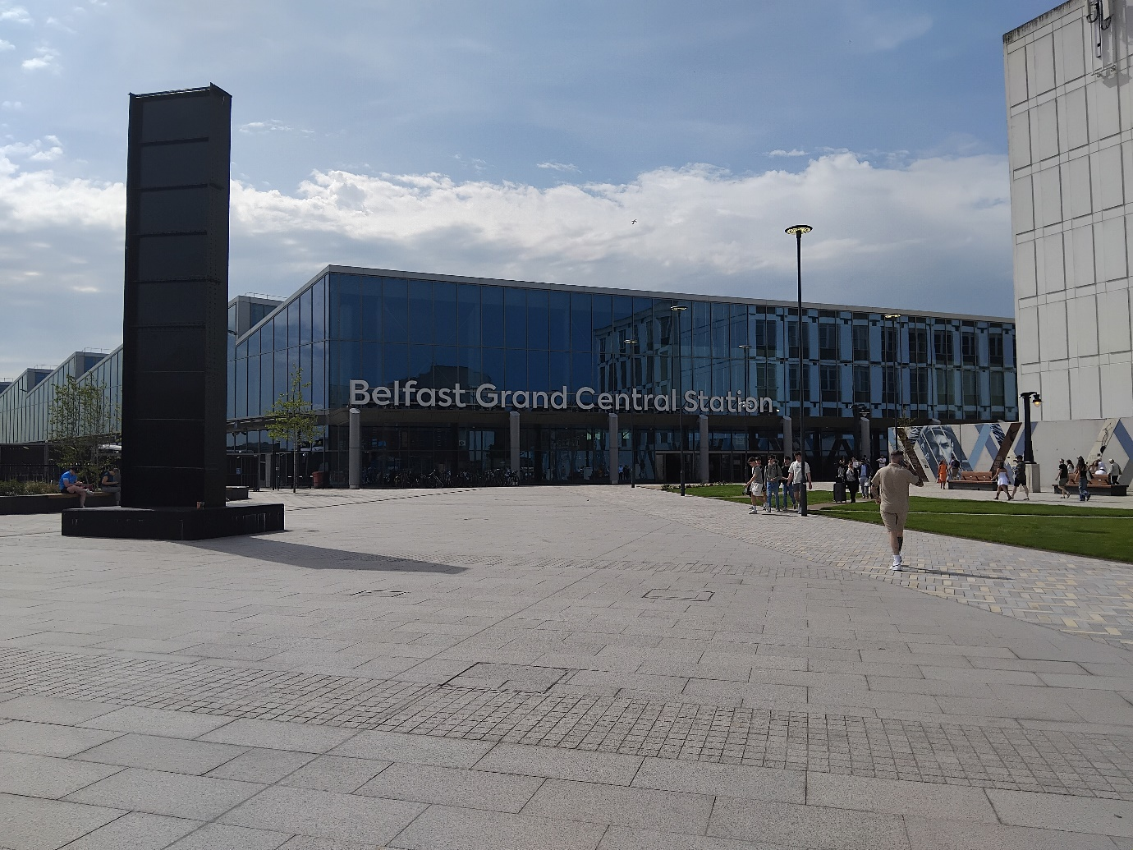

York Street Train Station
York Street Station is located north of Belfast city centre, approximately a 15-minute walk or wheel from Ulster University. It provides rail services to destinations across Northern Ireland and offers easy access to the Cathedral Quarter and several Fleadh venues.

Accessibility Overview
Step-free entrance
Lift access
Internal tactile walkways
Accessible toilets
Changing Place

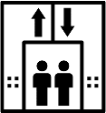

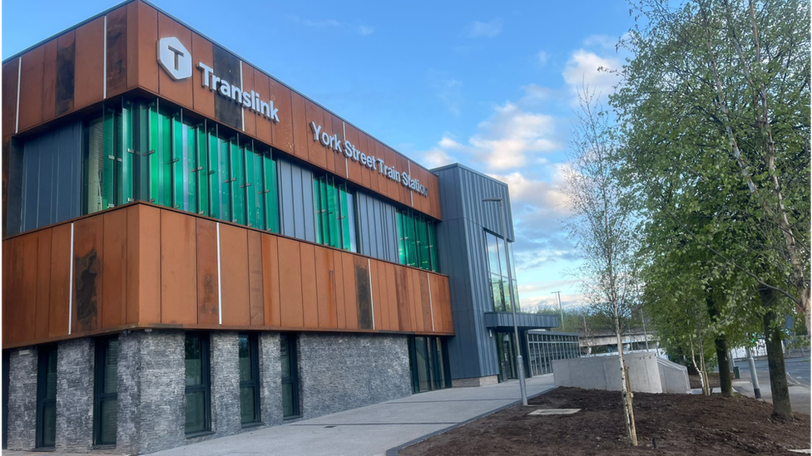

Lanyon Place Train Station
Lanyon Place Station is located on the eastern side of Belfast city centre, just a 5-minute walk or wheel from ICC Belfast and Waterfront Hall. The station provides regular rail services across Northern Ireland and is well connected to nearby bus services, making it a convenient arrival point for visitors attending the Fleadh.

Accessibility Overview
Step-free entrance
Lift access
Internal tactile walkways
Accessible toilets
Changing Place

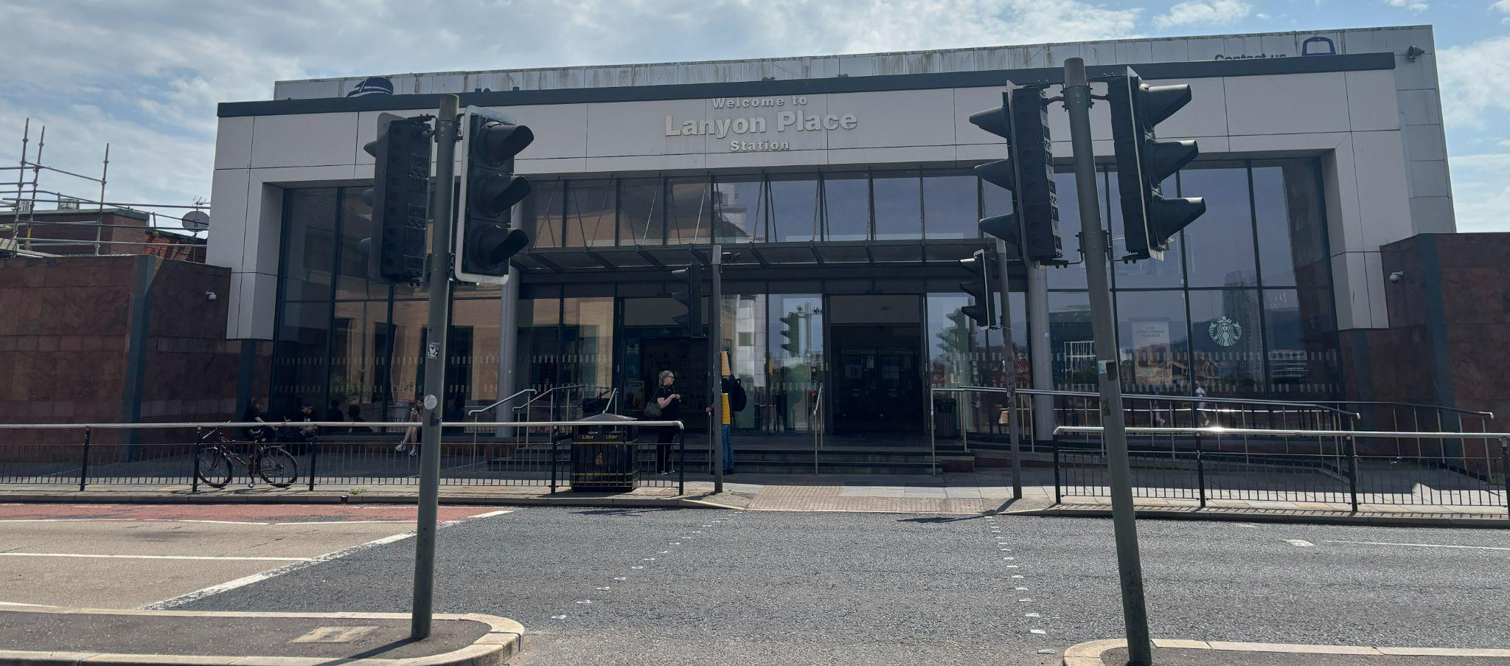
Lanyon Place Station is a 5-min walk or wheel to ICC Belfast and Waterfront Hall.

Laganside Bus Centre
Laganside Bus Centre is located beside the River Lagan, around a 10-minute walk or wheel from Belfast City Hall. The station serves local and regional bus services and is conveniently located for visitors travelling to the city centre and nearby Fleadh venues.

Accessibility Overview
Step-free entrance
Accessible toilets

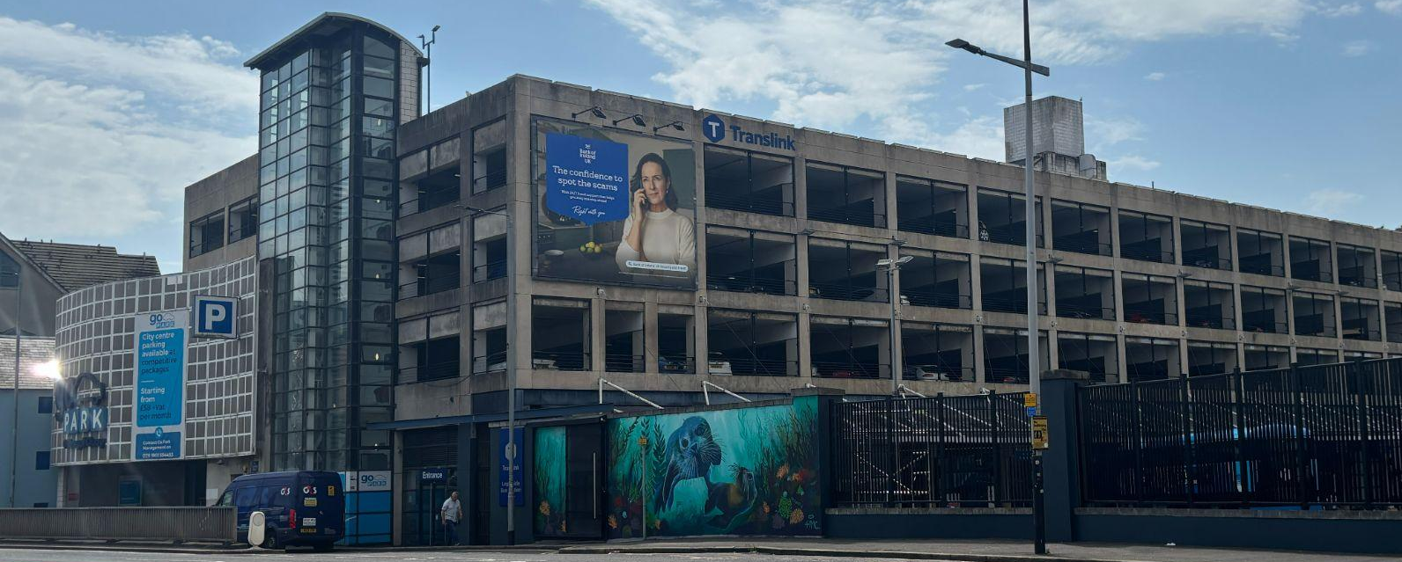

Park and Ride Services
During the Fleadh, park and ride services will operate from the following locations:
Giant’s Park
Eikon Exhibition Centre
Belfast Harbour

Low-floor accessible shuttle buses will serve these routes, with ramp access available from the driver. Blue Badge parking will be available at each Park and Ride site.
Car parking spaces need to be booked in advance; details are available on the Fleadh website.

Accessible Bus & Glider Features
Gliders and buses include priority seating, wheelchair spaces and audio-visual journey information. All Glider services and Matro buses provide space for one wheelchair user; some Metro buses can accommodate two wheelchair users.
An accessible city-centre loop shuttle will operate around the city centre pedestrian zone.

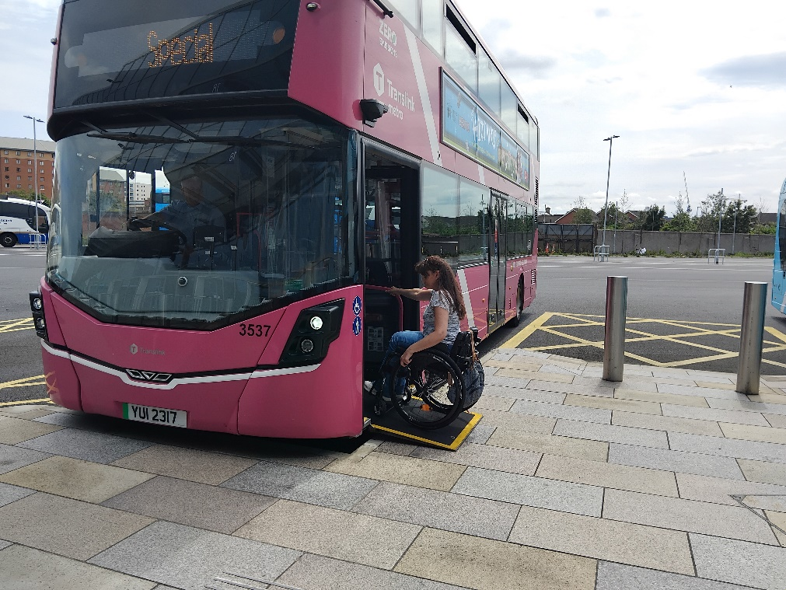

Blue Bage Parking
Most city centre car parks will remain open, including CastleCourt, Victoria Square and St Anne’s Square car park. Dunbar Link (outside Common Market) and Smithfield (to the rear of CastleCourt) car parks will be reserved solely for Blue Badge holders only during the Fleadh.

Accessibility Hub
If you need information, support or advice during your visit, the Accessibility Hub at CastleCourt is here to help.
Friendly staff from Open Arts can provide accessibility information, answer questions about getting around the city, and help you make the most of your Fleadh experience.

The Accessibility Hub will have:
Communication aids
Hearing induction loop
Quiet space and sensory supports, such as ear defenders and fidget tools
Drinking water available for Assistance Dogs
Charging points for powerchairs and other access aids
Take as you need sanitary and incontinence products
Various seating options



Accessible Toilets and Changing Places
Accessible toilets and Changing Places facilities are available at key locations across the city. Venues with a Changing Place are:

Belfast City Hall
CastleCourt
ICC Belfast
Ulster University
Lanyon Place Station
York Street Station
Titanic Belfast
Victoria Square
Plus, an additional mobile one will be situated outside 2 Royal Avenue in Bank Square

There will also be additional temporary portable toilet provision in City Hall grounds, Fountain Lane, Hill Street and Verner Street (beside St Georges Market). Each site will include a minimum of two accessible portaloos. There will also be a parent and child changing space within the City Hall grounds and Hill Street provisions

Information and Assistance
Volunteers from Volunteer Now will be available to assist you throughout the city. They will be wearing yellow t-shirts with writing in English or Irish.

