Belfast City Centre and Key Venues
Access Guide

Welcome! This guide is designed to help everyone enjoy their visit. It includes information about accessible venues, getting around the city, available facilities and where to find support.

Quick Tips
Allow extra travel time between venues.
There will be lots of volunteers from Volunteer Now in yellow T-shirts if you need assistance.
Visit the Accessibility Hub at CastleCourt for access information and support.
Accessible toilets and Changing Place facilities are available at key locations.

Belfast city centre is compact, and many Fleadh venues are within easy walking or wheeling distance of one another. Accessible footpaths, pedestrian crossings and dropped kerbs help connect key locations across the city.

Using City Hall as a central reference point, Grand Central Station lies to the south-west, Ulster University to the north, and the ICC and Waterfront Hall to the east.

City Centre Accessibility Features
Throughout Belfast city centre you will find:
Dropped kerbs
Tactile paving
Wide footpaths
Signal-controlled pedestrian crossings
Audible crossing signals
Rotating cones beneath crossing buttons
Public seating areas

Venues

Belfast City Hall
Belfast City Hall and its grounds are the central point of the Fleadh and home to the Gig Rig. The Gig Rig is free and unticketed entry throughout the week. There will be an accessible viewing area in front of the stage which is unreserved and available on a first-come first-served basis. Please note that there will be a limited number of free tickets available for the Accessible Viewing area for the Opening and Closing ceremonies. Tickets for the Opening Ceremony, 12pm Sunday 2nd August, are available now online here Fleadh Cheoil na hÉireann Opening Ceremony – Accessible Viewing Area Only. More information to come for Closing Ceremony tickets.

Accessibility Overview
Step-free entrance
Lift access inside the building
Seating in the building and in the grounds
Accessible toilets in the building
Changing Place in the building available until 5pm

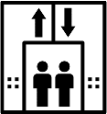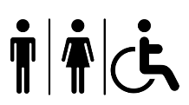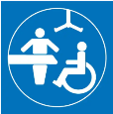

You can find more detailed information on the AccessAble website here Belfast City Hall on AccessAble
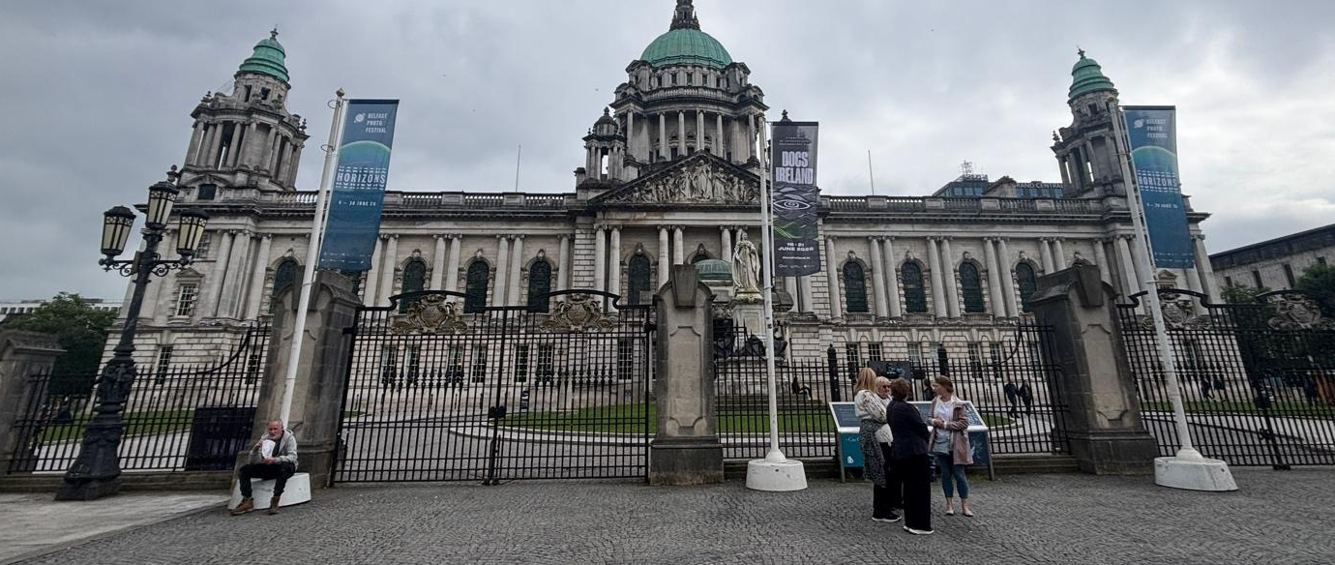

Ulster Hall
Ulster Hall is located close to Belfast City Hall.

Accessibility Overview
Step-free entrance
Lift access in the building
Hearing induction loop system available
Accessible toilets



You can find more detailed information on the AccessAble website here Ulster Hall on AccessAble

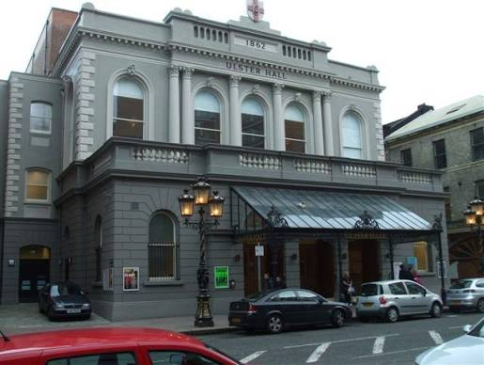

2 Royal Avenue

2 Royal Avenue is just a short walk or wheel away from Belfast City Hall.

Accessibility Overview
Step-free entrance
Accessible toilet
Seating

You can find more detailed information on the AccessAble website here 2 Royal Avenue on AccessAble

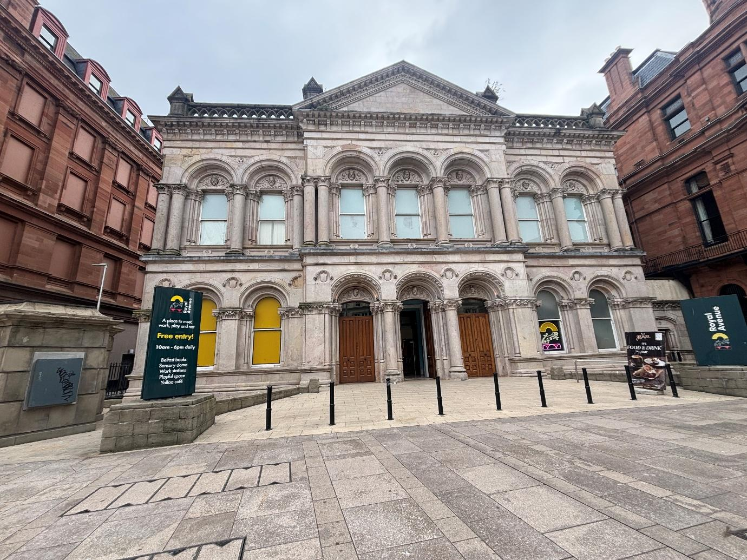

The Waterfront Hall and ICC
The Waterfront Hall and ICC are located beside the River Lagan and are a short distance from Belfast City Hall.

Accessibility Overview
Step-free entrance
Lift access
Hearing induction loop system available
Accessible toilets
Changing Place in the ICC

You can find more detailed information on the AccessAble website here The Waterfront Hall on AccessAble

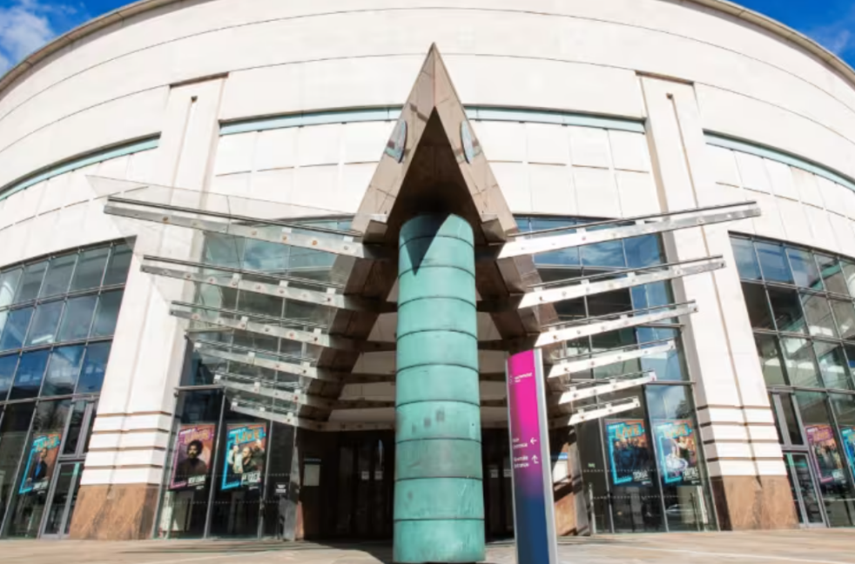

Ulster University
Ulster University is to the north of Belfast City Hall and close to York Street Station.

Accessibility Overview
Step-free entrance
Lift access
Hearing induction loop
Seating
Accessible toilets
Changing Places

You can find more detailed information on the AccessAble website here Ulster University on AccessAble

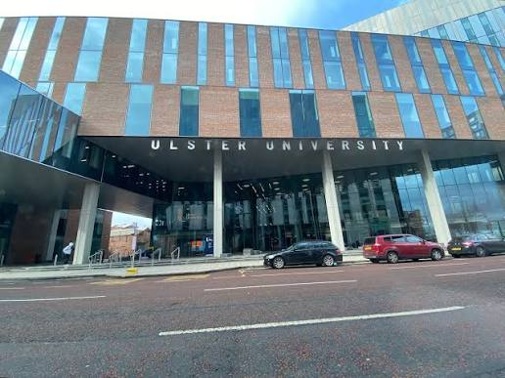

The MAC
The MAC is in St Anne’s Square in the Cathedral Quarter of the city.

Accessibility Overview
Step-free entrance
Lift access
Hearing Induction Loop
Seating
Accessible toilets

You can find more detailed information on the AccessAble website here The MAC on AccessAble

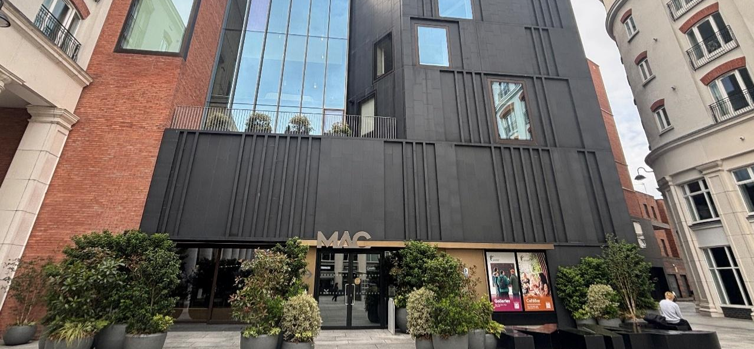

Discover Ulster-Scots Centre
The Discover Ulster Scots Centre is also in the Cathedral Quarter of the city and only a few minutes from The MAC.

Accessibility Overview
Step-free entrance
Seating
Accessible toilets

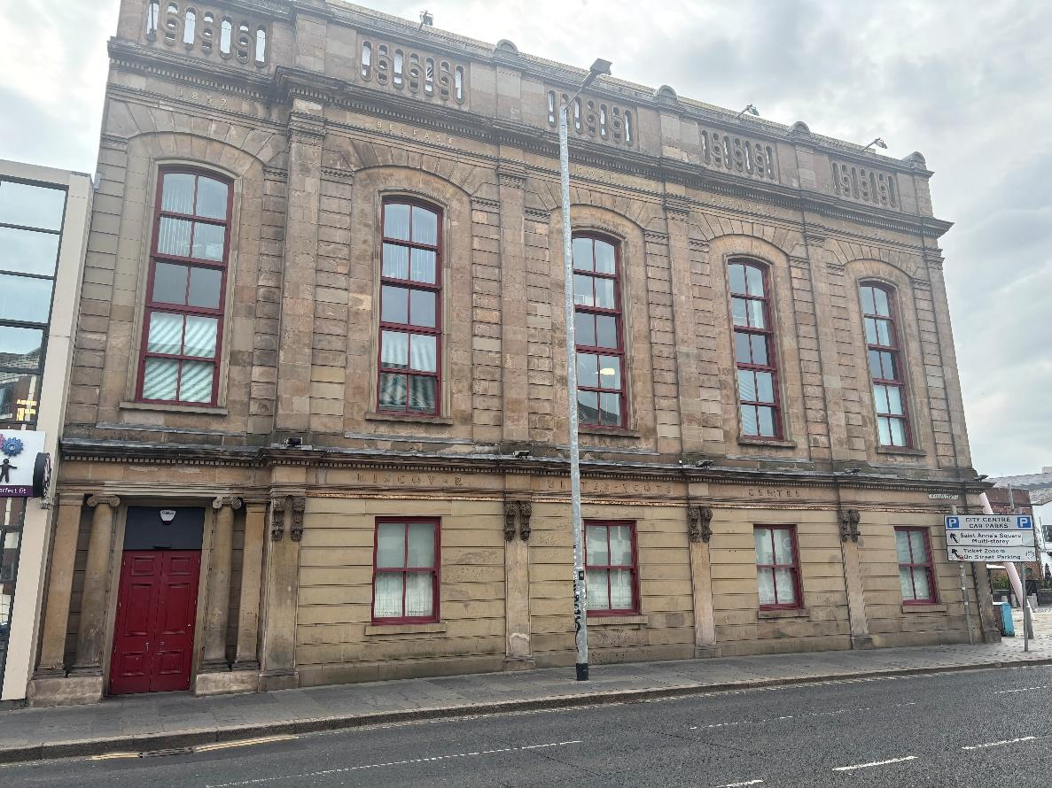

Writers' Square
Writer’s Square is in the Cathedral Quarter, directly opposite St Anne’s Cathedral.

Accessibility Overview
Level access public space
Accessible routes from surrounding streets
Seating

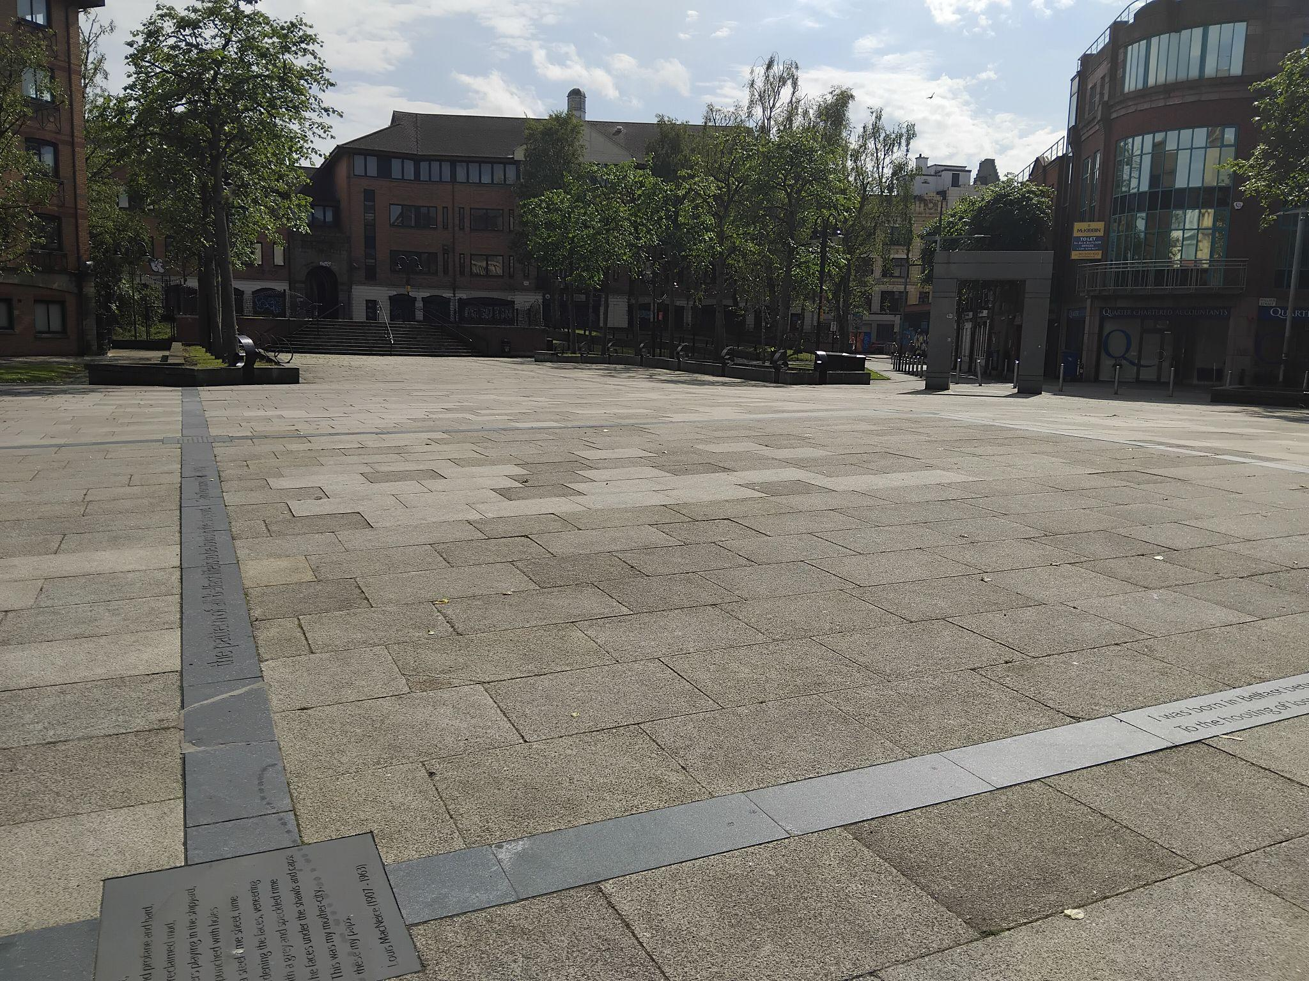
Belfast Met
Belfast Met's Millfield Campus is around a 15-minute walk from Belfast City Hall.

Accessibility Overview
Step-free entrance
Lift access
Seating
Accessible toilets

You can find more detailed information on the AccessAble website here Belfast Met on AccessAble

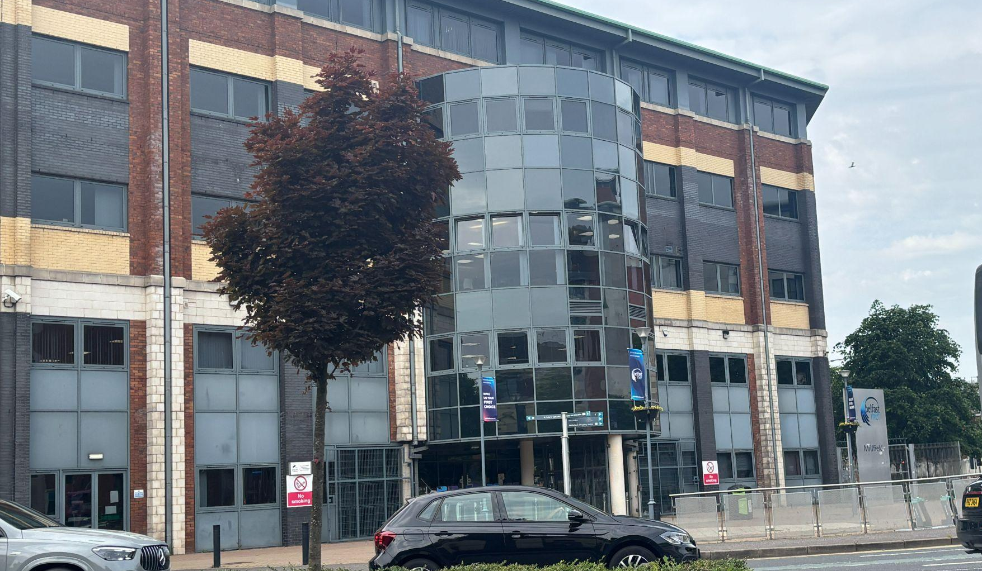

CastleCourt
CastleCourt is centrally located and is the home of the Accessibility Hub, making it a useful support point for visitors attending Fleadh venues across the city centre.

Accessibility Overview
Step-free access
Lift access
Seating
Accessible toilets
Changing Place

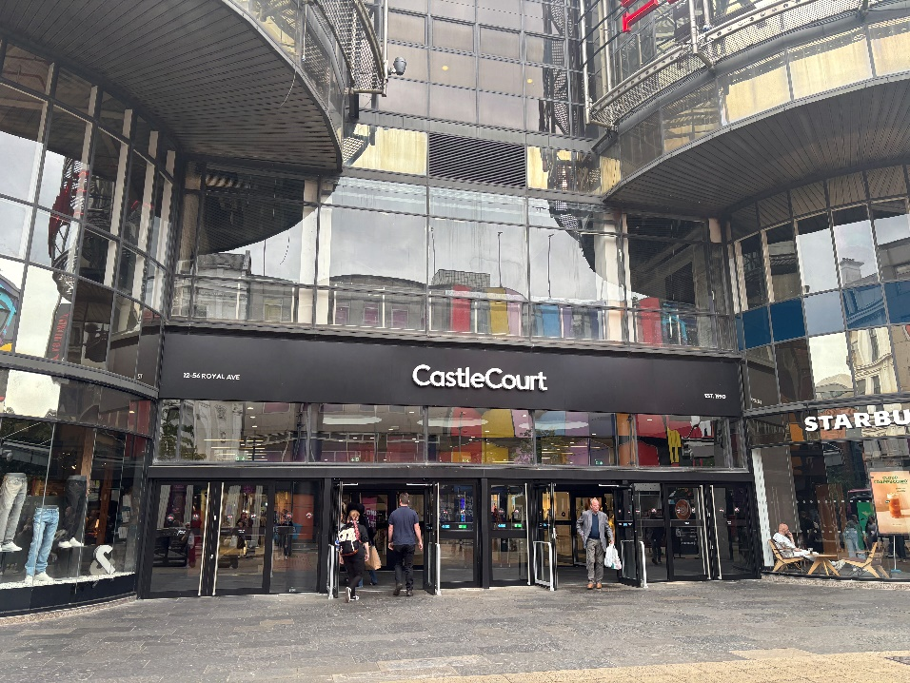
Accessibility Hub
If you need information, support or advice during your visit, the Accessibility Hub at CastleCourt is here to help.
Friendly staff from Open Arts can provide accessibility information, answer questions about getting around the city, and help you make the most of your Fleadh experience.

The Accessibility Hub will have:
Communication aids
Hearing induction loop
Quiet space and sensory supports, such as ear defenders and fidget tools
Drinking water available for Assistance Dogs
Charging points for powerchairs and other access aids
Take as you need sanitary and incontinence products
Various seating options

Accessible Toilets and Changing Places
Accessible toilets and Changing Places facilities are available at key locations across the city. Venues with a Changing Place are:

Belfast City Hall
CastleCourt
ICC Belfast
Ulster University
Lanyon Place Station
York Street Station
Titanic Belfast
Victoria Square
Plus, an additional mobile one will be situated outside 2 Royal Avenue in Bank Square

There will also be additional temporary portable toilet provision in City Hall grounds, Fountain Lane, Hill Street and Verner Street (beside St Georges Market). Each site will include a minimum of two accessible portaloos. There will also be a parent and child changing space within the City Hall grounds and Hill Street provisions

Information and Assistance

Volunteers from Volunteer Now will be available to assist you throughout the city. They will be wearing yellow t-shirts with writing in English or Irish.

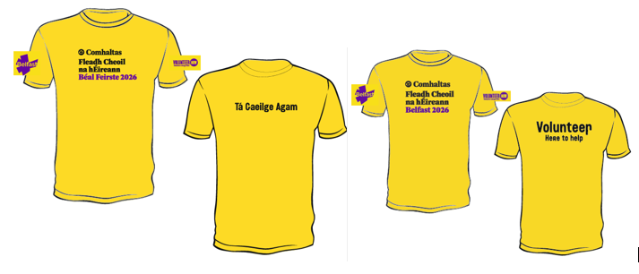

Mobility Aid Hire

Shopmobility Belfast is a charity that provides the only free daily rental service of mobility scooters and wheelchairs. The service is available to anyone who has difficulty accessing and travelling around Belfast City Centre and the greater Belfast area. To use the service, you will need to register. For more information email info@shopmobility.co.uk or visit the Shopmobility website

They have 2 locations near the City Centre. One in Great Northern Mall/HALT, which is very close to Grand Central Station and another in Smithfield Market, which is close to CastleCourt where the Accessibility Hub is located.

