Large Print

Visit Belfast guide for disabled visitors
Contents
About this guide 2
Useful information 3
Getting here 9
Getting around 16
Top things to do 21
Local’s picks: one- and two-day itineraries 36
Local’s picks: Culture and heritage 37
Local’s picks: Family friendly 43
Local’s picks: The great outdoors 47

About this guide
This guide includes itineraries, recommendations, top attractions and useful information on getting to, getting around and support services.
It is available:
- online
- to download in a choice of formats including large print and plain text
- in other formats on request by contacting Visit Belfast
This access guide was created in collaboration with Open Arts, a local organisation that supports the creative and artistic development of disabled people.

Useful information

Visit Belfast Welcome Centre
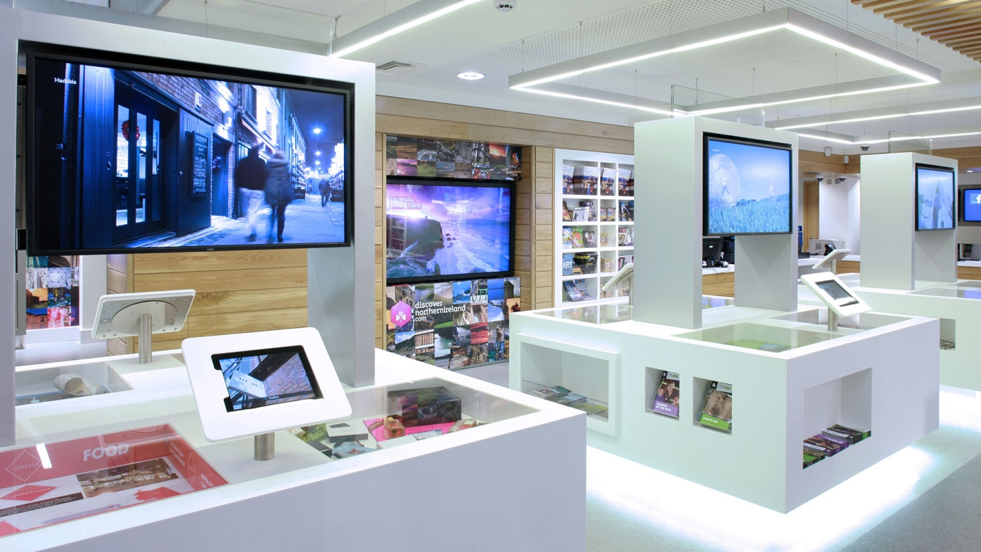 Image courtesy of Victoria Square Belfast
The Visit Belfast Welcome Centre is the official tourist information centre for Belfast and Northern Ireland. It is open daily, and staff can help you with tourist information, planning itineraries, rail and bus ticket sales, tickets for tours and events and accommodation bookings.
In the city centre, it can be reached by bus, taxi or on foot. The nearest train station is Lanyon Place, and your rail ticket gives you a free ride in to the centre on any purple Glider or pink Metro bus service from outside the station.
For more information on access to the Welcome Centre, visit AccessAble.

Left luggage facilities
The Visit Belfast Welcome Centre, located opposite Belfast City Hall in Belfast City Centre, has a luggage storage facility so visitors can securely store their luggage while exploring the city.

Assistance dogs
Assistance dogs are widely welcome, and water bowls are generally available on request.
Dogs entering the country must comply with the Pet Travel Scheme. Check with your ferry or airline for any additional requirements.

Currency
Northern Ireland uses the pound sterling (£), the currency in circulation in England, Scotland and Wales. Card and contactless payments, including Mastercard (Access), Visa, Google Pay and Apple Pay, are in general use.
You can find wheelchair accessible and “talking” audio assistance ATMs using this map.

Shopping
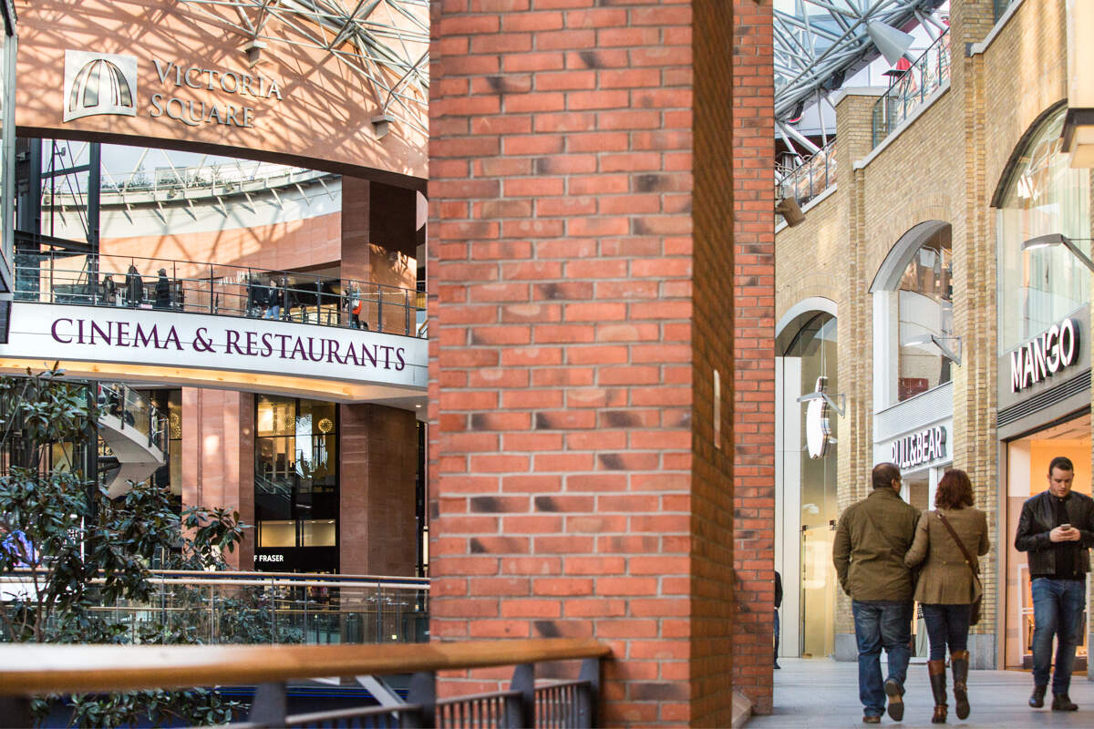 Image courtesy of Victoria Square Belfast
Many shops in Belfast City Centre are open from 9am to 6pm with late night shopping on Thursdays until 9pm. Sunday opening hours are generally 1pm to 6pm.
Shops are generally welcoming of disabled visitors. Shops that display the JAM card are trained in providing quality service to people with communication and hidden disabilities. Larger shops may have toilets available for customers.
There are two large shopping centres in the city centre. Victoria Square has a play area, quiet spaces, accessible toilets and a Changing Places. Visitors can borrow a free sensory pack including fidget toys, ear defenders and a RADAR key from customer services on the ground floor.
Castle Court has accessible toilets and a Changing Places and scooters and wheelchairs are available to rent from its Shopmobility store.

Toilets
You can find public toilets managed by Belfast City Council on its website. These include 24-hour access automatic toilets. There is a 20p charge to use automatic toilets, payable in coins or by card.
All public toilets include accessible facilities which can be accessed with a RADAR key.

Changing Places
There are nearly 100 registered Changing Places in Northern Ireland. These include City Hall, Titanic Belfast, Belfast Zoo, SSE Arena, Crescent Arts Centre, Northern Ireland Assembly Buildings, Divis and the Black Mountain and the Ulster Folk Museum.
You can find registered facilities on the Changing Places map.

WiFi
Belfast has a free public WiFi network, Belfast WiFi. It is available is available at 109 hotspots, including visitor attractions, community and leisure centres and other public buildings.
WiFi is also widely available in shops, coffee shops, restaurants, visitor attractions, libraries and more.

Safety
Belfast is one of the safest cities in Europe, and Northern Ireland has the second lowest crime rate in Europe. However, it is always wise to be sensible and follow good advice when exploring a new destination. As with all travel, follow general safety tips such as leave money and valuables in a safe place and lock valuables out of sight.

Emergencies
The number for emergency services is 999. This will connect you to the fire brigade, police, ambulance, lifeboat and mountain rescue services.
For non-urgent crimes, contact the police by calling 101.

Support services

Sign Video
Sign Video is an online service that can connect you through your phone or tablet to a BSL or ISL interpreter. It is available in leisure centres, visitor attractions such as Belfast Zoo and City Hall, hospitals and anywhere that displays the Sign Video sign.

Mae Murray Foundation
The Mae Murray Foundation has a library of free inclusive equipment and resources including all-terrain wheelchairs and buggies, trikes, travel seats, portable bath and toilet seats, safety beds, weighted blankets, play packs and soft play mats and retractable driveway guards.
It is quick and straightforward to sign up as a member of the Mae Murray Foundation. You should then complete an application form to borrow equipment at least seven days in advance. Equipment must be collected from and returned to their office in Larne, which is 20 miles (30km) north of Belfast.

Shopmobility
Shopmobility Belfast provides free daily rental of mobility scooters and wheelchairs to members. Members must sign-up using an online form and be assessed in person at locations in Belfast. They can then use scooters at a variety of venues, including Titanic Belfast, the Game of Thrones Studio Tour, shopping centres and parks.
Non-members can also pay a small fee to rent Shopmobility scooters, wheelchairs and leg extensions.

Other equipment hire
Mobility Direct NI offers scooters for holiday hire.
Red Cross wheelchairs are available in a wide range of sizes, fitted with footrests as standard and free accessories such as leg elevators, cushions and stump supports.
AMS Mobility Services has a large range of wheelchairs including children’s wheelchairs and bariatric capable chairs with adaptions such as reclining backrests, elevating footrests and pressure relief cushions.
John Preston Medical and Mobility rent a range of equipment including wheelchairs, hoists and electric profiling beds with a choice of mattress.

Getting here

By air

George Best Belfast City Airport
George Best Belfast City Airport is just five miles (8km) from Belfast’s city centre.
Value Cabs is Belfast City Airport’s taxi partner. There is a booking desk in the arrivals area and a taxi rank just outside. Wheelchair accessible taxis are limited and booking in advance is advisable.
The Translink Airport Express 600 bus service connects the airport to the city centre. It runs from the front of the terminal building to Belfast Grand Central Bus Station up to every 20 minutes. It is a low-floor accessible bus with space for one wheelchair user and other priority seats for disabled passengers.
The closest railway halt is Titanic Quarter. You can get a free shuttle bus to the halt by asking at the Airport Parking Services desk in the arrivals area. There are limited services at this halt, and passengers need to use a footbridge, so the airport advises passengers against this option if they have reduced mobility.
City Airport can provide assistance to travellers – from familiarisation visits to help with checking in, going though security, boarding the aircraft and collecting baggage. Assistance should be requested at least 48 hours before you fly. Hidden disability “sunflower” lanyards are also available from the special assistance desk.
The airport has produced access and autism guides, and further information is available on AccessAble.

Belfast International Airport
Belfast International Airport is a 30-minute drive from Belfast city centre.
Belfast Airport Taxis is the official taxi partner. There is a taxi rank just outside the building, and bookings can also be made online. Bookings for wheelchair accessible taxis are best made in advance.
The Translink Airport Express 300 bus service runs from just outside the terminal and Belfast Grand Central Bus Station. It is a low-floor accessible bus with space for one wheelchair user and other priority seats for disabled passengers.
Belfast International Airport can provide assistance to travellers – from familiarisation visits to help with checking in, going though security, boarding the aircraft and collecting baggage. Assistance should be requested at least 48 hours before you fly. Hidden disability “sunflower” lanyards are also available at the airport.
The airport has produced an access guide and autism guides.

Car hire
There are guides to accessing car hire at George Belfast City Airport and Belfast International Airport.
There are a wide range of rental options available including automatics, people carriers and vans. Some firms offer delivery and collection services.
Europcar have Motability cars that should be booked in advance. Enterprise and SIXT can provide adaptive driving devices with advance notice. McElmeel Mobility Services specialise in wheelchair accessible holiday rentals.

By sea

Stena Line
Stena Line ferries travel to Belfast from Liverpool and Cairnryan. Staff have been trained to provide assistance when required, but some ferries and sailings may have restrictions. You should check and let them know if you need any special assistance at least 48 hours before you sail.
The number 96 Metro bus service runs between the ferry terminal and the city centre four times a day and takes just over 20 minutes.
A taxi-share scheme is in operation to the city centre offered by black public hire taxis just outside the terminal building. Taxis may also be pre-booked through FonaCAB. Wheelchair-accessible taxis are limited and booking in advance is advisable.

P&O Irish Sea
The P&O Irish Sea ferry travels from Cairnryan to Larne, 40 minutes north of Belfast. There are direct rail and bus connections from the terminal.
P&O has produced an access guide for the route. They also provide hidden disability “sunflower” lanyards at check in or before you sail. You should let them know about other access requirements or special assistance when you book.

Isle of Man Steam Packet Company
The Isle of Man Steam Packet Company operates a ferry from the Isle of Man to Albert Quay, a 15-minute drive from the city centre. Staff are trained to provide assistance, and you should let the company know of any requirements at least 48 hours in advance of sailing.

Cruise ship
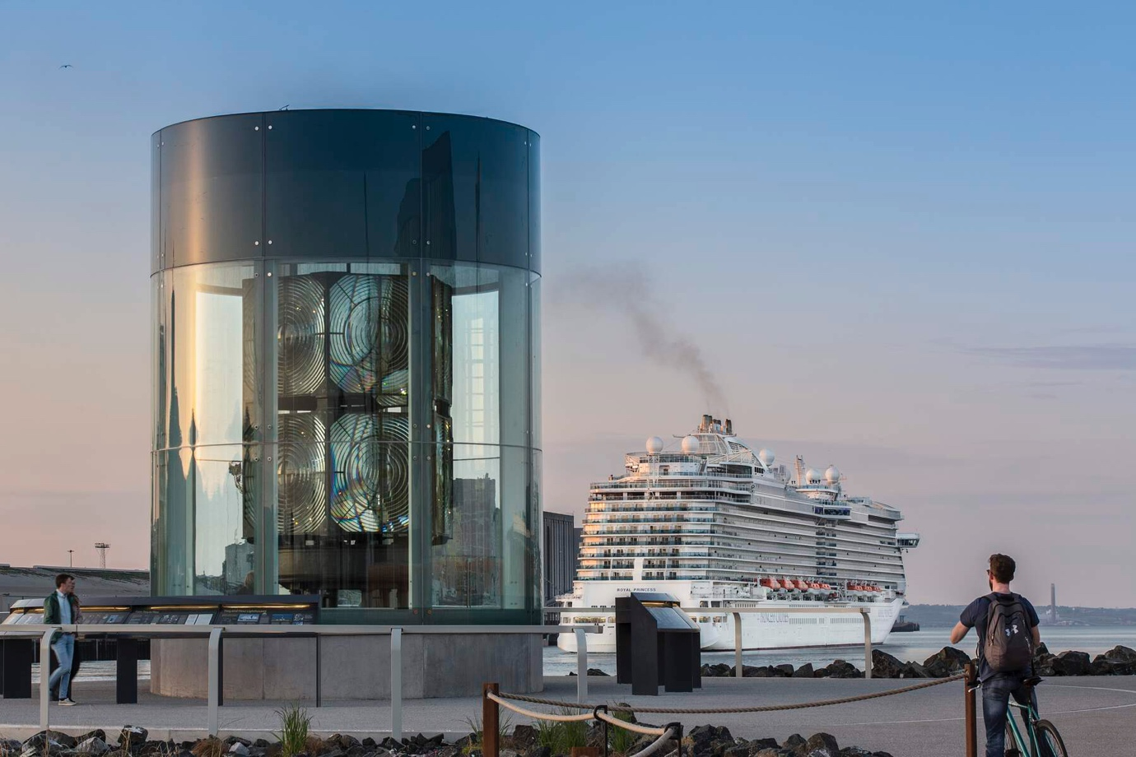 Image ©Bernie Brown bbphotographic for Tourism Ireland
If you are travelling to Belfast on a cruise ship, you will be greeted by a cruise welcome ambassador. There is generally a low-floor, accessible shuttle bus service from the port to the Visit Belfast Welcome Centre in the city centre. There may be a charge for the shuttle bus service, which is set by the cruise ship company.

By rail
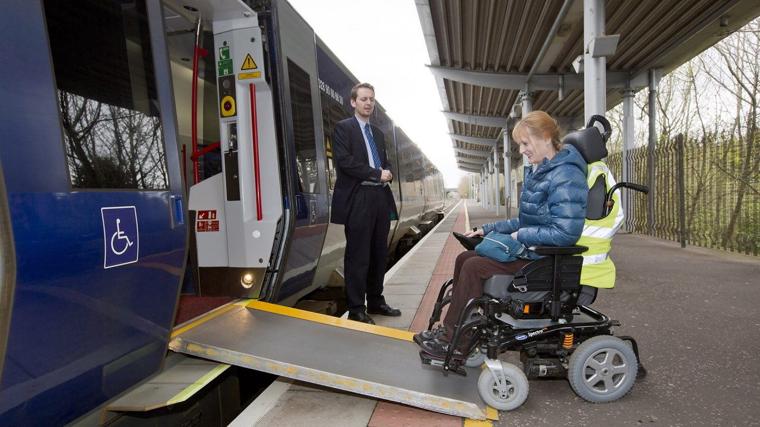
Image courtesy of Translink
There are two dedicated spaces for wheelchair users on every train, other priority seating and accessible toilets. There are audio and visual journey announcements to let you know where you are and when you are approaching your stop.
Trains can carry most type 1 and 2 mobility scooters, but not type 3. If you wish to travel with a mobility scooter, you must contact Translink, the train operator, in advance and get an approval sticker through a scheme that has been developed with Disability Action.
Main stations have been recently upgraded to be more accessible, and there are Changing Places at Lanyon Place and York Street stations. However, smaller stations and halts may not have staff and may not be accessible for all. If you are planning to use a service that is not advertised as accessible, Translink recommend you contact them 24 hours in advance.
You can find out more on the rail operator’s access guide.

From Dublin
The Enterprise Train service travels between Dublin’s Connolly Station and Lanyon Place Station, Belfast, up to eight times a day. The journey time is approximately two and a half hours.
Trains have two dedicated spaces for wheelchair users, an accessible toilet and audio and visual announcements.
Your train ticket gives you a free ride in to Belfast city centre on any purple Glider or pink Metro bus service from outside Lanyon Place.

By bus
Most buses, including the pink Metro and purple Glider services which operate within Belfast city limits, are accessible for wheelchair users. Visual journey announcements let you know each stop. Ulsterbus and Goldline services operate using a mix of vehicles, some of which have steps.
Buses may be able to accommodate smaller mobility scooters. If you wish to travel with a mobility scooter, you must contact Translink, the train operator, in advance and get an approval sticker through a scheme that has been developed with Disability Action.
If you are planning to use a service that is not advertised as accessible, Translink recommend you contact them 24 hours in advance.
You can find out more on the bus operator’s access guide.

By road
The main roads in to Belfast are the M1 motorway from the south and the M2 motorway from the north. Both are well signed.
Belfast City Council has a guide to free and charged car parks it owns or maintains. It also has a guide to its free and charged accessible parking bays. Other parking is available in commercially owned car parks, for example, belonging to shopping centres or hotels.

Park and Ride
There are also Park and Ride facilities in where you can park outside Belfast and get a bus in to the city centre.

Getting around

Walking and wheeling
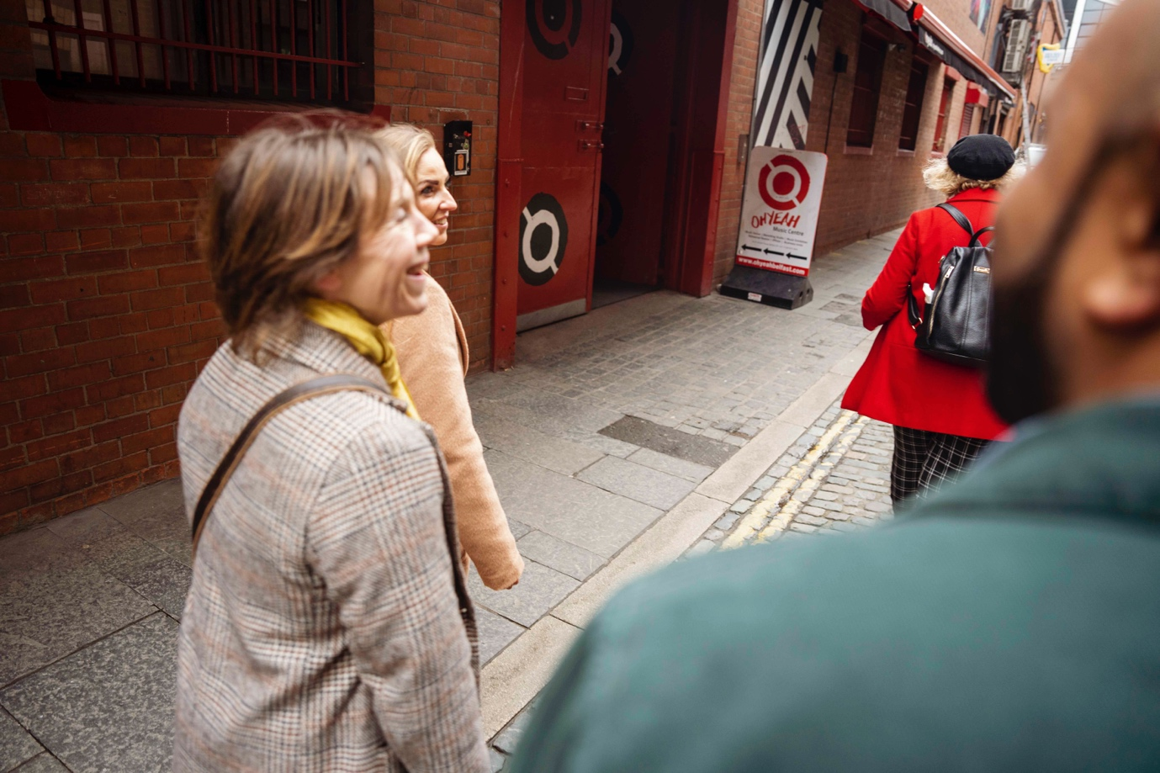Image courtesy of Tourism Northern Ireland
Belfast is a relatively small city, and its city centre is generally flat. Most tourist attractions are within a 30-minute walk.
There are parks and pedestrian areas, which make pleasant places to sit or rest, although public seating varies outside the city centre. The main shopping areas and thoroughfares are well signposted, and pavements are generally wide and maintained with drop kerbs and pedestrian crossings with audible and visual cues. Some pavements, particularly away from the centre, may present trip hazards, and the historic Cathedral Quarter is largely cobbled.

By car
There are guides to accessing car hire at George Belfast City Airport and Belfast International Airport.
There are a wide range of rental options available including automatics, people carriers and vans. Some firms offer delivery and collection services.
Europcar have Motability cars that should be booked in advance. Enterprise and SIXT can provide adaptive driving devices with advance notice. McElmeel Mobility Services specialise in wheelchair accessible holiday rentals.

Taxi
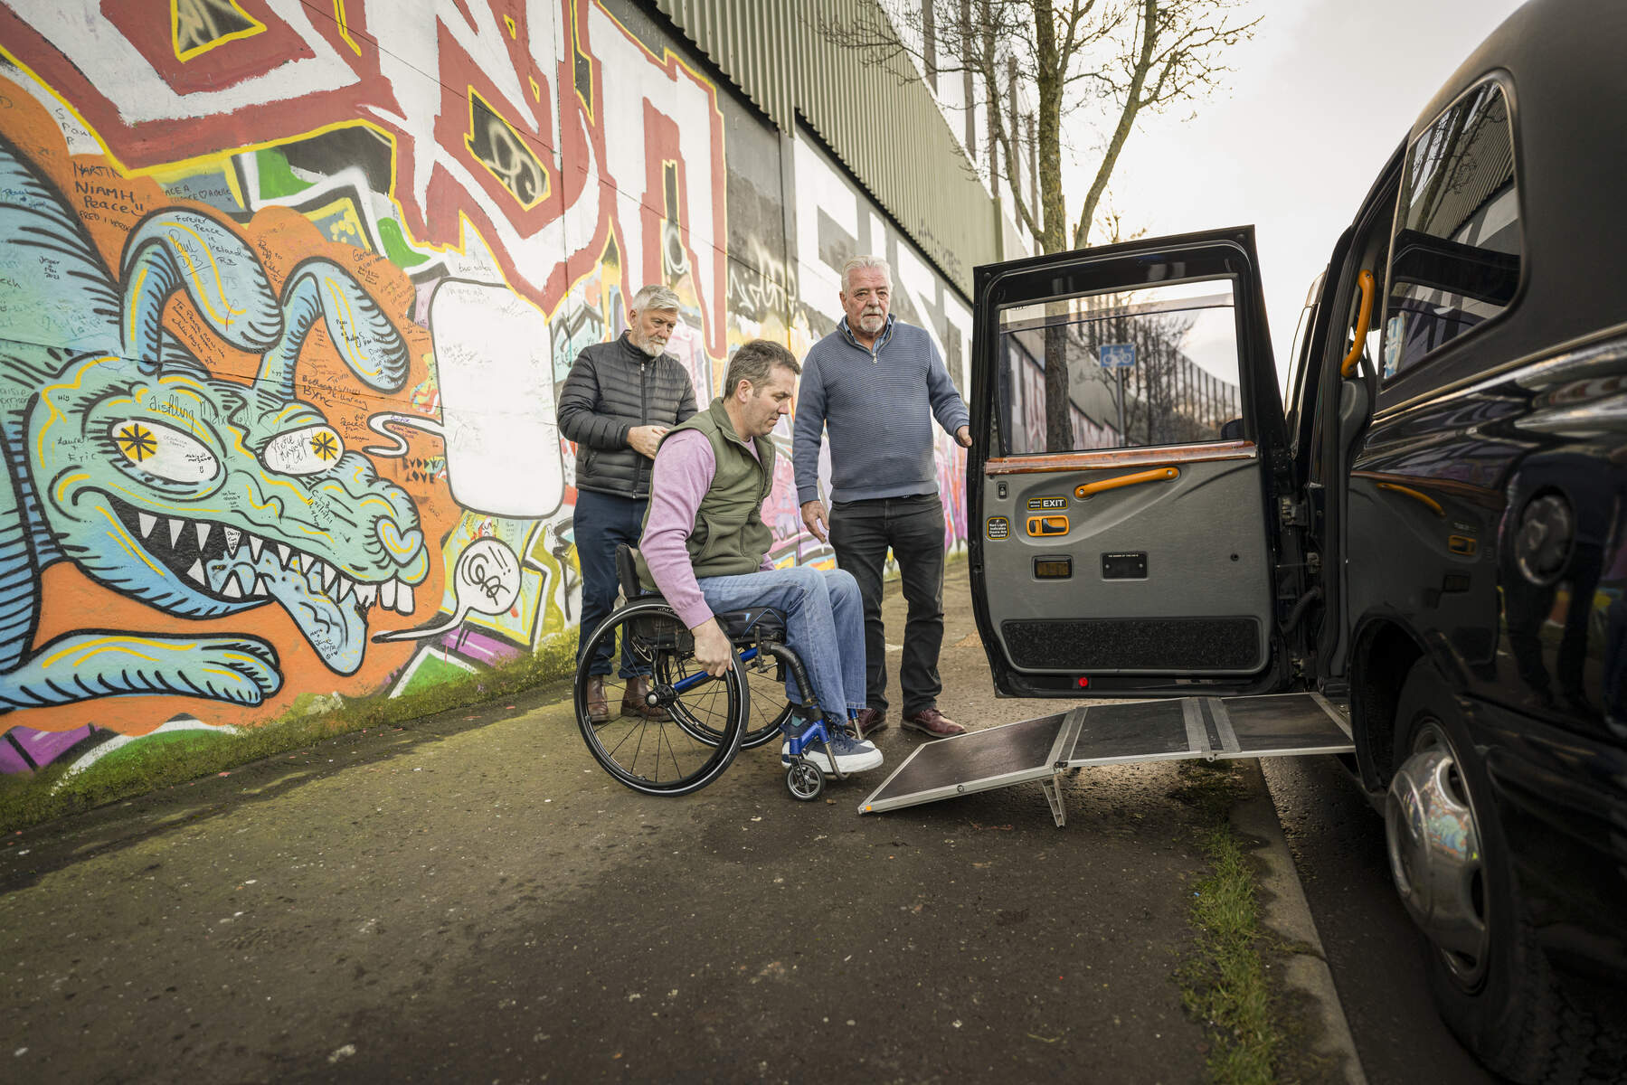
Image courtesy of Tourism Northern Ireland
There are taxi ranks throughout the city, and you can also order directly from a local taxi company, such as Value Cabs, or via a number of taxi apps, which give you real time updates on your taxi's current location and estimated time of arrival.
Taxi firms can generally provide wheelchair accessible vehicles. However, numbers are limited, and booking in advance is advised.

Bus
All pink Metro and purple Glider buses are low-floor kneeling buses with space for one wheelchair user and priority seats for other disabled passengers. There is a handrail throughout and frequent, accessible, bell pushes and on-board next-stop audio and visual announcements.
Drivers are trained to assist people to use the buses. This includes keeping the bus still until you are in your seat and announcing you have arrived at your stop if you ask for this.
If you are planning to use a service that is not advertised as accessible, Translink, the operator, recommend you contact them 24 hours in advance.
You can find out more on the bus operator’s access guide.

Train
Image courtesy of Translink
There are two dedicated spaces for wheelchair users on every train, other priority seating and accessible toilets. There are audio and visual journey announcements to let you know where you are and when you are approaching your stop.
Trains can also carry most type 1 and 2 mobility scooters, but not type 3. If you wish to travel with a mobility scooter, you must contact Translink, the train operator, in advance and get an approval sticker through a scheme that has been developed with Disability Action.
All train conductors have been trained to provide appropriate assistance including using a ramp and other help to get you on and off the train.
Main stations have been recently upgraded to be more accessible, and there is Changing Places facilities at Lanyon Place and York Street stations. However, smaller stations and halts may not have staff and may not be accessible for all. If you are planning to use an unstaffed service or a service that is not advertised as accessible, Translink, the rail operator, recommends you contact them 24 hours in advance.
You can find out more on the rail operator’s access guide.

Parking
Belfast City Council has a guide to free and charged car parks it owns or maintains. It also has a guide to its free and charged accessible parking bays. Most other car parks also have designated disabled bays.
You can use a valid disabled person’s parking permit, such as a Blue Badge, to park for free on-street in designated parking spaces or elsewhere if you are not causing an obstruction. Other restrictions may apply, so check street signs, and always park sensibly and safely.
A parking permit does not entitle you to park for free in off-street car parks such as multistorey car parks and at shopping centers.
FIA (Federation Internationale de L’Automobile) has the most up-to-date information on using EU disabled parking permits in the UK.

Top things to do

Titanic Belfast
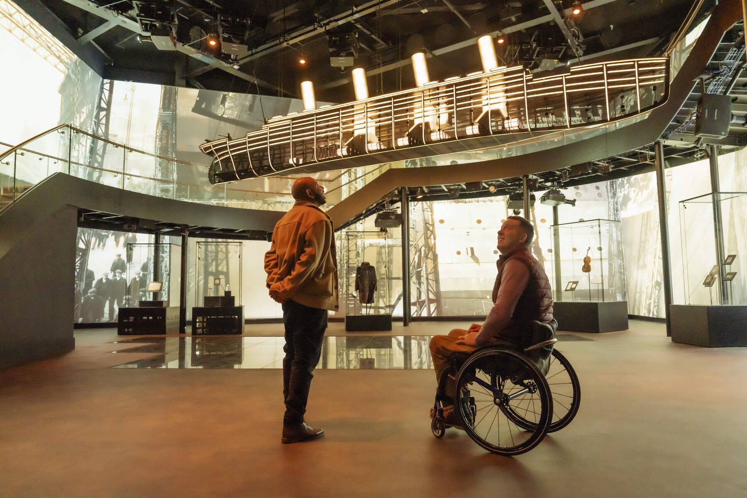
Image courtesy of Tourism Northern Ireland
Titanic Belfast is the world’s largest Titanic visitor experience and the city’s most popular attraction.
There is a bus stop within 150m, and the nearest train halt, Titanic Quarter, is a 15-minute walk away. This is not suitable for people with reduced mobility as it involves steps and a footbridge. There is an underground car park with spacious accessible parking spaces. There is also a dedicated Value Cabs pick-up, drop-off and freephone service. Wheelchair accessible taxis are limited, and booking in advance is advised.
Titanic Belfast has produced an access guide and a sensory guide. They can also provide ear defenders, blackout tents, VIP wristbands and wheelchairs. Mobility scooters can also be borrowed by Shopmobility Belfast members.
The tour is self-guided, and the multimedia guide includes BSL and audio description. Printed, Braille and large print guides and transcripts can also be provided.
There are onsite cafes, a gift shop, accessible toilets and a Changing Places.
Ulster Museum 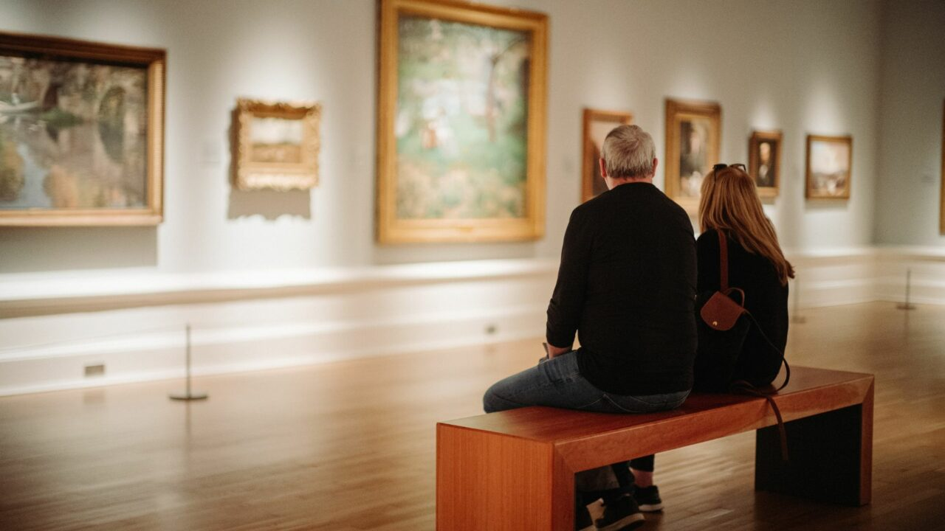
Image courtesy of Visit Belfast
The Ulster Museum is home to rich collections of art, history and natural sciences all set within the beautiful surroundings of Belfast’s Botanic Gardens.
Botanic Station is the nearest railway station, a 10-minute walk away. There are also bus stops within 150m of the museum. Parking is on-street, and there are four accessible parking spaces at the Stranmillis Road side of the building.
The museum is free. Exhibits are well labelled, and there are touch displays and audio stations.
It is a large building over multiple floors, connected by stairs, lifts, ramps and stair lifts. Mobility scooters are welcome, and there are wheelchairs available for loan. There are a few areas that are not accessible for wheelchairs and buggies. Maps describe access to each area, and staff can help you plan your route.
There are an accessible and inclusive toilet on the ground floor, a gift shop and coffee shop.
More information can be found on AccessAble.

Crumlin Road Gaol
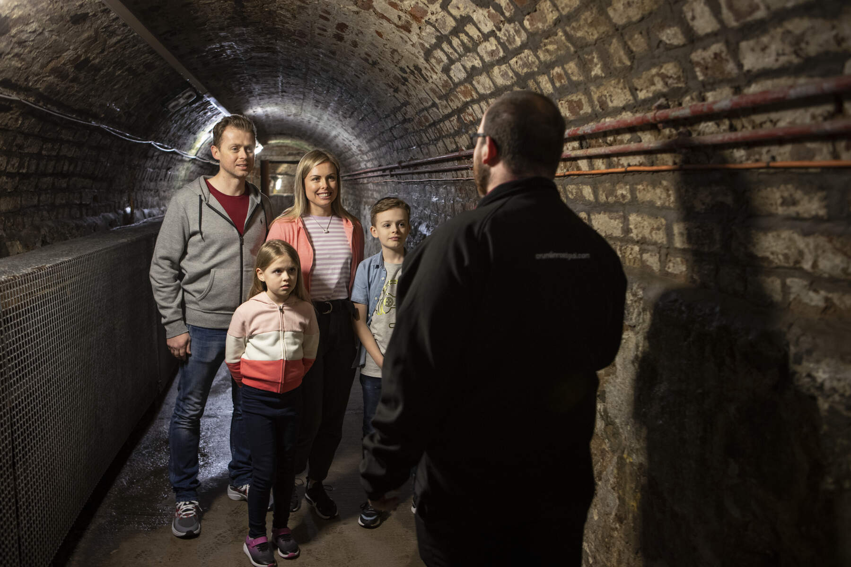
Image courtesy of Tourism Northern Ireland
The Crumlin Road Gaol is a nineteenth-century listed jail that has witnessed murderers, suffragettes, loyalist and republican prisoners, executions, escapes, hunger strikes and riots.
There is a bus stop within 150m of the entrance, and free parking with six disabled bays.
The site includes a number of historic buildings, which are largely accessible for wheelchair users and people with reduced mobility. A lift to the C-Wing basement can be operated by staff, and only narrow manual wheelchairs can enter due to the width of the cell doors. The gaol has two manual wheelchairs which can be reserved in advance.
The one area which is not accessible is the underground tunnel between the gaol and the courthouse. However, they have installed a video outside the tunnel so that all visitors can experience what lies beneath.
The tour is self-guided. Video guides, which include BSL translation, are available for d/Deaf customers free of charge.
They offer free carers tickets.
There are accessible toilets throughout, including in the restaurant.
The gaol has produced its own access guide, and further information is available on AccessAble.

Belfast Zoo
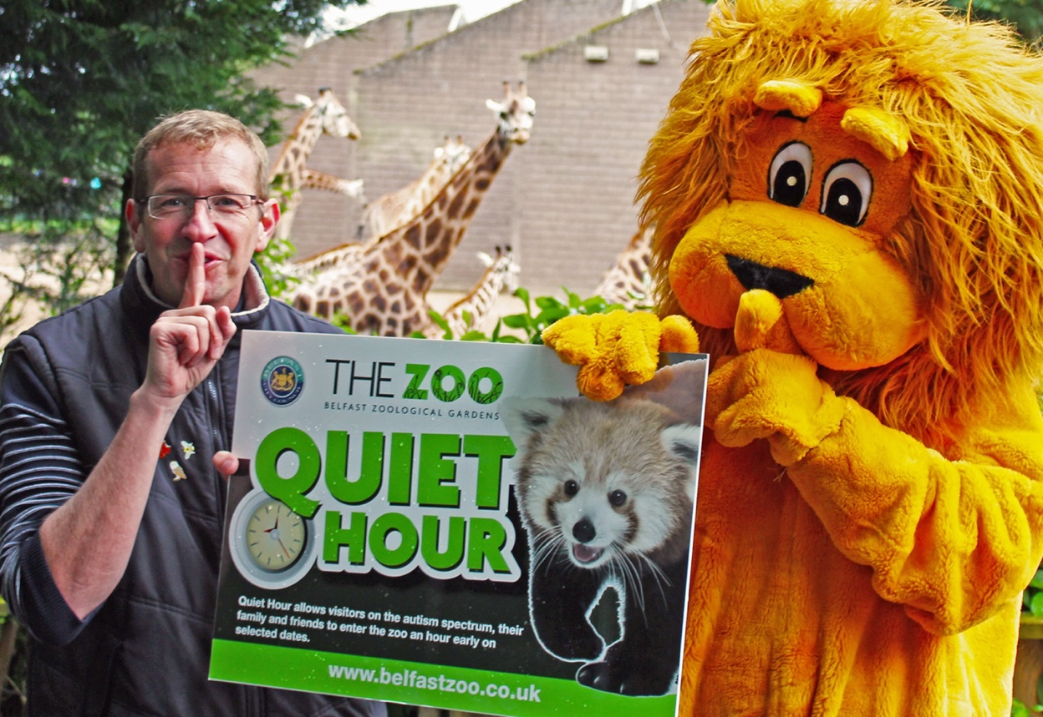
Image courtesy of Belfast City Council
Belfast Zoo, which is home to more than 120 species of animal, is located on Cave Hill. This means some of the paths are steep. The zoo map highlights steeper areas of the zoo, which can help you plan your visit.
The zoomobile is an accessible buggy that can carry wheelchair and non-wheelchair users. Visitors can choose to have either a two-hour tour or to be dropped off at the top to the zoo to make their own way back down. Both must be booked in advance.
Visitors can also rent manual wheelchairs. Mobility scooter users are welcome, and they should make sure their vehicle is suitable for the terrain.
The zoo was recently awarded Autism NI’s Impact Award, and disabled visitors can use the “fast track” route through the Zoovenir Shop if there is a queue. Carers can get free entry.
There are accessible toilets at four locations including the cafes, and a Changing Places at the visitor centre.
The zoo has a large car park with disabled parking bays near the entrance of the visitor centre. Bus routes for the Antrim Road and Bellevue run past the zoo, and there is a bus stop at the entrance to the grounds. There is then a 500m uphill walk to the visitor centre.
The zoo has its own access guide, and a visual guide that walks you through the sights and sounds you can expect on your visit is available by email. Further information is available on AccessAble.
The zoo also has regular quiet hours and an annual sensory day.

W5

Image courtesy of W5
W5 is an award-winning science and discovery centre for children and their families. Carers can get free tickets.
W5 is located in the middle of the Odyssey Pavilion. Glider, Metro and Airport Express bus services all stop outside the Pavilion. There is also a taxi rank at the entrance, and disabled parking bays are available in car parks to the front and rear. The nearest train stop is Titanic Quarter, a 15-minute walk away. This is not suitable for people with reduced mobility as it involves steps and a footbridge.
Some exhibitions include strobe lighting and strong magnets, which staff at the ticket desk can turn off. There is a quiet room, and visitors can borrow ear defenders.
Visitors can borrow a wheelchair from reception.
There is tactile and Braille signage for some exhibitions.
There are accessible toilets on all levels of W5 including at the coffee shop, and there is Changing Places on the ground floor.
W5 has its own access guide, and you can find more information on AccessAble.

Belfast City Hall
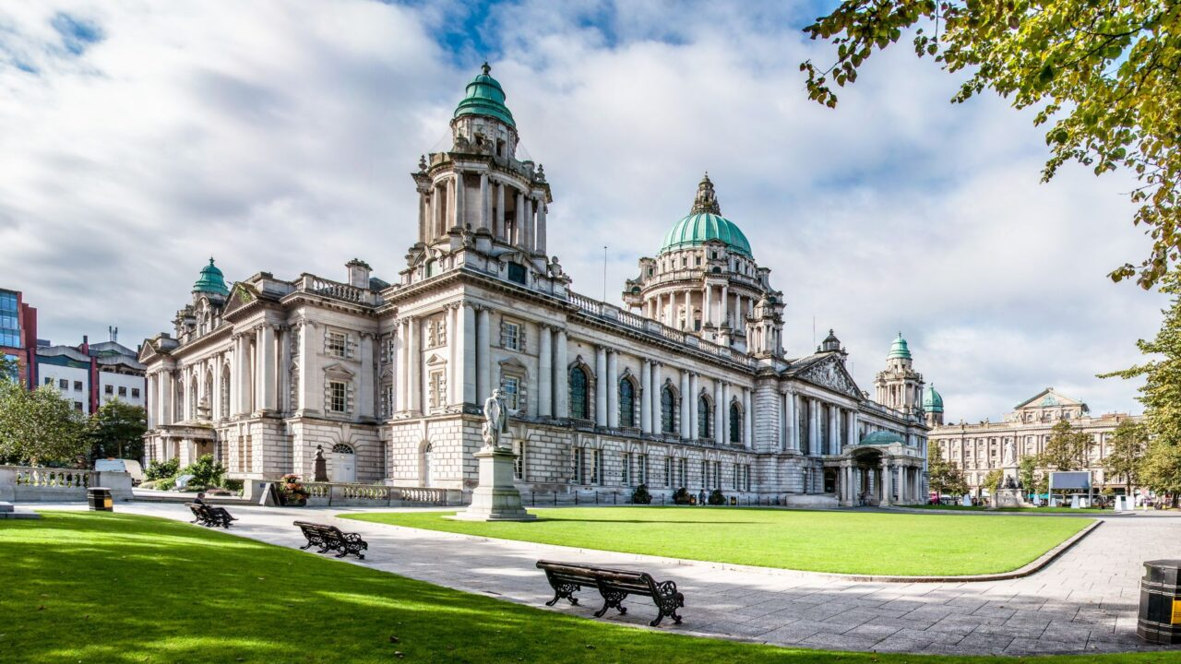
Image courtesy of Visit Belfast
City Hall is one of Belfast’s most iconic buildings. There is a self-guided visitor exhibition and guided daily tours.
Located at the city centre, it is best reached by bus, taxi or on foot. The nearest train station is Lanyon Place, and your rail ticket gives you a free ride in to the centre on any purple Glider or pink Metro bus service from outside the station.
The grounds include a cenotaph, Titanic Memorial Garden, sculptures and statues. There is a cobbled path around lawns with access to the main entrance on the Donegall Square North side of the building via steps or a ramp.
A limited number of wheelchairs and scooters can be borrowed from the reception desk just inside the main entrance. Induction loops are available at different locations in the building, including in the visitor exhibition, at reception and in the café. Exhibition audio headsets are compatible with hearing aids. There are BSL, ISL and International sign language video guides to the exhibition.
There are accessible toilets and a Changing Places on the ground floor.
The Bobbin Café is managed by Loaf Catering and Cafes, which provide training and work for people with a learning disability, Autism or Asperger’s.
You can find out more information on AccessAble.

St George’s Market
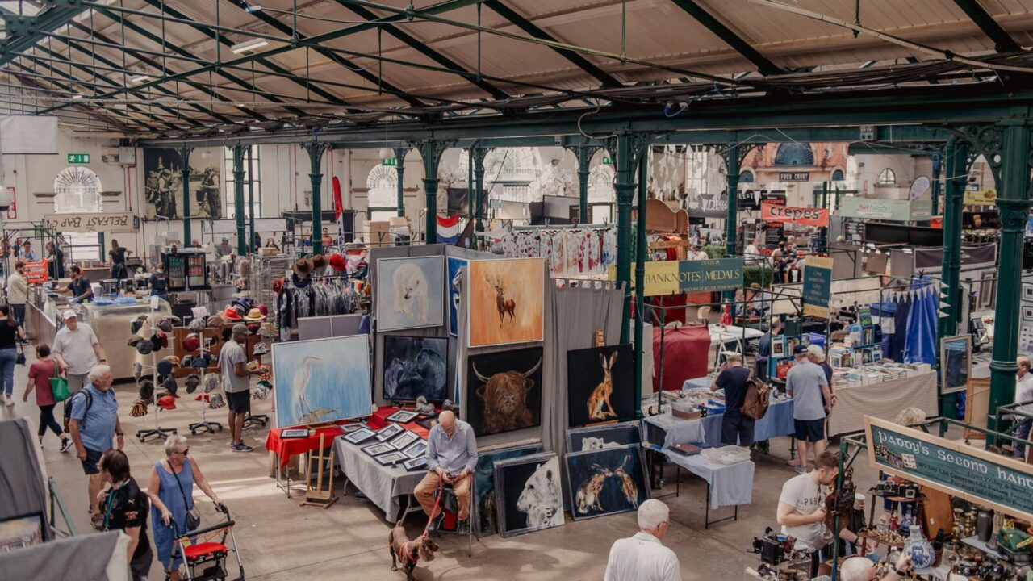
Image courtesy of Visit Belfast
St George’s is a thriving, historic market near the city centre. It opens Friday, Saturday and Sunday.
There is on-street car parking, and market customers can get special discount for nearby car parks, which can get very busy during opening hours. There are bus stops within 150m, and Lanyon Place Railway Station is five minutes away on foot up a gradual hill.
There is lots of bustle, sights, sounds and smells to be enjoyed in the market. It operates a quiet hour each morning, when music is turned off and other noise reduced.
Twice daily walking tours, where you can learn all about the history of the market and talk to traders, can be booked through Visit Belfast.
Two accessible toilets are located near two entrances.
Further information can be found on AccessAble.

Belfast Castle and Estate
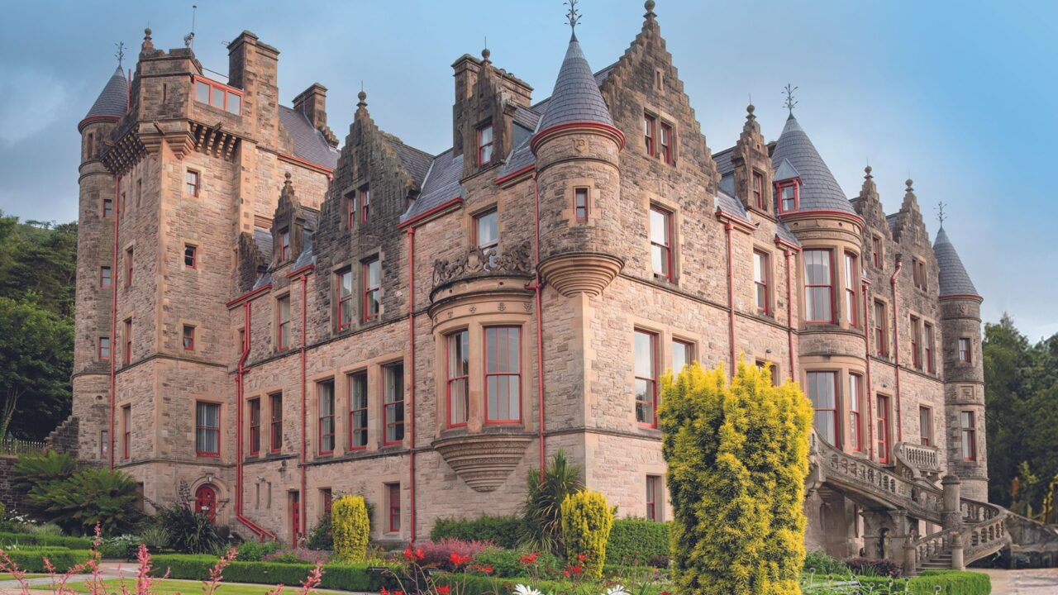
Courtesy of Visit Belfast
Belfast Castle sits at the foot of Cave Hill and is one of the most iconic locations from which to view the stunning skyline of Belfast.
Built in 1862 on a site occupied since the twelfth century, the castle has been adapted to improve accessibility. There is a lift to the basement-level Cavehill Visitor Centre and gardens, which are wheelchair accessible. Parts of the building are not accessible on motorised scooters. There are accessible toilets on two floors.
There are a number of free car parks on site including one at the castle which has disabled bays. York Street train station is three miles (5km) away. The nearest bus stop is just over half a mile (1km) away. The route to the castle is paved and uphill.
Staff are training in Autism awareness and are progressing towards becoming Autism NI Impact Champions.
Belfast Castle and Estate has a brief access guide, and you can also find out more on AccessAble.

CS Lewis Square
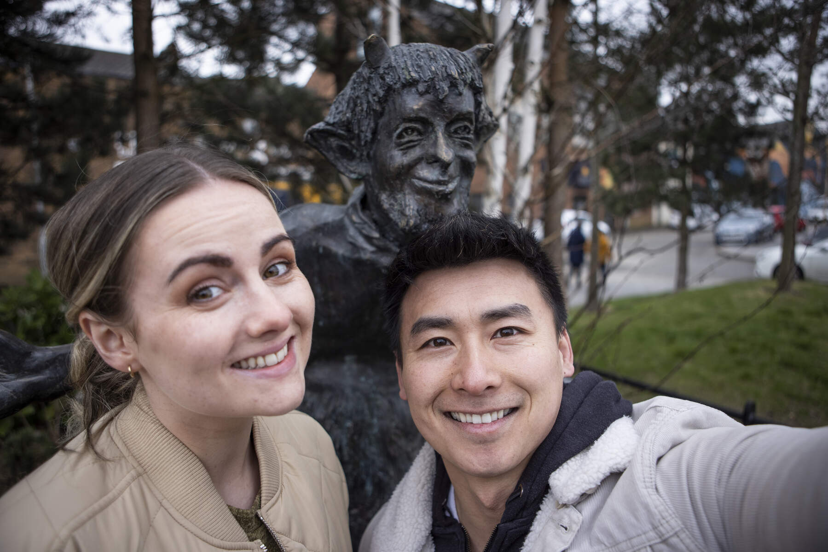
Image courtesy of Tourism Northern Ireland
CS Lewis Square is a level-access public space celebrating the Belfast-born author of the Chronicles of Narnia, CS Lewis. You can touch and interact with seven bronze sculptures from the Lion, the Witch and the Wardrobe, which is a great sensory experience.
The nearest railway stops are at Titanic Quarter Halt and Lanyon Place Station. Titanic Quarter Halt is not suitable for people with reduced mobility as it involves steps and a footbridge. There are frequent buses that stop within 150m of the square, and it is less than five minutes by taxi from the Value Cabs taxi rank at Lanyon.
The square is beside the EastSide Visitor Centre, where there are interactive information screens, interpretative panels and a wall map. A number of self-guided trails start and finish from EastSide Visitor Centre, whether you want to follow in the footsteps of George Best and find out what inspired some of Van Morrison's most famous songs.
The visitor centre includes a coffee shop with accessible toilets. Disabled parking bays are also available on street and in the nearby Connswater Shopping Centre.

Divis and the Black Mountain
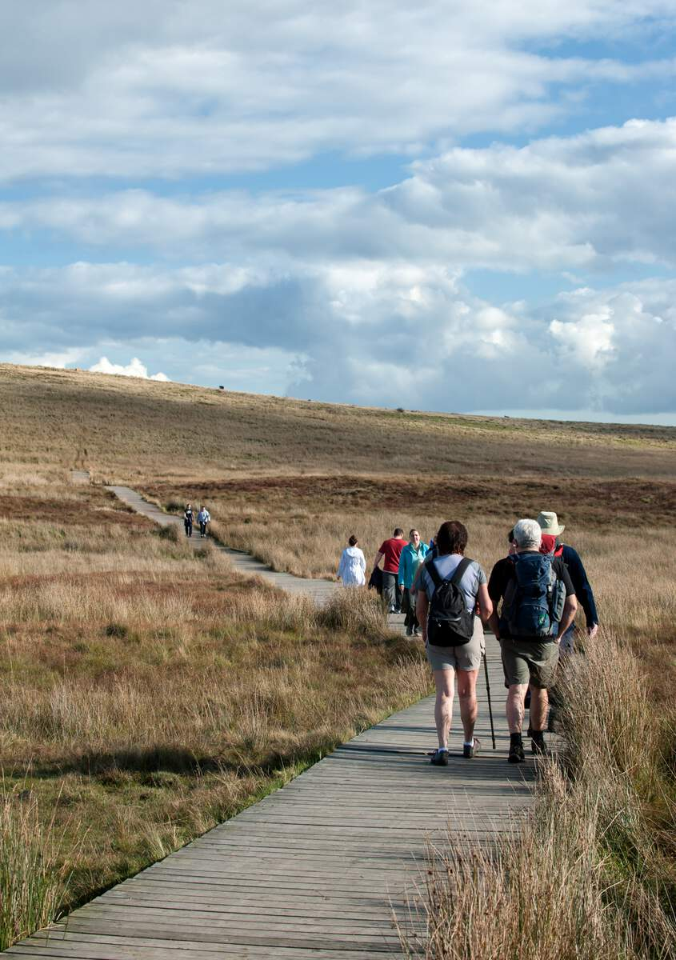
Image courtesy of Tourism Ireland
With spectacular panoramic views over Belfast, Divis and the Black Mountain is home to heath and bog, rich biodiversity and archaeological remains. On a clear day there are views of Strangford Lough, Scotland and Donegal.
The mountain is best accessed by car. There are two car parks with disabled parking bays. The upper car park, behind the Barn Café, is closest to the start of the walking trails. This is also the location of accessible toilets and a Changing Places. Car parks can get particularly busy at peak times.
Access to the mountain is free, and there is a choice of three waymarked routes. The Lough Trail is a wheelchair accessible, circular route. It slopes gently for one mile (1.5km) over compacted gravel.
The other routes are described as moderate to challenging covering between 2.8 and 4 miles (4.5 and 6.4km) over a mixture of boardwalk, gravel, heath and bog. There may also be stiles across a river. Suitable clothing must be worn.
The National Trust and Walk NI have detailed guides and route descriptions.

Taxi tours
Image courtesy of Tourism Northern Ireland
A tour from the comfort of one of Belfast’s iconic black taxis, such as Taxi Tours Belfast or Taxi Trax, is a popular way to explore the city and beyond. Tours include political, mural, sightseeing and history tours. Outside Belfast, popular attractions include the Giant’s Causeway and Carrick-a-Rede Rope Bridge and the Game of Thrones studio tour.
All black taxis are wheelchair friendly. Other taxi firms, such as Value Cabs can also provide tours in wheelchair accessible vehicles.
Tours are available over a few hours or several days.

Walking tours
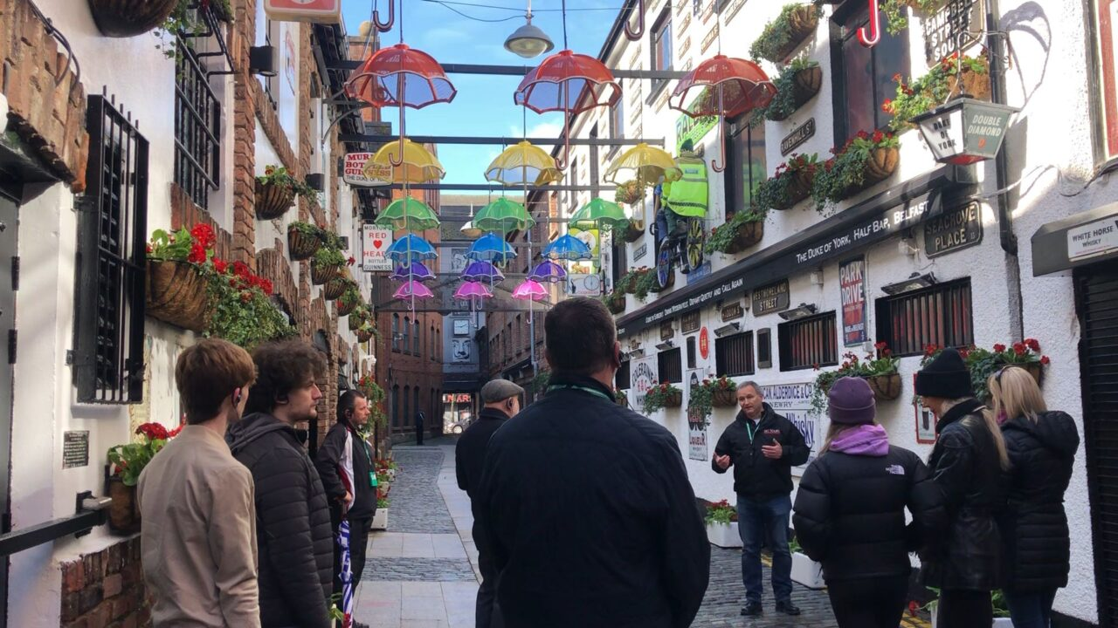
Image courtesy of Visit Belfast
Popular walking tours include history, politics, murals, art, food and drink. Most are wheelchair friendly, although terrain can vary across the city, and they can accommodate different requests, but it is best to check with the provider in advance.
DC Tours run self-guided, sightseeing and history tours from the city centre following flat, step-free routes, although some areas may be cobbled.
Street art walking tours take place in the Cathedral Quarter, which includes cobbled areas, and they are happy to accommodate special requests.
In West Belfast, Coiste Irish Political Tours are delivered by former political prisoners who share their personal experiences of the British/Irish conflict.
The hour-long Titanic Discovery Tour takes explores the slipways and heritage around the Titanic Belfast visitor centre. You will be provided with a roaming headset. There is also a self-guided Titanic Trail following a detailed, downloadable map to discover key Titanic and maritime heritage attractions. Routes are generally flat and paved with some cobbled areas.

Local’s picks: one- and two-day itineraries

48-hours in Belfast with Lorcan
Lorcan is a 12-year boy with Autism. Let Lorcan and his family be your guide to some of their favourite – and inclusive – places in Belfast. Highlights include the Connswater Community Greenway, Maritime Mile, W5 and Titanic Belfast.

24-hours in Belfast with Talia
Talia is a 24-year-old with cerebral palsy. She uses technology to help her speak and a powerchair to get about. Let Talia be your guide as she shows you around the city and some of her favourite — and most inclusive — things to do. Highlights include pubs, clubs, shopping and a street art tour.

24-hours in Belfast with Margaret
Margaret is an older blind woman. Let Margaret be your guide as she shows you around the city and some of her favourite — and most inclusive — things to do. Highlights include a visit to the Ulster Museum and a show at the Grand Opera House.

Local’s picks: Culture and heritage
We asked some local disabled people for their favourite Belfast experiences. Here’s what they recommend.

The MAC
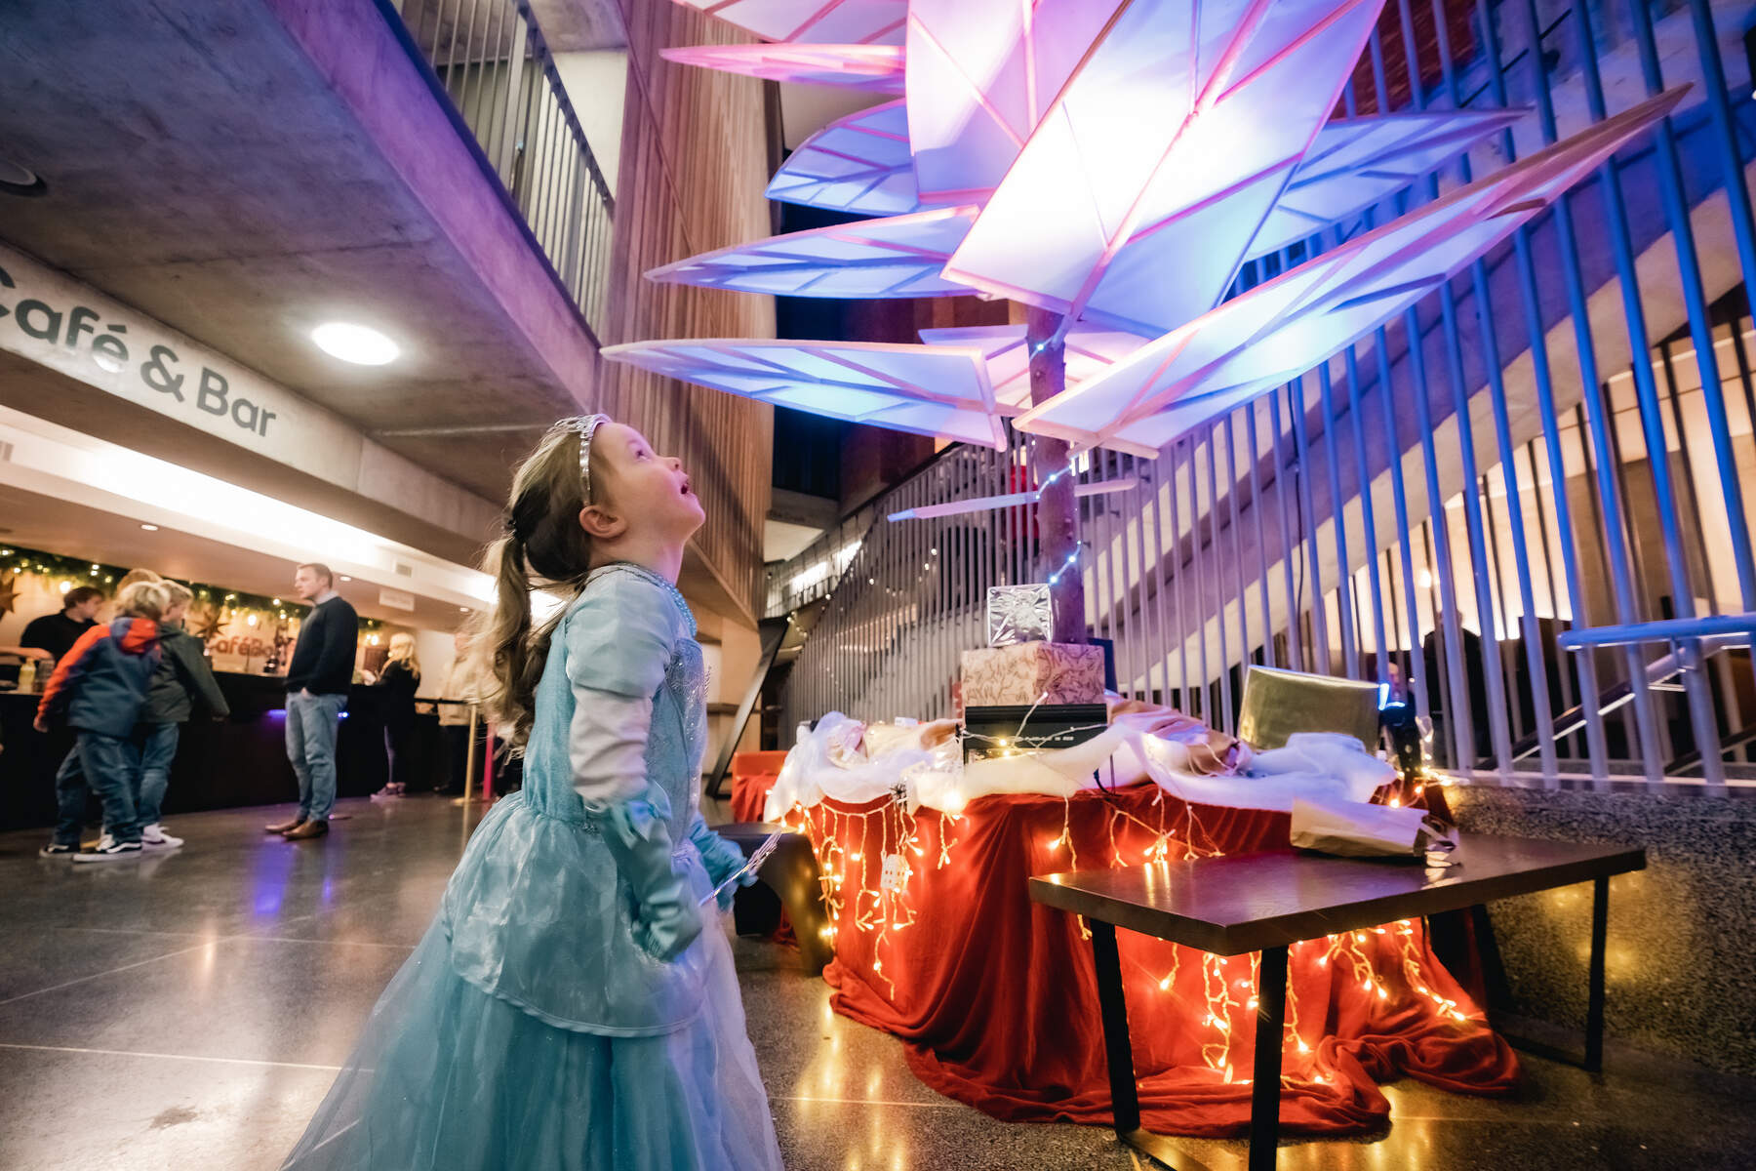
Image courtesy of Tourism Northern Ireland
“This is a great place to bring the family. It is very friendly, and there are helpful front-of-house staff and welcome volunteers.”
Ciara is mum to two Autistic boys, one in his teens and one under 10, who is non-verbal. They enjoy arts and creativity, and the MAC has a good blend of things to do and places to relax for both Mum and the boys.
The MAC is a cultural hub, home to all kinds of exhibitions, theatre performances, experimental works and endless goings-on.
There’s also a family room and ‘Imagination Stations’, which are full of art supplies and activity sheets that kids can enjoy at any time.
There is level access and lift access throughout with accessible toilets on each floor. Accessible performances include audio description, captioning, sign language interpretation and relaxed performances.
There is also a downloadable Welcome to the Mac Access Pack for those who may need to familiarise themselves with the building, an access guide and further information on AccessAble.

Linen Hall Library
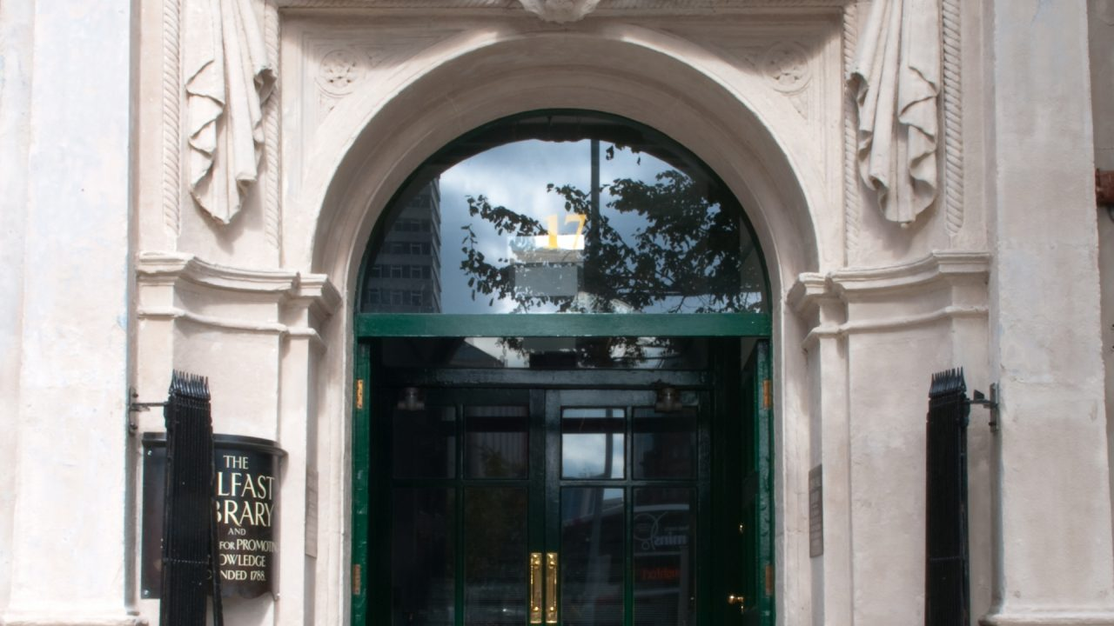
Image courtesy of Visit Belfast

“The Linen Hall is a great place to browse, soak up the atmosphere and feel like a local.”
Julia is a powerchair user in her 40s. She loves books and reading. Wherever she goes in the world, she loves to explore local libraries, and she think the Linen Hall is easily one of the best!
The Linen Hall is Belfast's oldest library with famous Irish and genealogy collections. It is housed in a listed Victorian linen building which has been adapted and expanded over several floors.
Step-free access is available through the Fountain Street entrance, where a lift to all floors can be found, and wheelchair access is available throughout the building.
There is a café and accessible toilets that are accessed using a code from the library desk.
Their website has an access video guide with captioning and BSL and a virtual tour. You can also find more information on AccessAble.

St Anne’s Cathedral
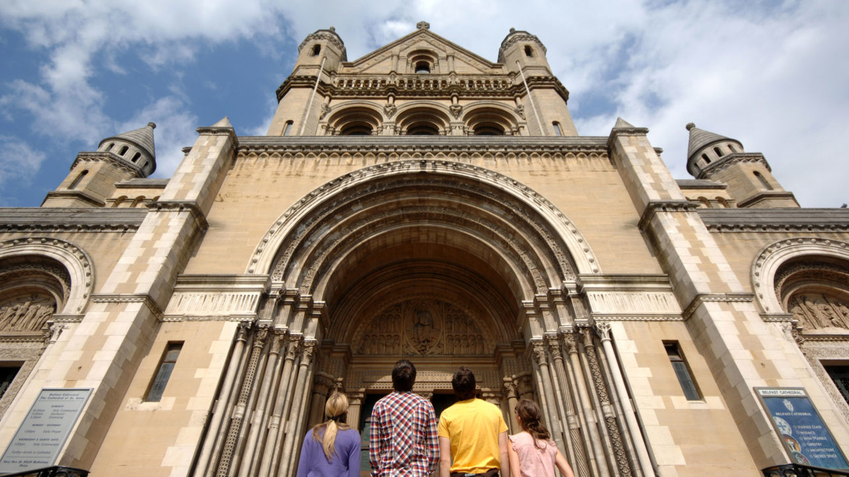
Image courtesy of Visit Belfast
“It’s a quiet space in the heart of the city. You can feel and sense the scale of the building and hear the sounds reverberating.”
Julia is a powerchair user in her 40s who loves reading books, learning languages and dancing. She recommends St Anne’s a great place to pause and reflect away from the bustle of the city.
St Anne’s Cathedral has level access. Motorised scooters are welcome, and there is an accessible toilet. Visitors can also take part in a guided tour or a self-guided tour using a guidebook or audio guide.
You can find out more information on AccessAble

2 Royal Avenue
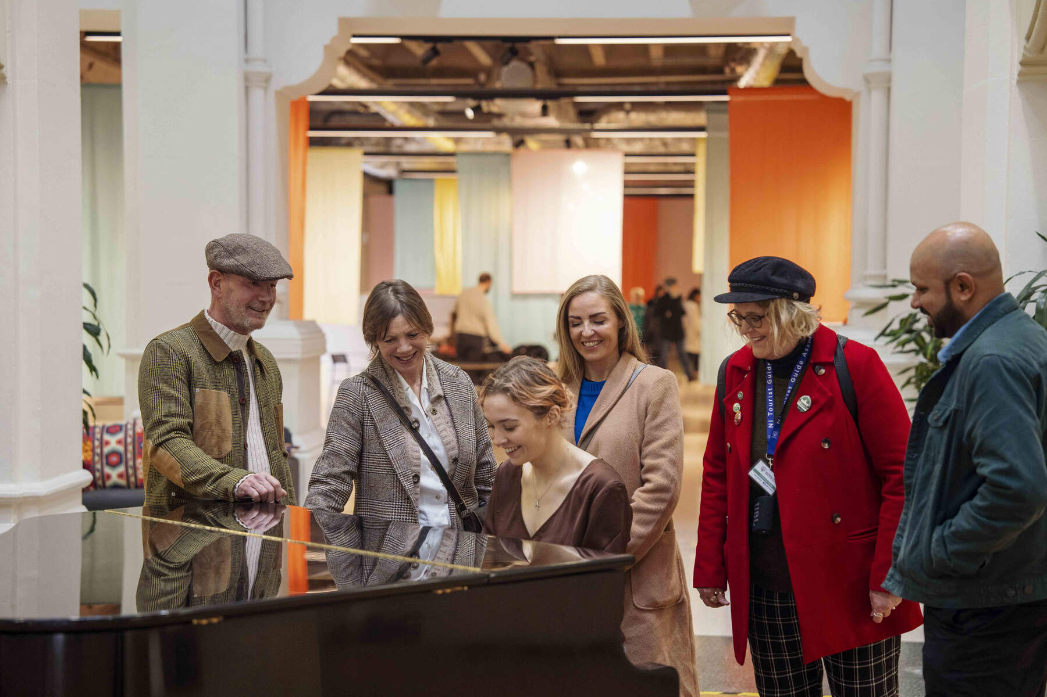
Image courtesy of Tourism Northern Ireland
“The staff and volunteers are very friendly and really support your visit.”
Holly is a Deaf, BSL user. When she is shopping in the city centre, she always calls in to 2RA (as the locals call it) for a coffee or a bun. There’s usually an exhibition and often an event on, and she always gets a warm welcome.

A listed former bank, 2 Royal Avenue is now a cultural and community hub at the heart of Belfast’s main shopping district.
There is a sensory dome with light and sound display, a quiet room, a “cosy” play area and comfy seating. An accessible toilet is located in a portable cabin to the rear of the building. Wheelchairs, fidget toys and headphones are available to borrow.

Local’s picks: Family friendly
We asked some local disabled people for their favourite Belfast experiences. Here’s what they recommend.

Dundonald Ice Bowl

Image courtesy of Visit Belfast
Dundonald Ice Bowl has regular inclusive skating sessions, which are recommended by Belfast-local Jo, a wheelchair user and adventure lover. Equipment includes sledges, and companions can go free.
There is ramp and lift access throughout the complex, which also includes ten-pin bowling and an indoor adventure area for under 12s.
There is a sensory room, and ear defenders can be borrowed on site.
Their Before you visit guide for Autistic visitors, is “the loveliest guide I have ever seen”.
Sarah, disability activist and carer

Mo Mowlam Play Park
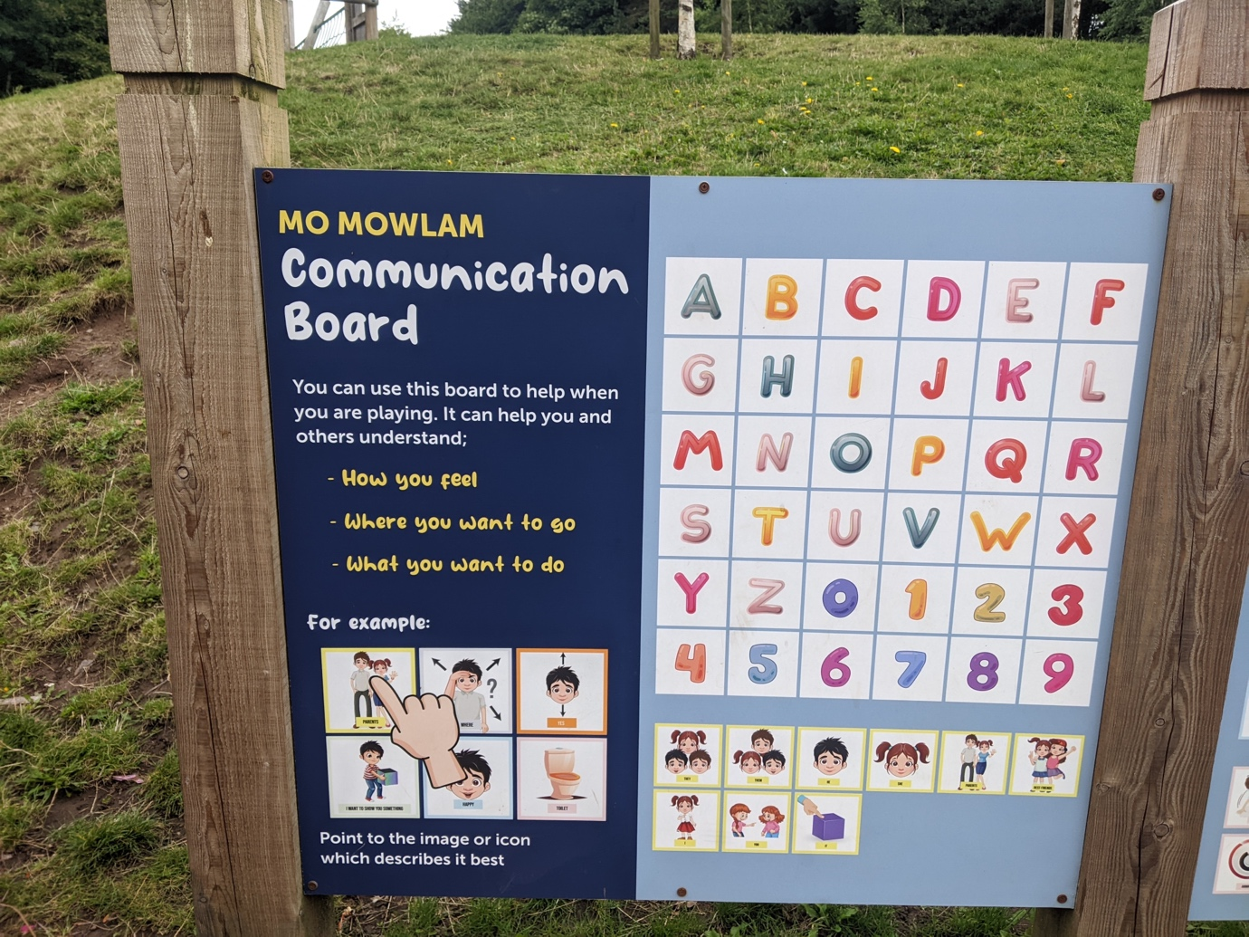
Image courtesy of Open Arts
“Surrounding by woods and park land, it doesn’t feel like being in the middle of a city. It is so inviting and fun and a great place to bring kids of all ages.”
Ciara is mum to two Autistic boys, one in his teens and one under 10, who is non-verbal. The playpark is designed so that children of all abilities can play together. She particularly loves the communication board.
The Mo Mowlam Play Park in the Stormont Estate has been designed so that children of all abilities can play together. It includes an inclusive play area with a roundabout and a swing that can accommodate a wheelchair, low-level lookout tower and a trampoline. There is also a multi-sensory play area. Communication boards pair words commonly used in play with images so that children can express themselves.
There is a coffee dock and a toilet block at the play park and a Changing Places at the car park.
More information on getting there and getting around is available on AccessAble.

High Rise Indoor Adventure Centre

Image courtesy of Visit Belfast
The High Rise Indoor Adventure Centre is in Lisburn, a 10-minute drive from Belfast. It includes Clip ’n Climb, soft play and two sensory rooms.
There is a café, accessible toilets and a Changing Places.
They are Autism NI Impact Champions. Ear defenders are available to borrow, and an alternative entrance is available on request that avoids busy areas and gives direct access to the sensory area. Sunday mornings are designed for Autistic children and adults with no music, fewer visitors, supportive instructors and shorter safety briefings.

Local’s picks: The great outdoors
We asked some local disabled people for their favourite Belfast experiences. Here’s what they recommend.

Botanic Gardens
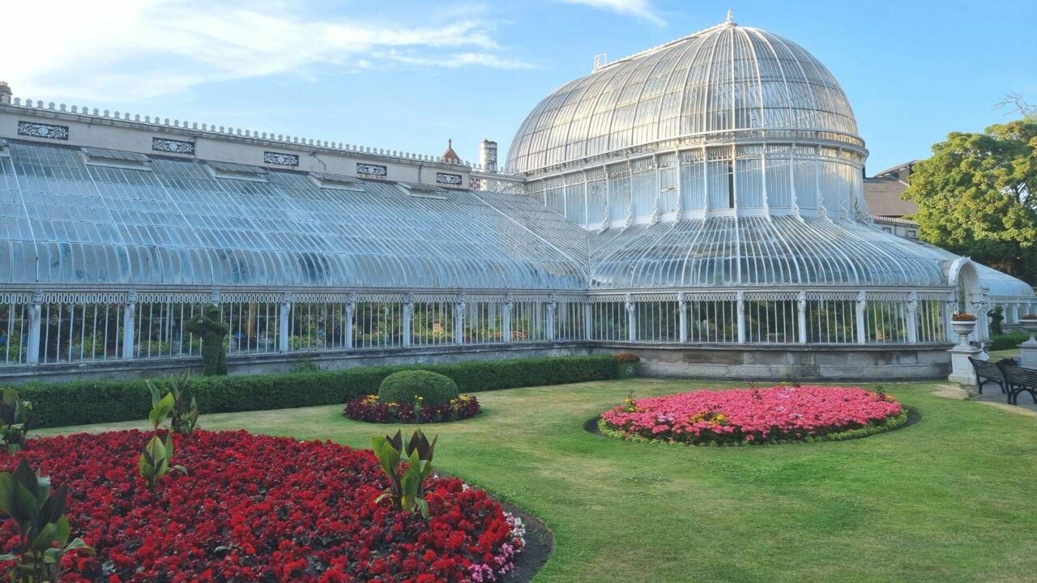
Image courtesy of Visit Belfast
“I especially like the recorded sound design of tropical birds in the Tropical Ravine – it makes the plants feel more at home.”
Helen and her husband are blind. They love to visit Botanic Gardens as there is lots to feel, touch and hear. They can easily spend half a day here, and the Topical Ravine is a particular highlight.
Botanic Gardens in the south of the city has tropical plants, giant bird feeders, a rose garden, an alpine garden, mature trees, flower beds and sculptures. It was established in 1828 by the Belfast Botanic and Horticultural Society. It is relatively flat with tarmacked paths linking grass and flowerbeds.
The Tropical Ravine, which was recently restored to its original Victorian design, is a rich sensory experience and has interactive panels. Some doors are automatic with level access throughout. There is a lift to the lower floor and accessible toilet.
The Palm House is a white painted cast-iron glasshouse. There’s a rich mix of floral smells and array of exotic plants. There are a couple of steps into the main entrance with a level access door to the side. Grated metal flooring is used for drainage, so care is advised if you have a walking stick or cane.
You can find more access information about Botanic Gardens on AccessAble.

Rowallane Garden
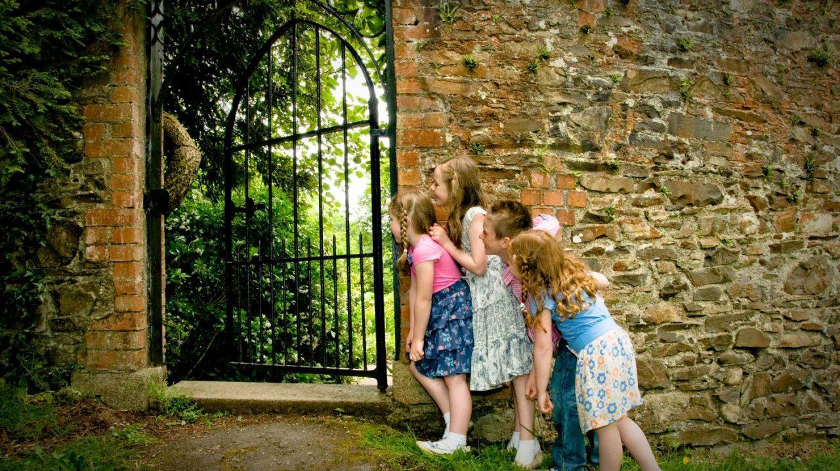
Image courtesy of Visit Belfast
Rowallane Garden has a mix of formal and informal gardens, filled with unique plants from across the world. Enjoy a leisurely stroll or a bite to eat in the café. Younger visitors can borrow free bicycles and explore the natural play area.
Rowallane Garden is located outside Saintfield and is 12 miles (19km) south of Belfast. There is a 17-minute walk from the nearest bus stop. For those arriving by car, there is a car park, disabled parking bays and visitor drop-off point at the visitor centre.
The grounds are mainly gravel and grass paths with terrain that rises and falls. There is some uneven terrain, steps and steep slopes, particularly in the lower garden and around Rock Garden Wood, but there are also accessible routes, and staff will be happy to show you on the map. Two mobility scooters and a wheelchair are available to borrow – booking in advance is recommended.
“Calm Bags” are also available to borrow for those who need a little extra support during the busy periods. They include fidget toys, ear defenders and other sensory items.
The National Trust and AccessAble have produced detailed access guides.

Groomsport inclusive beach
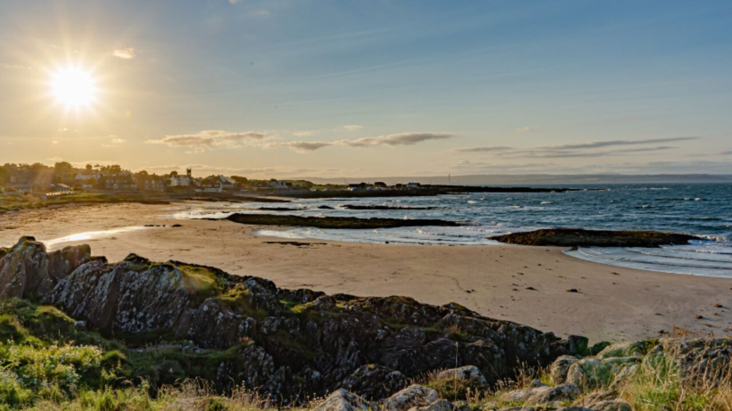
Image courtesy of Ards and North Down Borough Council
“You can easily become a member of Mae Murray Foundation to access their beach equipment loan scheme, all of which is free.”
Jo is an adventure-loving wheelchair user in her 20s. She loves exploring the outdoors when she goes away, and while the beaches in NI may not be the sunniest, she thinks they are among the most beautiful.
The inclusive beach initiative is run by the Mae Murray Foundation, a charity that was set up to allow people of all ages and abilities to take part in activities in an inclusive environment.
There is accessible parking within 100m of Groomsport beach, and there is step-free access across a paved and tarmacked path. There is also an accessible toilet and Changing Places in the car park.
Mae Murray’s all-terrain beach wheelchair is lightweight and easy to manoeuvre across all surfaces. Booking must be made at least 72 hours in advance.
You can find more information on getting to and around Groomsport and its beach on AccessAble.
Mae Murray also has other inclusive beaches and equipment at Benone, Cranfield, Portrush and Portstewart.

