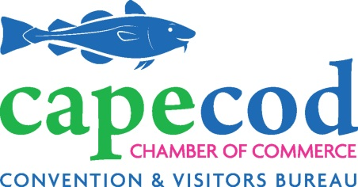
Board of Directors Meeting
Wednesday, November 6, 2019
7:30 AM
Chamber’s Sandy Neck Conference Room, 5 Patti Page Way, Centerville

AGENDA

7:30 AM Board Chair Report & Consent Agenda Bert Talerman
Audited Financial Statement review by Chamber’s audit firm, Sanders Walsh & Eaton (Joe McGee)
Executive Session with auditor.

VOTE TO Appoint the Nominating Committee as presented
- Feeney or Markham Chair
- Carol Edmondson
- Lisa Parenteau
- David Troutman
- Richard Delaney, Center for Coastal Studies
- Dan Wolf, Cape Air
- Sarah Swain, Cape Women’s Collaborative / Frying Pan Gallery
- Jon Hagenstein, Beacon Marine Construction
- Abby Rose, Robt. B. Our Construction

CAST ONE VOTE: to approve consent agenda items:
- Minutes of the last meeting
- New & Dropped Members
- KPI Dashboards
- Reauthorization of policies
  - Risk Assessment Plan
  - Vendor Management Policy
  - Antitrust Policy
  - Social Media Policy

7:40 AM Treasurer’s Report Oliver
September Financial Statements
License Plate proceeds payment error by RMV Northcross

7:45 AM CEO Report Northcross
VOTE: Related Transaction Authorization to Hire Director Curry
Website Tour
Action Plan Overview & VOTE TO Approve

8:15 AM Pillar/Task Force Reports:
Board Buddy volunteers Parenteau
Membership Services Knell
VOTE to approve new tiers as presented
CVB/Destination Marketing Catania
Economic Development
Wastewater Task Force
Transportation Funding Task Force

9:00 AM Adjournment @ 9 AM - Economic Development / Expedition Blue meeting convenes at 9:15 AM

