DATE: | Thursday, August 18, 2016
TIME: | 11:45 AM to 12:45 AM
LOCATION: | Founder’s Room, US Bank
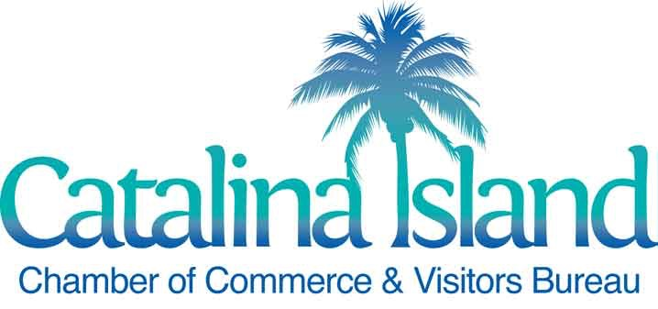
MEETING AGENDA
MARKETING COMMITTEE MEETING

AGENDA DETAILS

- Welcome – Dave Stevenson, Chairman
- Review 2016 visitor survey results and synopsis (March through June) – Jim Luttjohann
- Review YTD Consumer Marketing Campaign Results and upcoming initiatives – Cathy Miller
- Review Holiday Events, Packaging and Posting - Amelia Lincoln
- 2017 Visitors Guide production update – Michelle Warner
- Next Meeting : Thursday, September 15, 2016, 11 :00 AM
  - Future meetings: October 20, November 17 and January 19, 2017
  - December: NO MEETING

Mission: To attract visitors and advocate for commerce on Catalina Island.

