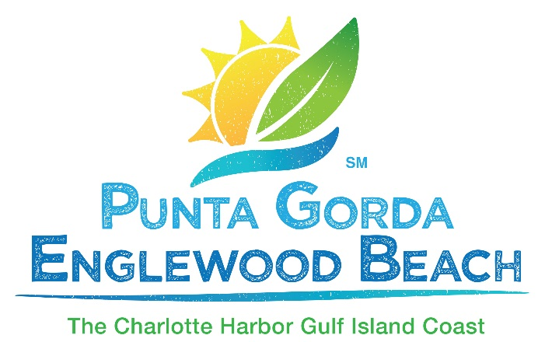
Tourism Hall of Fame
2020
Nomination Guidelines

The Tourism Hall of Fame recognizes people who have a body of work relating to Charlotte County tourism spanning at least 10 years. This recognition is given only to those who, through their efforts and leadership, have had a significant impact on tourism in Charlotte County. Induction into the Charlotte County Tourism Hall of Fame is not for a single event, activity or act, but rather for continual service to the tourism industry over a period of 10 or more years.
Nominations for the Tourism Hall of Fame open March 9, 2020. All nominations are due by 5:00 p.m. on April 3. Nomination packets received after 5:00 p.m. on April 3 will not be accepted. The Hall of Fame induction is on May 7, 2020, at the Charlotte Harbor Event and Conference Center.
Nomination Process
Assessment of nominations will be based solely on the information provided in the packets. It is important to assure all relevant information about the nominee is included when you submit your nomination.
Only one packet will be accepted for each nominee. However, you may include letters of support with your submission. It is very important that you contact the Visitor and Convention Bureau before you begin to develop your nomination packet. VCB staff will let you know if someone else has planned to nominate the same person. We encourage people to work together on a single nomination packet.

Creating the Nomination Packet

Please title each section of the nomination packet (example: Body of Work Relating to Tourism) and order the sections as shown below.

- Describe the nominee’s body of work relating to tourism. Please be as detailed as possible. As this award is for a body of work spanning 10 or more years, please include as much information as possible regarding contributions through the past decade. However, please note: it is the quality of the content that matters – not word count.

- Explain how the nominee’s efforts have created positive exposure for Charlotte County both regionally and nationally.

- Describe how the nominee’s efforts have positively impacted Charlotte County’s economy.

- If relevant, describe how the nominee has helped to engender support of tourism within the community.

- Describe how the nominee has supported the work of the Tourist Development Council.

- Include letters of support and articles or other information you believe are relevant to the nomination.

Packet Inclusions

- You may email your packet; HOWEVER a hard copy must be mailed or personally delivered to the Punta Gorda/Englewood Beach Visitor and Convention Bureau,
1700 Tamiami Trail, Unit G2, Port Charlotte, FL 33948

- The person submitting the nomination should attach a business card or a sheet of paper with their name, email address and phone number.

Electronic Deliverables

- Send a high resolution, color photo of the nominee along with a current bio to: Chip.Futch@CharlotteCountyFL.gov

- Still photos and video clips relevant to the activities or accomplishments described are welcomed and should also be sent to Chip Futch at the address above.

