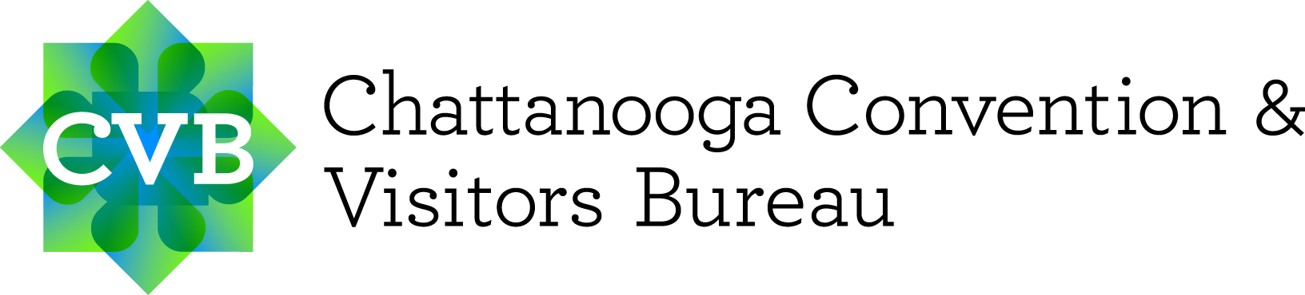
CHATTANOOGA, TENNESSEE
INDIVIDUAL MEDIA ASSISTANCE REQUEST

Thank you for your interest in the Best Town Ever! To initiate a visit, please fill out this form and email it within
10 business days of your visit. If multiple media are traveling together, this information must be submitted for each media person who will be working on the story.

Please return this Media Assistance Request form to:
Candace I. Litchfield, Marketing & Public Relations Manager
candacel@chattanoogacvb.com | 423-424-4430 | chattanoogafun.com

TRAVEL DATES
- Date & approximate time of arrival:
- Date & approximate time of departure:

*CVB reserves the right to determine a “reasonable” amount of days for a media request based on your story focus and length.

MEDIA INFORMATION
- Full name:
- Title:
- Date of Birth:
- Full mailing address:
- Cell phone:
- Email:
- Emergency contact:
- Special food requirements:
- # of adults traveling with you:
- # of children traveling with you:

*Costs incurred by family members/friends traveling with the writer will not be paid by the CVB.

ARTICLES
Links to articles published within six months prior to your media request:
- Article 1:
- Article 2:
- Article 3:

*All media are required to submit three or more samples of articles.

MEDIA OUTLET INFORMATION
- Media type:
- Media name:
- Media website:
- Media demographics:
- Language:
- Circulation/audience numbers:
- Website unique visitors:
- Media outlet profile (overview of publication):
- Advertising rates:
- Value of published article:

*Online media please provide Google analytics information.

ANTICIPATED RESULTS
- Date of publication/air date:
- Expected coverage results:
- Assigning editor:

SOCIAL MEDIA PLATFORMS
- Facebook fans/followers:
  - Link:
- Twitter fans/followers:
  - Link:
- Instagram fans/followers:
  - Link:
- Pinterest fans/followers:
  - Link:
- YouTube fans/followers:
  - Link:

- Will content be published/shared on any of the publication’s social media outlets?
  - If yes, which ones?:

PREVIOUS CHATTANOOGA SPONSORED VISIT(S)
- Dates:
- Results from assisted visit(s) – include links:

JOURNALIST STORY GOALS
- Story focus:
- Requested Chattanooga experiences:
- Requested interviews:

MORE INFORMATION
Chattanooga CVB Website
Chattanooga Image Library
Chattanooga Visitors Guide
Chattanooga Events Calendar
Chattanooga Blog
Chattanooga Fun Facebook
Chattanooga Fun Twitter
Chattanooga Fun Instagram

