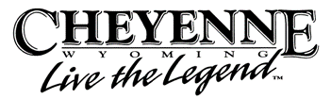

Host Hotel:
Red Lion • 204 W Fox Farm Rd Cheyenne, WY 82007 • 307-638 -4466
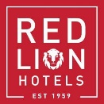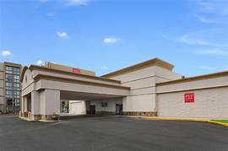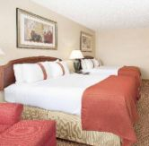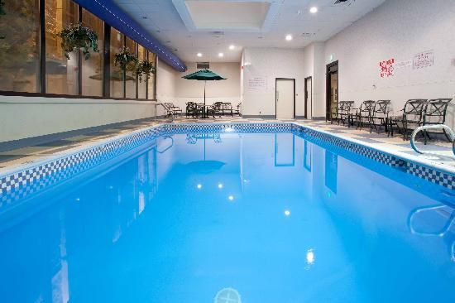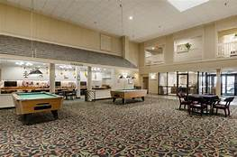

Best Western Plus Frontier Inn • 8101 Hutchins Dr Cheyenne, WY 82007 • 307-638-8891
Candlewood Suites • 2335 Tura Pkwy Cheyenne, WY 82001 • 307-634-6622
Comfort Inn & Suites• 201 W Fox Farm Rd Cheyenne, WY 82007 • 307-514-6051
Days Inn • 2360 W Lincolnway Cheyenne, WY 82001 • 307-778-8877 or 1-800-325-2525
Fairfield Inn • 1415 Stillwater Ave Cheyenne, WY 82009 • 307-637-4070
Fairfield Inn Southwest • 1820 W Lincolnway Cheyenne, WY 82001 • 307-634-0401
Hampton Inn • 1781 Fleischli Pkwy Cheyenne, WY 82001 • 307-632-
Historic Plains Hotel 1600 Central Ave • Cheyenne, WY 82001 866-2PLAINS or 307-638-3311
Holiday Inn Express Hotel & Suites 1741 Fleischli Pkwy • Cheyenne, WY 82001 307-433-0751 or 1-800-HOLIDAY
La Quinta Inn • 2410 W Lincolnway Cheyenne, WY 82001 • 307-632-7117
Little America Hotel & Resort 2800 W Lincolnway • Cheyenne, WY 82009 307-775-8400 or 1-800-445-6945
Microtel • 1400 W Lincolnway Cheyenne, WY 82001 • 307-634-3200
My Place Hotel • 1920 W Lincolnway Cheyenne, WY 8200 1 • 307-634 -1400
Oak Tree Inn • 1625 Stillwater Ave Cheyenne, WY 8200 9 • 307-778 -6620
Quality Inn • 2245 Etchepare Dr Cheyenne, WY 8200 7 • 307-638 -7202
Springhill Suites • 416 W Fox Farm Rd Cheyenne, WY 82007 • 307-635 -0006
Staybridge Suites • 5109 Frontier Mall Dr Cheyenne, WY 82009 • 307-634-6370 or 1-877-238-8889
Super 8 Motel • 1900 W Lincolnway Cheyenne, WY 8200 1 • 307-635 -8741 or 1 -800 -800 -8000
TownePlace Suites by Marriott • 1710 W Lincolnway Cheyenne, WY 8200 1 • 307-634-0400
TRU by Hilton • 423 W Fox Farm Rd Cheyenne, WY 8200 1 • 307-222-3600

Full Listing of all Hotels/Motels

