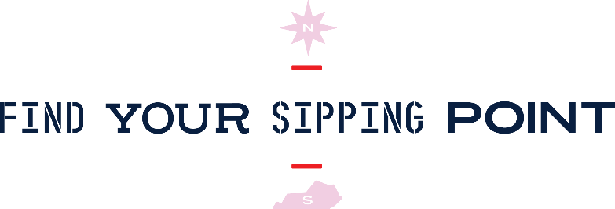
So you want to get on this bourbon bound collective and join The B-Line?
Thanks for your interest in joining the experience that celebrates the edge of Bourbon Country and Bourbon state-of-mind. The B-Line is collection of distilleries, bars and restaurants with a bourbon focus and a dedication to the celebration of bourbon culture.
The criteria and process for joining The B-Line is spelled out in detail in this application and we look forward to hearing your bourbon inspiration.
All final decisions for inclusion in The B-Line are the responsibility of an impartial committee that evaluates which venues best meet the needs of the endeavor and have a dedication to the spirit of The B-Line’s guiding brand principles: inclusive, non-traditional, connected, evolving and above all, Bourbon spirited. In addition, there will be a maximum of one B-Line bar and restaurant added from NKY yearly as well as one B-Line bar or restaurant added from the surrounding counties yearly.
Applications should be submitted to hello@meetNKY.com by March 31, 2022. Final decisions for inclusion on the line will be made by May 31, 2022.
Cheers!
The B-Line

The Bourbon Line/B-Line Criteria

Applications are accepted starting January 27, 2022, with the deadline to meet criteria on June 1, 2022. Final decision for inclusion will be made by May 31, 2022. Inclusion in new marketing and media initiatives begin in Q3 2022 after announcement of inclusion on National Bourbon Day 2022.

- Operation: Establishment must have been opened consistently for at least one full year and be locally owned in the Cincinnati region or Commonwealth of Kentucky. Establishment must also have a local Northern Kentucky address.

- Philosophy: Bourbon should be at the center of your culture. While we also love great beer, wine and other spirits, The B-Line is all about Bourbon. If you are a bar, you should be able to call yourself a true bourbon bar and if you are a restaurant, bourbon should be part of your culinary focus. And of course, without saying, if you are a distillery, you should be making America’s Native Spirit.

- Restaurant Criteria: Must stock at least 50 labels of Bourbon with a preference for Kentucky Bourbon; Must stock all local varieties of The B-Line distilleries (currently New Riff, Boone County Distilling, The Old Pogue Distillery, Neeley Family Distillery and Second Sight); Offer Bourbon Flights and specialty Bourbon cocktails; Host Bourbon related events when available; Have at least one signature Bourbon infused menu item; complete B-Line onboarding and training for all staff; display all B-Line collateral in restaurant and be full engaged and active with Trip Advisor, Yelp and Google.

- Bar Criteria: Must stock at least 100 labels of Bourbon with a preference for Kentucky Bourbon; Must stock all local varieties of The B-Line distilleries (currently New Riff, Boone County Distilling, The Old Pogue Distillery, Neeley Family Distillery and Second Sight); Offer Bourbon Flights and promote the quarterly specialty B-Line cocktails; Host Bourbon related events when available; B-Line training onsite for all staff; display all B-Line collateral in bar and be full engaged and active with Trip Advisor, Yelp and Google.

- Distillery: Member in Good Standing with the Kentucky Distillers Association; Inclusion on the Kentucky Bourbon Trail or Kentucky Bourbon Trail Craft Tour; display all B-Line collateral; be full engaged and active with Trip Advisor, Yelp and Google.

- Establishment must display The B-Line signage on location and promote the usage of the Line Guide in digital and paper forms.

- Renewal and continued participation in The B-Line is subject to the ongoing monitoring of commitment to criteria, site inspections and review site opinions and shall be reviewed yearly.

B-Line Venues Receive:
- A supply of Line Guides and a self-inking stamp with your customized B-Line name.
- Participation in digital Line Guide with PIN check-in for your establishment
- B-Line placemaking with door clings, signs and promotional items including customized drink coasters, table tents, mirror stickers, Line Guide holder, quick view guides and custom barrel head for display.
- Inclusion on the theBLine.com website that receives 100k+ visitors yearly and has a robust marketing campaign to increase visitation.
- Inclusion in media events with our media partners in the region including Source Cincinnati and the Cincinnati CVB. We have brought in more than 50 national writers to enjoy their first sips of Kentucky hospitality.
- Inclusion in the social media efforts of meetNKY and The B-Line across Facebook, Instagram, Twitter, Pinterest and YouTube to drive additional traffic to your website and social channels.
- meetNKY handles all fulfillment of B-Line redemptions.
- Inclusion in potential for out of market events to promote The B-Line.
- Inclusion in the yearly Northern Kentucky section of The Bourbon Country Visitors Guide as well as bourboncountry.com and Best Bourbon Bars in America (subject to vote).

Bourbon Line/B-Line Application

Company Name:
Address:
City, State Zip:
Phone number:
Website:

What Month: _____________ Year: ___________ did you open?

Ownership Name/Address:

Media Contact Name/Email:

Head Bartender Name/Email:

General Manager Name/Email:

Hours of operation:

Applying as a: ________ B-Line Bar ______ B-Line Restaurant

Please include a 100-word description about your establishment and its unique charm/twist. Why would your venue make a good B-Line Stop and how does it add to The B-Line Brand? Keep in mind we may use some of this for your description on The B-Line website.

Please describe Bourbon training that you and your staff will undergo in 2018:

Have you claimed your listing on Google, Trip Advisor and Yelp?

Are you active on social media and are you willing to include B-Line hashtags, tags, etc. in your social activity?

Bar Application- How many Bourbons do you currently shelf and what is your top selling Bourbon Flight?

Restaurant Application – How many Bourbons do you currently shelf and what is your most popular menu item?

