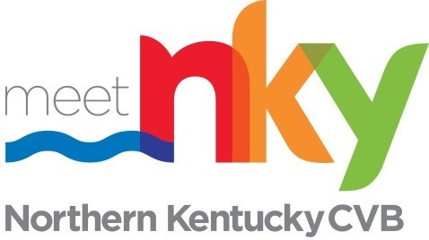 JOB DESCRIPTION

Position Title: Product Development Director
Classification: Exempt
Department: Administration/Northern Kentucky Tourism Development Corp.
Reports to: President & CEO

Job Summary: The Product Development Director assists communities and tourism partners in giving new life to existing resources and in fostering new tourism products within communities. This position has responsibility for enacting the overall Tourism Master Plan as well as the yearly development Business Plan.

Essential Duties
- In concert with the President & CEO and Board of Commissioners, provides leadership to maximize Northern Kentucky’s potential for generating increased visitor spending and creating compelling, sustainable traveler experiences throughout the region.
- Develops research to measure performance and provides input on strategy, sets performance metrics, and shares findings with key stakeholders, including county and city leadership, Kentucky Tourism, and industry partners.
- Owns performance implementation plan of capital and development programs from the NKY Tourism Master Plan.
- Other duties as prescribed by leadership or Board of Commissioners.

Development
- Manages regional tourism product development initiatives that build NKY’s reputation as a premier destination for cultural tourism, outdoor recreation, meetings related travel, low-impact travel, and agritourism in partnership with Kentucky tourism industry partners.
- Manages the growth of the NKY’s regional tourism strategy in partnership with the Cincy Region development strategy.
- Manages design and delivery of initiatives that promote hospitality training and visitor readiness, with a focus on supporting industry partners in emerging destinations.
- Supports the creation of potential incentives to support continued tourism growth in the NKY region.
- Provides input on the design and award of grants and funding programs in partnership with Marketing and Finance Committee.
Industry Communications and Alliances
- Collaborates on the development of success stories related to NKY Destination Development programs and the production of these success stories on the NKY website and stakeholder communications.
- Provides support to tourism industry partners that participate in Destination Developments programs on ways to build awareness of their achievements and supports the relationship growth with the industry partners.
- Creates a convening environment for public partners (economic development in cities and countries as well as at the state level) and private partners (Growth Partners – Chamber, Tri-Ed, companies and stakeholders) to accomplish goals and metrics of the Tourism Master Plan.
COMPETENCIES:
- Leadership: Creates and communicates a compelling vision; engages others to implement vision; builds enthusiasm, participation and positive morale and loyalty; takes charge of groups and situations; sets a strong leadership role by walking the talk; promotes a safe, challenging work environment.
- Strategic Planning: Identifies and analyzes organizational opportunities; accurately forecasts trends and emerging needs; frames strategic questions; makes decisions and deploys resources in alignment with strategic priorities; plans for future problems and opportunities by forecasting business trends and outside forces.
- Negotiation & Issue Resolution: Openly manages conflict and disagreement through collaborative discussion to reach positive conclusions; arrives at constructive solutions whilst maintaining positive working relationships; seeks win-win situations; diplomatically explores common and opposing options to reach mutually acceptable positive solutions.
- Communication: Is understood by and understands others; clearly articulates key points when writing and speaking; actively listens; effectively interprets non-verbal communication and truly hears what a wide variety of people are trying to say; accurately assesses personal styles and adjusts own style of communication to optimize personal effectiveness.
- Results Driven: Drives for successful results; makes things happen and conveys a sense of urgency; sets aggressive goals and works hard to achieve these goals; moves tasks and assignments toward closure; invests considerable effort to ensure goals are met in a high-quality manner.
Minimum Qualifications, Substitutions & Conditions of Employment
REQUIRED KNOWLEDGE, SKILLS & ABILITIES:
Previous knowledge and demonstrated skill in program planning and coordination of multiple projects and assignments. Ability to work with a wide variety of people at all levels in stressful situations and exercise confidentiality and discretion as appropriate. Skill in relationship building and networking with a diverse population of organizations, associations, and interest groups.
Strong oral and written communication skills that include the demonstrated ability to edit and write. Excellent time management skills, including the demonstrated ability to meet timelines and prioritize multiple projects.
Team orientation and the demonstrated ability to work effectively with peers, subordinates, and supervisors. Ability and willingness to work hours beyond the standard daily or weekly schedule when necessary. Travel will be required for role.

