Belle of Louisville Riverboats
Steamboats and Their Connection to Slavery

Though it tends to be a little-known fact, the invention of the steamboat dates to right after the Revolutionary War (the first working boat was launched on the Delaware River in August, 1787), and it has been involved in the social and economic development of our country in every way imaginable. On the inland waterways, the availability of steamboats actually accelerated the growing of cotton, since there was now a way to get large volumes of the crop to market, and, in the South, with the expansion of the cotton industry came the expansion of the use of slaves as field hands before and during the Civil War, and freed slaves from 1863 on.

The steam packet (freight) boat was a booming industry for most of the 19th century, carrying every type of product from port to port and market to market, and while cargo was their mainstay, they also, typically, carried passengers as well. Workers were needed for loading and unloading freight and for passengers’ services, and the workforce was drawn from groups of people available at the time. Without question, steamboats played an important role in the movement of people and goods and in the employment of workers during the decades surrounding the Civil War.

Before the Civil War

Jobs of All Kinds

Roustabouts were the lowest level of the steamboat job hierarchy, and while some slaves and freed slaves were taken on in that capacity, for the three decades prior to the Civil War the majority of roustabouts were native-born Americans or immigrants – especially Irish and German – entering the country by the tens of thousands each year and often willing to work for very low pay. For boats that separated “deck” positions, deck hands were just a small cut above the roustabouts, were typically white, and were often given greater responsibilities for handling the cargo.

A survey of the make-up of steamboat workers in 1850 provides an idea of the typical mix of ethnicities normally found on packet boats at that time: 43% native white, 24% Irish, 11% Germans, 3% other whites (often Swiss, Scandinavians, and French), 6% free Blacks, 12% slaves.
In the southern states along the river ways, slaves were sometimes hired out by their masters to work on steamboats, especially during slow times on the plantations and farms, and some became roustabouts. However, slaves were considered more valuable than immigrants and their masters could demand a higher rate of pay for them; so it was a common practice for boat owners and operators to fill their lowest crew positions with people who would work cheaply. As time went on, that practice changed considerably.

While there were many types of work on steamboats, captains, pilots, mates, engineers, and clerks were jobs for whites only. Most cooks, stewards, and waiters tended to be white, while cabin crew – including chambermaids and porters – were often a mix of races. In some cases, the jobs slaves were doing for their masters on their plantations and farms trained them well for jobs they did on steamboats; and, in an interesting note, the only jobs available for women were chambermaids and low cabin crew positions.

Firemen working in the boiler room were most commonly rented slaves on boats traveling south of Louisville and St. Louis, while Irish and German immigrants were typically firemen on boats traveling north of both those cities. Being a fireman gave a slave close access to the side of the boat, so escape was relatively easy. The difficulty in reaching freedom, in part, lay in reaching the borders of a free state – something more easily done the further upriver the boat traveled.

The bar on the boat (certainly one of the most popular places on board!) was often rented space – sometimes by slave owners who earned a great deal of money by placing their own slaves on board as barmen; and while some bartenders were white, the bar might also be run by freed slaves or freed Black men. A similar situation of renting space applied to barbers on board, but for the most part barbers tended to be freed slaves who made a good living traveling on steamboats.

Life on Board

Being hired out to a steamboat provided some forms of freedoms not commonly available to slaves at that time.
(continued)
They earned money for their masters as well as some for themselves, they were out from under the watch of the master or overseer, it gave them a chance to hunt for family members from town to town, and the opportunity for escape was greater (though it appears the majority of rented-out slaves did not attempt to achieve freedom from boats). In return, the master received some income for his plantation at the times of year when income was generally slow, and he did not have to feed or clothe the workers or manage their daily care. A watchful slave could also learn the social skills needed to blend into a northern society; so, if able to escape, more capable of remaining free as time went on.

For the most part, southern boats kept the same racial distinctions as were practiced on land. Slaves could not be on board unless they were a worker or under the control of their master. Freed slaves could not purchase a ticket for a stateroom and were only allowed “deck passage,” which gave them space on the main deck, the lowest deck on the boat, where cargo and livestock traveled. They generally provided their own food and slept where they could.

Prior to the Civil war, most deck passengers were new foreigners or American migrants, often traveling in groups from south to north and connecting to other boats. Plantation owners might also transport slaves – in small or large groups – from one location to another, either to move to a new plantation or to share their slaves with another plantation for a short time.

Sanitation was minimal at best, and deck travelers would, by necessity, take charge of their own accommodations. There, of course, was no privacy, and the space was shared with people of all temperaments from the social classes with the fewest resources. It might have been a cheap form of travel but it left a lot to be desired – especially if there was nowhere else you were allowed to go on the boat. The deck might be shared by people of all races, but there were formal and informal rules of behavior and social hierarchies still to be followed.

Packet boats were considered the best way to transport anything quickly in that time, including all forms of cargo. It was such a common practice to use boats to
move slaves that were heading to or leaving a slave market that the passengers staying in staterooms on the second deck hardly noticed it – or them.

The Underground Railroad

The Underground Railroad also found pathways by boat, including by steam-powered packets. One historian has described it this way: “The Underground Railroad was a network of people, African American as well as white, offering shelter and aid to escaped slaves from the South. It developed as a convergence of several different clandestine efforts. The exact dates of its existence are not known, but it operated from the late 18th century to the Civil War, at which point its efforts continued to undermine the Confederacy in a less-secretive fashion.”

Freedom seekers would occasionally stow away on a riverboat going the direction they sought with a greater or lesser degree of success. “Stowing away” required the agreement of other travelers on board, since it very likely could not be accomplished with complete anonymity. It was more easily managed if there were a large number of deck passengers, especially other slaves, so a runaway could blend in to the crowd; but money could be made by returning fugitive slaves, so there was no guarantee of safety. However, boats of all types did become vessels of freedom for many – thousands, even – men, women, and children seeking a different life and using the rivers as part of their journey.

During the Civil War

A Change to Military Use

The use of steamboats on the inland waterways changed dramatically from 1861 – 1865. While during the early part of the war typical packet trade continued as usual on routes heading to northern states, it was changing rapidly on routes leading to the southern states. Though in some cases boats were built for military service, more of the time both Union and Confederate troops took the less expensive route of commandeering already-existing boats – and cargo – for their use. Regardless of their origin, gunboats, hospital and supply boats, and troop transports were commonly found on any waterway directly affected by the war.

(continued)
As an example, to avoid the cost of building from scratch, ironclads and tinclads often began as packet boats “taken over” by one side or the other. They were then sheeted over with tin or iron to become resistant to rifle and shell fire, and used to wage river-based battles against strategic towns on land.

Providing supplies to meet the needs of troops on both sides required acquiring large quantities of goods and moving them rapidly by river whenever possible. In addition, boats moved troops in much the same way – by river as rapidly and as often as possible, including, for the Union army, transporting Black soldiers – the Colored Troops – as well, though if it could be arranged, on separate boats.

Though regular passenger transportation did not completely stop during most of the war years, schedules were erratic and safety could not be guaranteed even for short distances. To avoid loss of life or possessions, it was more likely that people would choose to stay in place and close to home as much as they could. Business owners at first tried to arrange cargo runs along their usual routes, but since boats were continually taken over by one military force or the other, it became very difficult to predict the outcome of loading a boat and getting it to its destination. Though the civilian use of packet boats did not stop completely, it became more and more risky in all ways.

In addition, it was getting harder and harder to find crew members to handle a boat and its cargo needs, since many experienced hands were either recruited into a military force or left the territory to avoid being recruited; and the non-military workforce was depleted significantly. When one side or the other took over a boat, they had to hope they had enough steamboat crew members or enough troops with steamboat experience – especially captains, pilots, and engineers – to carry on the operation. It also happened that boats were scuttled to avoid them being captured by the other side, if operating the boat was not feasible or if sinking her was a more disruptive choice.

The Emancipation Proclamation was signed into law on January 1, 1863, giving freedom to all slaves in states which were in rebellion to the Union – all the states that had declared themselves part of the Confederacy. The northern states and most of the western states and territories had already outlawed or abolished slavery to one degree or another, and there were a few states that had remained neutral throughout the war. The neutral states, like Kentucky, were not affected by the Emancipation Proclamation until the Civil War’s ceasefire was officially signed, keeping slavery legal in those states through the war years.

After the Civil War

The steamboat world was changing once again. When word was spread that the war had ended, steamboats were immediately put into service returning troops to their home bases and transporting wounded and damaged soldiers to places of assistance. With the end of the war in April, 1865, and with the adoption of the 13th Amendment in December that year, putting a final end to slavery as a legal institution in the U.S., the rivers began to respond to the new differences in work force and social conditions.

A New Demographic

With southern plantations struggling for economic stability after the devastating effects of battles waged on their lands, and now paying former slaves to work the fields, more and more freed slaves were looking for employment elsewhere. The rivers and the packet boat industry recovered fairly quickly after the fighting stopped, and boat building and the movement of cargo and passengers had already begun again by the summer of 1865. As more boats were launched and more workers were needed, there was a shift in worker demographics as well.

Prior to the Civil War, the majority of low-level jobs on boats were done by white immigrants and white American citizens who were willing to work very cheaply, but following the war that changed more to freed slaves. Admittedly, the freed slave could now keep all the money he or she earned, though how much they were paid was not necessarily a significant rise above their former conditions. There were lots of jobs open, since there were lots of steamboats, and working on a steamboat was, at least, a form of ready employment anywhere along the inland waterways.

All kinds of skills were needed, so though roustabouts, deck hands, firemen, porters, chambermaids, and cabin crew were common jobs available, former slaves began to accept positions that might otherwise have been more reserved for whites, like cooks, stewards, and waiters. Bartenders and barbers could now rent out their own space and manage their own lives. Other changes, though, were slow to come.
(continued)
Decades of Change

In the last decades of the 19th century, Black passengers were not allowed to purchase cabin tickets providing them a stateroom, even if they had money enough to meet the cost, making deck passage their only option. As time moved into the 20th century, some cabins on some boats might be made available for Black passengers, though they were generally located in the less-desirable and more crowded places, and some areas of the boat were still off limits to them. What food was provided to Black passengers was different, and often of a lower grade, than the food served to the white passengers, though both had paid the price of a cabin ticket. White cabin passengers might be shown a menu in an elegant dining room, perhaps, that offered an abundance of choices to select, while Black cabin passengers might be served whatever was left over in a much cruder and separate dining area. There was a long road to travel yet before the old descriptions of society and position were revised, and following the Civil War everyone, regardless of the place they were raised, was still overcoming the distorted ideas of race and class imposed upon Black people by generations of slave owners and, especially, southern communities as a whole.
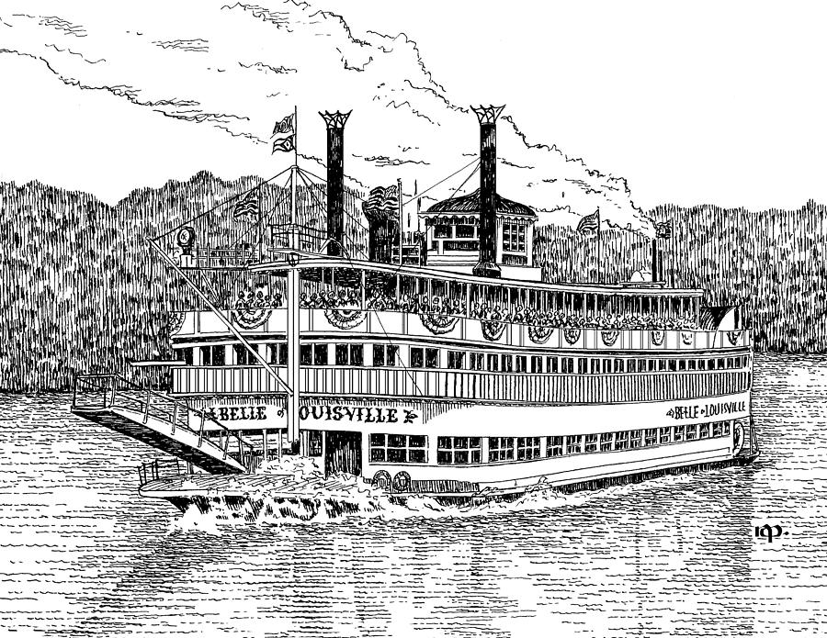
From Cargo to Excursion

With the coming of the 20th century, the steamboat era moved from a packet to an excursion way of life, and with that a change in how and why people traveled and what modes they used also came about. With the rapid expansion of railroads after the completion of the Transcontinental Railroad in May, 1869, leading into the booming railroad business of the first half of the 1900s, and then the introduction of the truck by the end of the 1920s, packet boat traffic was ending and towboat traffic (with the shipping of tons of commodities) was coming. By that time, packet boats that were still in business either went out of business or shifted to excursion work – in some cases by becoming “tramp” vessels, continually on the move and offering short recreational trips at towns and cities all along the inland waterways. The march of time began the slow change in social boundaries, as well, and by the 1940s virtually anyone with the price of a ticket could ride a steamboat for a short cruise. By the 1960s anyone with the price of a ticket could ride anywhere they wanted to on board an excursion boat.

What About Today?

The last of the steam-powered riverboats on the inland waterways began as the Idlewild in 1914, built as a packet boat and doing cargo and day-passenger excursion service until the early 1930s, when she shifted to excursion work only. In 1948, her name changed to the Avalon, and in 1962 to the Belle of Louisville. She is the last operating river steamboat of all the thousands of steamboats built between the 1820s and 1920s, the last built as a packet boat, and the last one still running with steam engines and a paddlewheel. She is the only river steamboat in American history to reach the age of 100.

The role of both the river steamboat and her passengers has changed considerably since the 18th century. While not always the case in river history, today, any ticket can be purchased by anyone wanting a ride, and any job on any riverboat in the United States can be done by anyone regardless of adult age, gender, creed, or ethnicity.

© 2020 History reported by Kadie Engstrom, Belle of Louisville Education Coordinator. All rights reserved. Latest revision January, 2021.

