Transfer Events using the Waitlist

There is no cost to add your name to the waitlist. You will be charged a transfer fee if you are selected from the waitlist and complete the transfer to the new race. You will remain registered for the original race until you complete the transfer to the new race.

The following instructions apply to transfers from the full marathon to the half marathon. Once the full marathon is at capacity, we will open a full marathon waitlist and these instructions will also be applicable for transfers from the half marathon to the full marathon.

# Please read all instructions and follow carefully.

Go to the race page, https://runsignup.com/Race/NY/Corning/WineGlassMarathon, and log into your account.

1. Click on **Edit Registration**
2. Click on **Transfer Event**
3. Click on **Start Transfer**
4. Select **Half Marathon (Full)** from the dropdown box
5. Click **Join the Waiting List** – **\*\*SEE ARROW #5. CLICK ON THE SHADED WORDS**\*\* and then click

**Continue**

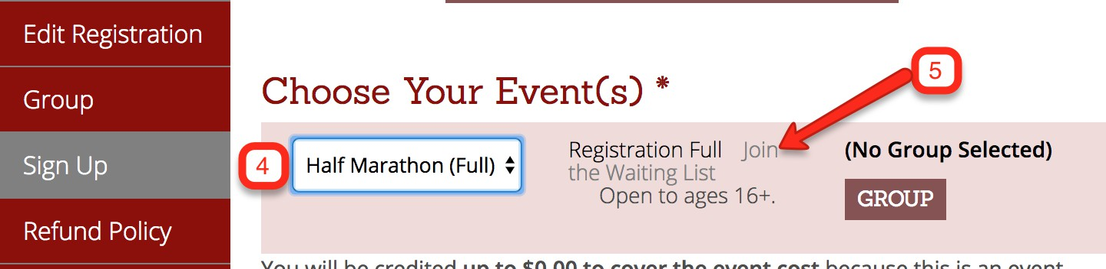

1. Click on **Transfer to Waiting List**
2. **A green bar will appear** stating that you have been successfully added to the waiting list

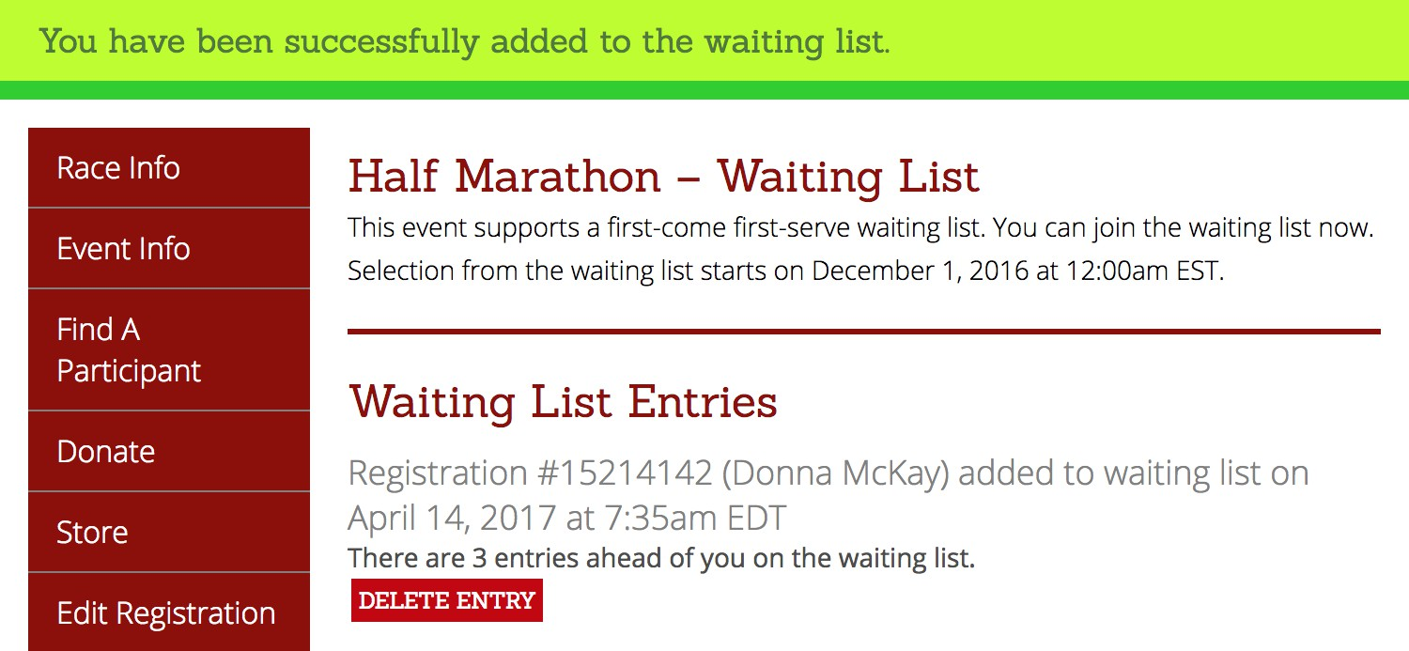

1. You will receive an **email confirmation** from RunSignUp confirming that you have been added to the waiting list
2. If you are selected, you will receive a **second email** notifying you that you have 48 hours to transfer
3. Once you complete the transfer, you will be charged a transfer fee