2023 RATE CARD
CUMBERLAND AREA ECONOMIC DEVELOPMENT CORPORATION ENEWSLETTERS

Get your message in front of CAEDC’s subscriber base with sponsored content and display advertising options that send users to a desired page on your website. All ads must be purchased by the month. Order forms, payment and ad content due the 15th of the previous month.

PARTNER ENEWSLETTER
- 3,300 Weekly Subscribers / 13,200 Monthly Impressions
Option One: Sponsored Content - $350/month
- Image: 400 x 400 pixels
- Title: 20 Characters
- Body: 50 Words or Less
- Link to Partner Website
Option Two: Guest Feature - $500/month
- Enews inclusion: 75 Words or Less
- Article posted indefinitely on CumberlandBusiness.com/News
  - Title: Up to 75 Characters
Option One
  - Body: 1,000 Words or Less
  - 1-3 Images or Logos
  - Up to 2 links to Partner Website
  - Advertiser provides content; CAEDC reserves right to edit
- Display ad on homepage of CumberlandBusiness.com for one month (avg. 5,800 session/month)
  - 322x180 pixels
  - Link to your site OR your article on CumberlandBusiness.com/News
- At least one social link to article from CAEDC Facebook or LinkedIn
Option Three: Leaderboard - $250/month
Option Two
- 600 x 75 pixels
Option Three
- Link to Partner Website
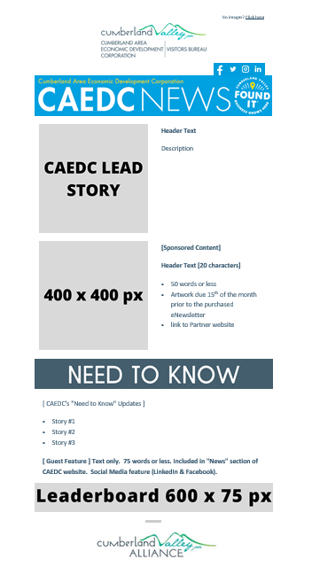

VISITOR ENEWSLETTER
- 14,500 Monthly Subscribers
- Only open to tourism businesses
Sponsored Content - $100/month
- Image: 400 x 400 pixels
- Title: 20 Characters
- Body: 50 Words or Less
- Link to Partner Website
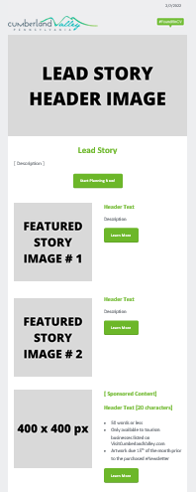

BEER TRAIL ENEWSLETTER
- 3.000+ Monthly Subscribers
- Only open to tourism businesses
Sponsored Content - $50/month
- Image: 400 x 400 pixels
- Title: 20 Characters
- Body: 50 Words or Less
- Link to Partner Website
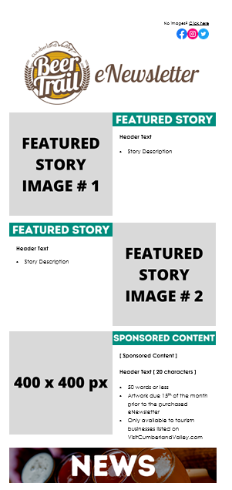

2023 ORDER FORM
FOR CAEDC ENEWSLETTERS

ENEWSLETTER (PARTNER, VISITOR, BEER TRAIL):

PLACEMENT (SPONSORED CONTENT, DISPLAY, GUEST FEATURE):

MONTH(S):

COST: $

CONTACT INFORMATION

BUSINESS ______________________________________________________________________________________

MAILING ADDRESS _____________________________________________________________________________________

CITY/STATE/ZIP _____________________________________________________________________________________

CONTACT NAME ______________________________________ TITLE __________________________________________

PHONE _____________________________________ EMAIL _________________________________________

SIGNATURE ______________________________________ DATE __________________________________________

PAYMENT
Upon receipt of your order form, payment and ad content, your ad will be included in the selected enewsletter(s). We will provide confirmation of your order and instructions regarding advertisement copy.

Form of payment: □ Check □MasterCard □Visa □American Express
Checks should be made payable to: Cumberland Area Economic Development Organization; 53 W. South Street, Suite 1, Carlisle, PA 17013
There is a 2.5% fee, or minimum of $2.00, for credit card transactions.
Amount of payment: $______________________ Name on Credit Card: __________________________________
Credit Card No.: _____________________________________________________________________________________
Expiration Date: ___________________________ Card Verification Value (CVV): ________________________
Authorized Signature: _________________________________________________________________________________

Email your completed order form to Ashley Kurtz, akurtz@visitcumberlandvalley.com

