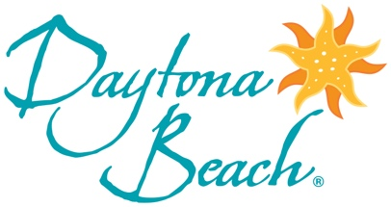

eNewsletter Theme: Golf

Subject Line: DON’T MISS OUT ON A GOLF GETAWAY!

Fast Cars, A Famous Beach and Great Golf
Daytona Beach is one of the Sunshine State’s fastest rising golf destinations and if you want to know why the “World’s Most Famous Beach” has become a hotspot for savvy group leaders, you’ve come to the right place.
4 Reasons Golfers Are Flocking to Daytona Beach

Golf Is Only Half the Fun
When the day’s final putt drops, the good times are only just beginning. The Daytona Beach area’s off-the-course activities put fun in play in a variety of ways. From a drive on the beach to high-octane action, flavor-filled forays and much more, a memorable experience is never more than a pitching wedge away.
LEARN MORE

Many Ways to Stay and Play
The stay-and-play package, allowing players to combine golf and accommodations in one value-filled offer, is at the heart of Daytona Beach’s appeal. Our array of golf packages lets golfers customize their trip on and off the course. Check out some of the area’s hottest deals!
LEARN MORE

DON’T MISS OUT ON A GOLF GETAWAY!
To access destination images, visit the Daytona Beach Media Gallery and register.

