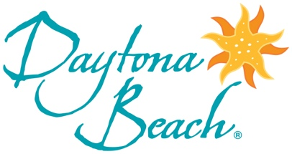

eNewsletter Theme: Monument & Statue Trail
Subject Line: Discover the New Monument & Statue Trail — A Fun and Unique Way to Explore Daytona Beach
The new Statue & Monument Trail is a great way to explore the Daytona Beach area. The trail provides a fascinating glimpse into the area’s history that includes stops at both popular and off-the-beaten path attractions. PREPARE TO EXPLORE

More Trails to Explore
The Ultimate Daytona Beach Trail Guide and its collection of car-, craft- and culture-oriented trails spotlights the area’s diversity. From craft beer and artisan spirits to African American history and photo-worthy iconic landmarks and more, our trail guide covers it all! HAPPY TRAILS

Stay and Play in Daytona Beach
Pair your getaway to Daytona Beach with a round (or two) of golf. The Daytona Beach area is home to nearly 20 courses including two 18-hole courses at renowned LPGA International. HIT THE LINKS

To access destination images, visit the Daytona Beach Media Gallery and register.

