Extranet Login, Partner Bulletins & Post Board

http://denver.extranet.simpleviewcrm.com

Logging In:
- You will receive an email from the VISIT DENVER with a URL link and a temporary password.
- Click on the link, which will take you to the “VISIT DENVER Extranet Login” screen.
- Type in your username, which is your full email address.
- Type in your password, which is the temporary one that was emailed to you.
- Upon logging in with your temporary password, you will be prompted to change your password to one of your preference.
  - If you are assigned to more than one member account (e.g. multiple hotels, restaurants, etc…), and have the same email address for each member account, you will be able to access all of your accounts with the same login credentials.
- If you ever have problems getting into your account, contact your account manager at VISIT DENVER for assistance.

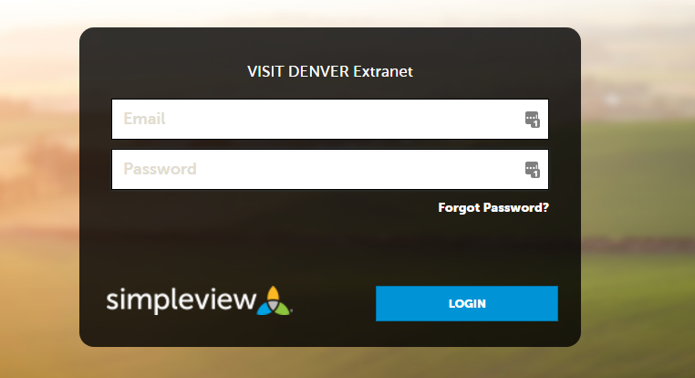
Once you have logged in, the default view is the “Home Page.” Listed along the left hand side are the sites navigation links. (Navigation links may look different depending on your partner access level)
- Home
- Profile
- Collateral
- Opportunities
- Reports

NOTE: If you have access to more than one account, you will see them all listed under the accounts section that can be found by clicking the Profile button and selecting Accounts.

Partner Bulletins:
- After successfully logging in, you will see the Partner Bulletins section. This is where VISIT DENVER will communicate partner information to you. Bulletins such as extranet documentation, event reminders, etc…
- Partner Bulletins are always located on the home page. This section gives you a brief summary of the bulletin and any attachments that pertain to the bulletin.
  - To the right of the bulletin title, it will indicate if you have read the bulletin and if so, give you the date it was read.

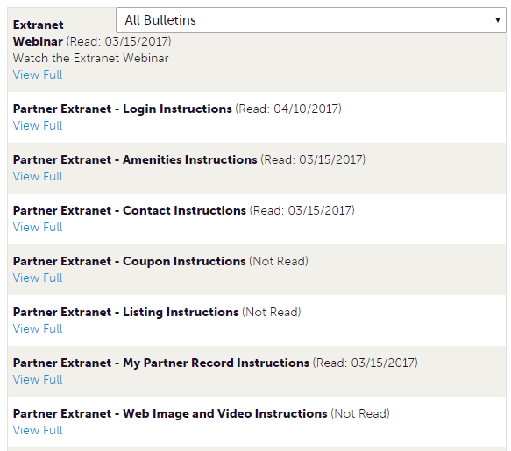
- To view the bulletin in more detail, click the “View Full” link at the end of the bulletin.

Post Board:
- The Post Board allows for partner-to-partner interactions and is located on the extranet home page. Anyone with Post Board access can post a new comment, reply to a comment or email the person who made the original post.
- Click the pencil icon to start a new post.
  - Add text into the body section and click Create Post.

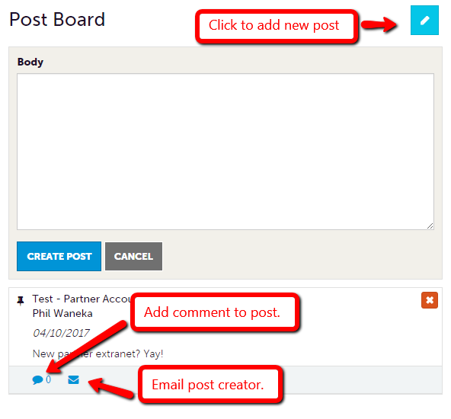
- To comment on a post click the caption bubble located below the post you wish to comment on. Or click the email icon to email them directly.
- Click the X icon in the top right corner to delete a post. Posts can only be deleted by the user who created them.

