Extranet Instructions
Updating Contacts

http://extranet.denver.simpleviewcrm.com

Viewing Your Partner Record
Depending on your access levels, there are various items that can be viewed under your Partner Profile:
- Contacts

Contacts:
- To update your contact records, click the Profile link and select Contacts. Once in the contact screen select the one you want to edit and click the pencil icon to the left of their name.
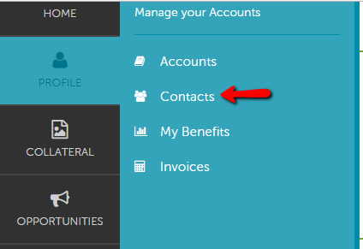

2. To add a new Contact, click the “Add Contact” button.

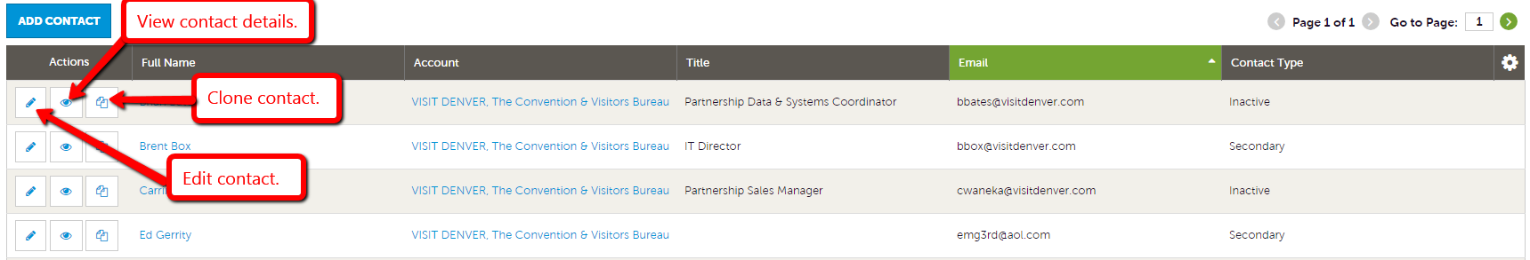

Please note: If a staff member leaves and a new one arrives, please clone the old contact. Change the account information as necessary and make the old contact inactive. You can do this by changing the “Contact Type” to Inactive. Or you can simply add a new person using the “Add New Contact” button.
