Extranet Instructions
Updating Listings

http://extranet.denver.simpleviewcrm.com

Viewing Your Member Record
Listings are found under the collateral section of the extranet. To view your listings click the Collateral link from the left main navigation and then click Listings.
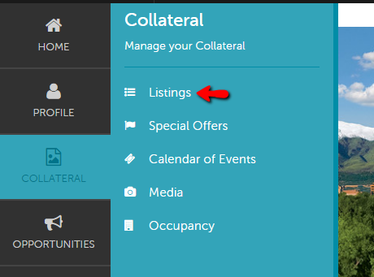

Editing a Listing:
- In order to update your listing, click the pencil icon to the left of the appropriate listing.
- Contact Drop-down: This contact will be the main contact for your listing if we were to send a referral to a visitor or group.
- Address Type: Select “Physical” to display the main address on your account
- Listing: Enter descriptive text for your venue.
- Search Keywords: Enter keywords that can be used on the website to locate your listing in a search.
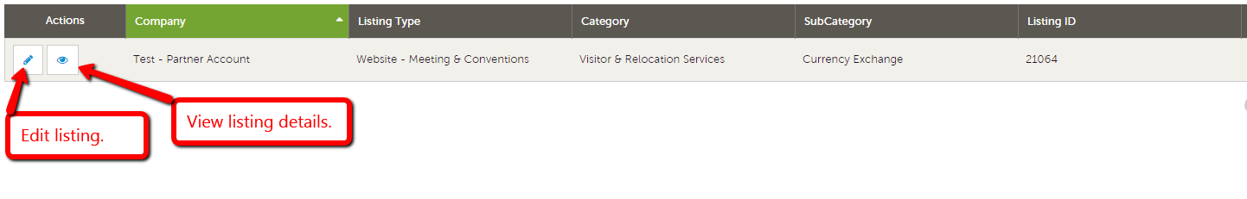
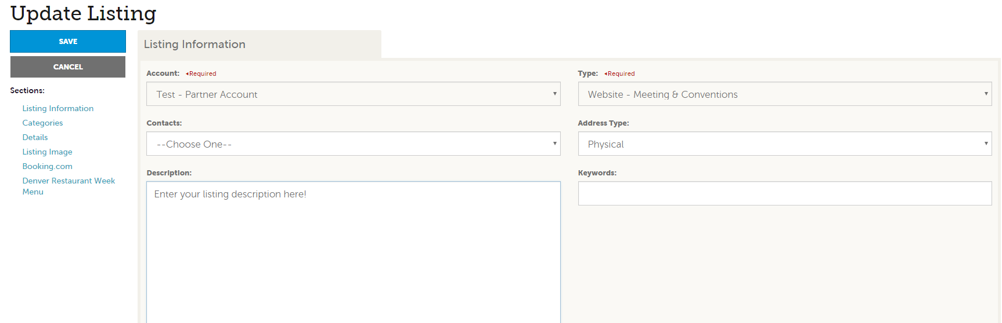

- Listing Details: This information will pull in from your Account Detail; however, by clicking the “Overwrite” radio button next to each field you may replace it with alternate text

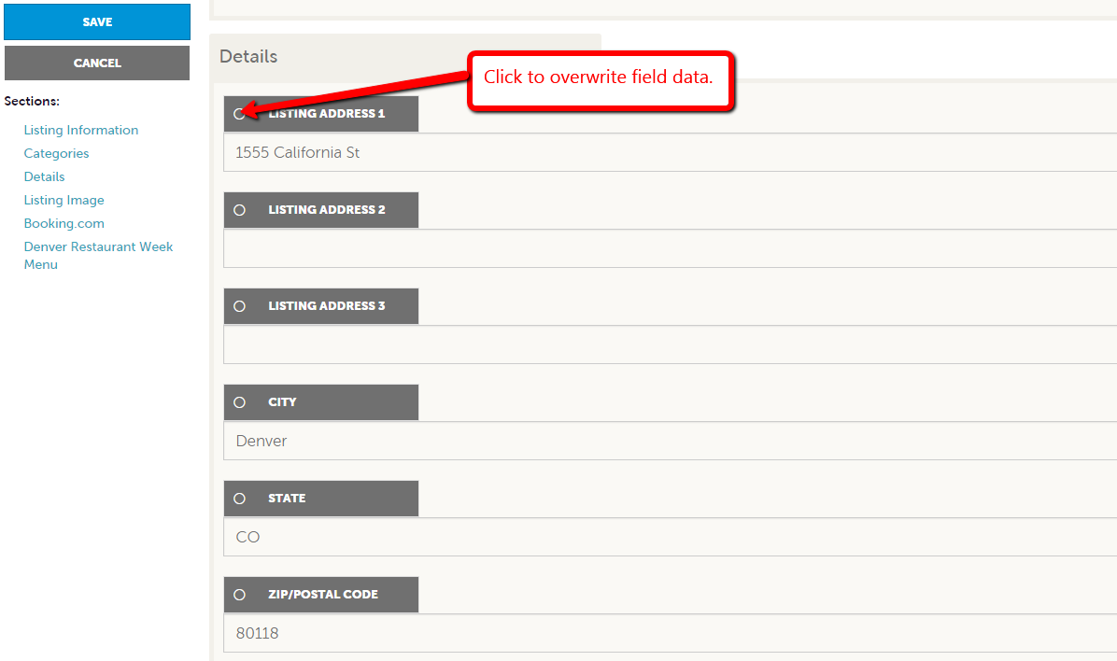

- Click the “Save” button when you are finished making any changes.
- Your changes will go into a pending status until a representative from VISIT DENVER approves them. You cannot alter a listing that is pending approval.
- When you return to your listing screen, you will be able to tell that your listing changes are pending by seeing that the far left pencil icon has turned into a clock icon.

