Extranet Instructions
Responding to and Viewing Leads

http://extranet.denver.simpleviewcrm.com

Reviewing Sales Leads:
- Once you are logged in, click on the “Opportunities” tab in the left hand area of your screen and click “RFPs”.
- Once inside the RFPs section you will see a grid of any leads that have been sent to your property. You can create your own filters to filter out any leads you do not want to see.
  - Status
    - Closed / No Bid Sent: the response due date is prior to today, and the property did not respond
    - Open: the lead is tentative, the response due date is either today or in the future, and property has not yet responded
    - Open / Bid Sent: the lead is tentative, the response due date is today or in the future, and the hotel responded as Pursuing
    - Turned Down: the property has responded as Not Pursuing
    - Closed / Decision Pending: the lead is tentative, the response due date is in the past, and the property responded as Pursuing
    - Closed / Lost to Another City: the Lead is Lost in CRM
    - Closed Cancelled: the Lead is Cancelled in CRM
    - Closed / Won: the Lead is Definite in CRM, and the property has been selected
    - Closed / Won - Properties TBD: the Lead is Definite in CRM, the property has not been selected, and the TBD Account is selected
    - Closed Lost: the property was not selected, and the TBD Account is not selected
  - Groups (Meeting, Tour, or Media)
  - Whether you have responded or not
  - Search for leads by Organization or Lead or Lead ID. Once your search term is entered, press tab on the keyboard and the results will be filtered
- You are able to sort your list of leads by clicking on any of the column headers (i.e. Meeting Name, Organization, etc)

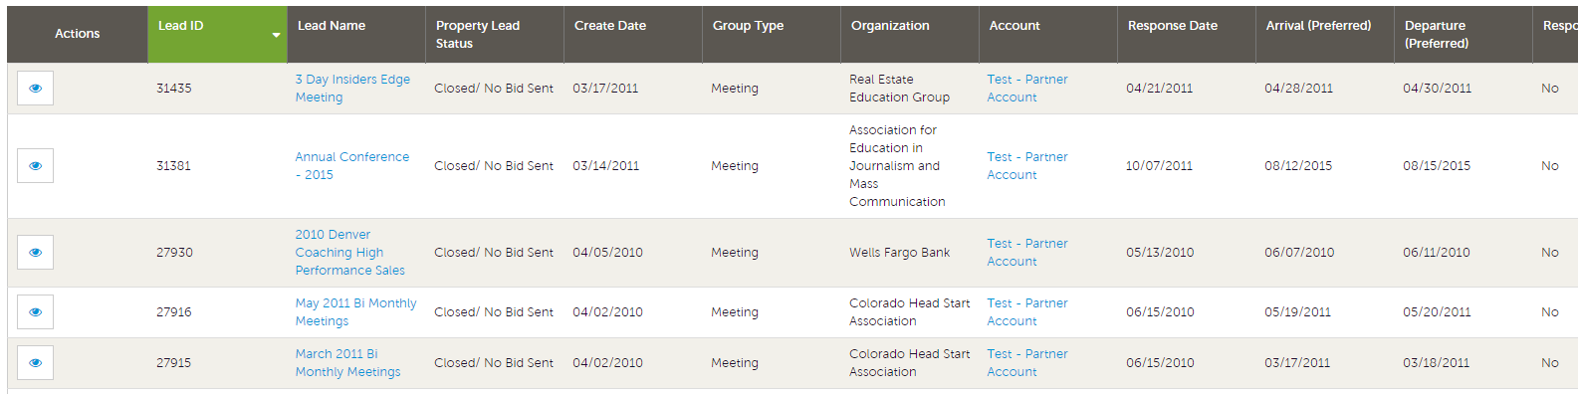

Assigning Leads:
If you are a Lead Catcher, you will be responsible for assigning a lead to your Sales Managers. To assign a specific lead, click the eye icon or lead name to get to the detail screen.

- In the detail screen, scroll to the Responses section.
- In the responses section you will see a field called Currently Assigned. Click the Assign link located in this field.

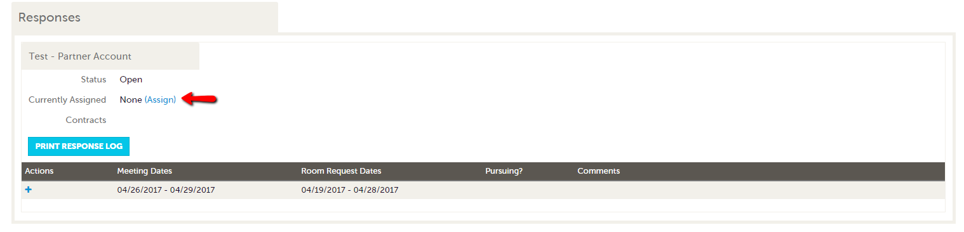

- A new window will open on the right hand side of the screen, select the Sales Manager that you would like to assign the lead to.
- Click Save. This will generate an email to the Sales Manager letting them know they have a lead assigned to them.
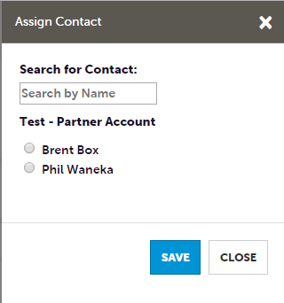

Viewing & Responding to Leads:
- Click on the eye icon or lead title to open the lead and scroll down to the responses section.
- Click the plus sign inside the responses section to create a new response.
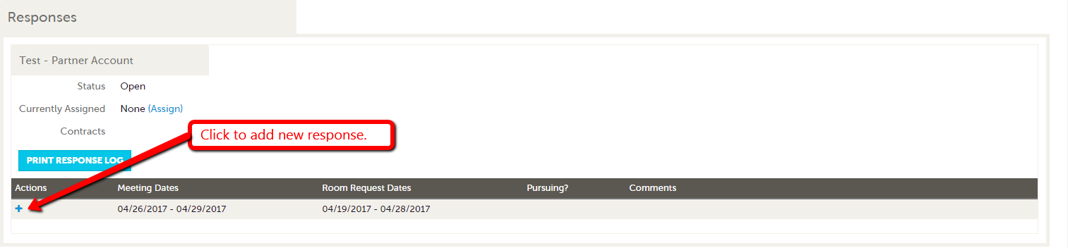
- Please note that the Hotel Response Date listed is your deadline to respond. Once this date has passed, you will no longer be able to respond to the lead online (or edit your response).
- If a client response is required, click on the client’s email address to send your response directly to the client (respond to the CVB online in addition to this response)
- If the lead has an attached RFP, it will be located in the File Attachments section. Simply click the file name to open/download it.
- Bureau Only Comments will only be seen by VISIT DENVER (the client will not see them)

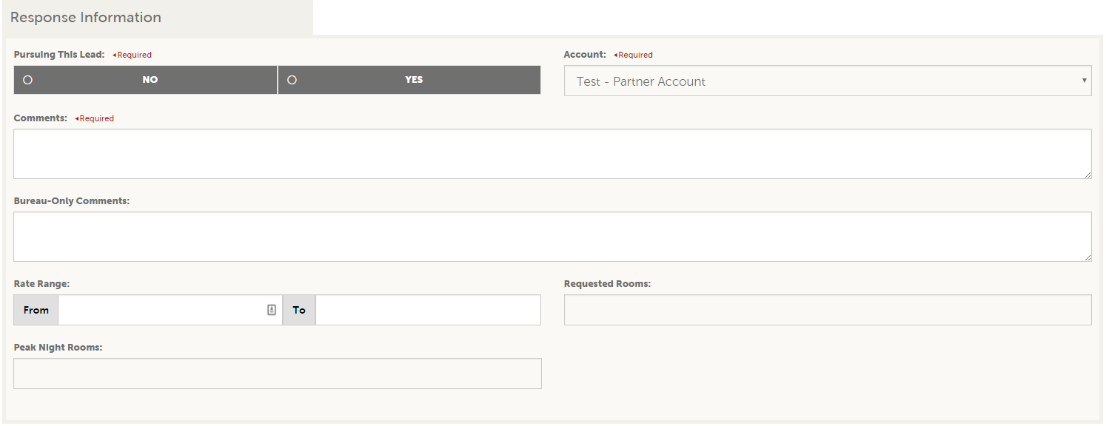

- Fill in any appropriate fields in the response information section.
- In the room information section enter the number of available rooms by type for each night of the block
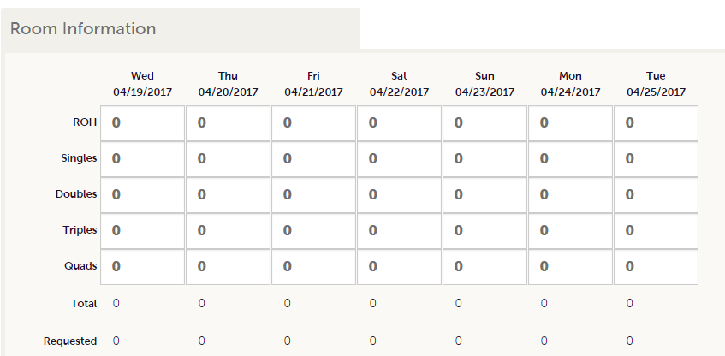
- Click Save! Once you click Save, an email is generated and sent to the Sales Manager at VISIT DENVER notifying them that you have entered a response.

Entering Pickup
- Once a meeting has been turned into Definite business, you will see a “Room Data” section at the bottom of the screen beneath the responses section.
- Click the Pickup link.
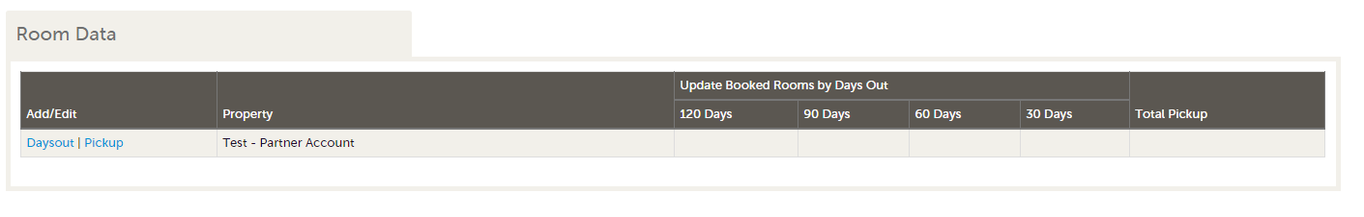3. After the meeting has taken place, you can enter the number of rooms you received from this meeting.
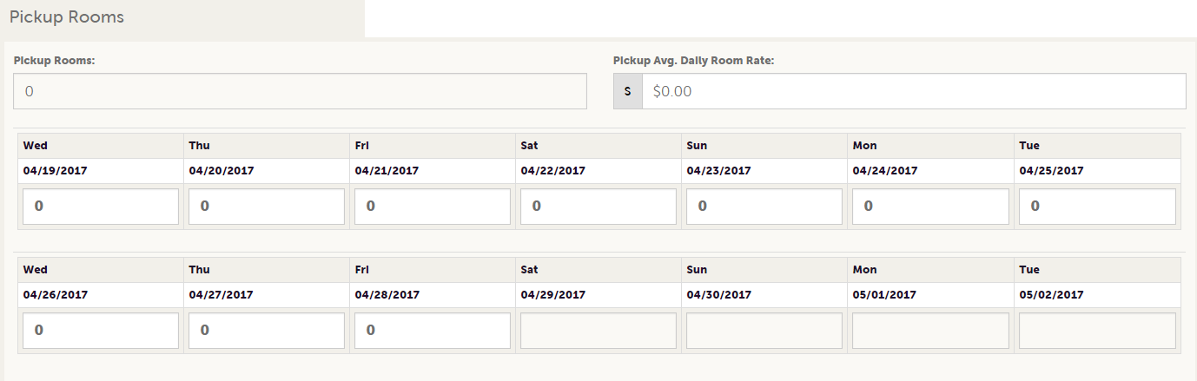

Entering Booked Rooms 30/60/90/120 Days Out
Properties that have been selected for a meeting sales lead can now enter their booked rooms leading up to the event date via the extranet.

Once a Lead has been updated to a "Definite" status the selected hotel properties will have the opportunity to enter the number of booked rooms 30, 60, 90, or 120 days out leading up to an event.

Select the lead you want to update by clicking its name or by clicking the eye icon in the actions column.

Navigate to the Room Data section on the lead and click the Daysout link to enter the 30, 60, 90 or 120 numbers.

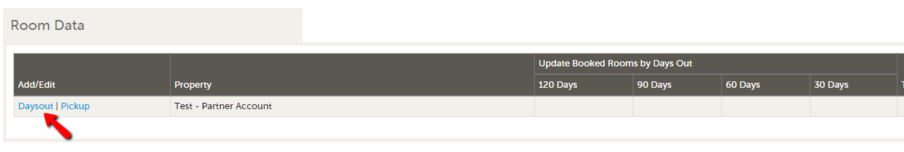

- Enter number of contracted rooms when the event is 30/60/90/120 days away from the contract start date.
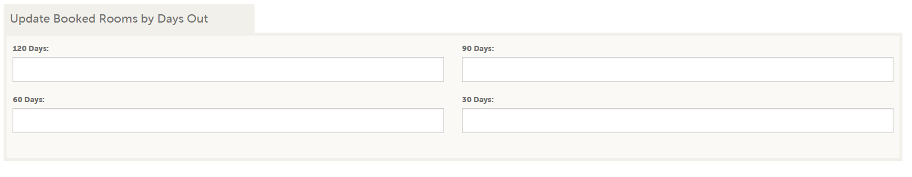
- Click Save!

