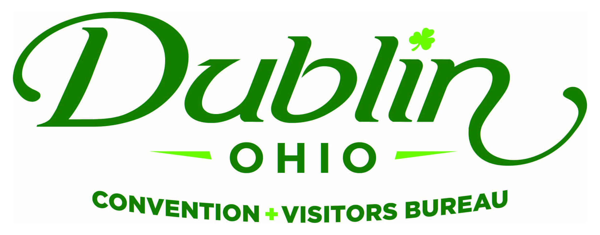
Board of Directors Meeting Minutes
August 13, 2018
Ohio University

Board Members Present: Phil Smith, Heather Baxter, Dr. David Lee, Michelle Crandall, Michael O’Malley, Craig Baldridge, Nichole Brinker, Bob Hoying, Pete Fingerhut, Dave Cecutti, Gerrilyn Rozich

Board Members Absent: Frank Willson, Eric Belfrage, Clay Rose, Amy Numbers, Orcun Turkay

Guests: Melinda Huntley, Ohio Travel Association; Charles Stuart, Hilton Garden Inn

Staff: Scott Dring, Pat King, Josh Bricker, Katie Rich

Board Action Items:

- Dr. David Lee made a motion to approve the August 2018 Consent Agenda, which included the June Board Meeting Minutes and July 2018 Financials. Gerrilyn Rozich seconded. All approved.
- Board to review draft of “Elevator Speech” and provide revisions/additions to Scott by Friday.

Detailed Minutes:

I. Welcome/Call Meeting to Order

- Welcome – Phil welcomed guests to Ohio University and the first Board Meeting of the fiscal year.

II. Consent Agenda

- Consent Agenda Approval – Dr. David Lee made a motion to approve the August 2018 Consent Agenda, which included the June Board Meeting Minutes and July 2018 Financials. Gerrilyn Rozich seconded. All approved.

- Financials – A summary of the financials for August 2018: Staff provided the financials earlier in the week as part of the Consent Agenda. Fiscal Year-To-Date bed tax revenue thru the month of June totaled $119,956 an increase of 4.4 percent over FY17 and a 0.8 percent increase vs. the YTD budget of $119,000. The current total in the checking and saving accounts after the month of July is $113,542. Account receivables total $3,950 due to the invoicing for the 2018 Destination Guide. It is the Bureau policy to have at least 15 percent of the overall budget for the reserve fund and the reserve fund balance stands at $200,000. Through July, total expenses year-to-date stand at 8.0 percent and the total income year-to-date stand at 9.1 percent. All account lines are where they should be at this point of the fiscal year. The Bureau’s Executive Committee reviews and the Finance Committee receives detailed financials on a monthly basis.

- 2018-19 Sales & Marketing Plan – Scott presented the results to date for the 2018-19 Sales & Marketing Plan.

III. Executive Committee Report

- Dublin City Council Finance Committee – Dublin City Council’s Finance Committee was scheduled to meet tonight to discuss the City’s Bed Tax, including its current allocation and commitments. That meeting has been postponed until a later date. Scott and Tim met with Finance Chair Mike Keenan several weeks ago and Mike asked that the Bureau offer an overview of the Bed Tax in general terms since the Bureau is a catalyst for the tax and monitors it on a daily basis. Scott is prepared to provide the presentation to the Finance Committee when that meeting is re-scheduled.

- Advertising Agency RFP – Scott noted that released an RFP searching for an agency to facilitate its Ohio and Regional Campaigns for FY19. A Selection Committee was created to review the submissions and select the agency. The Committee included Pete Fingerhut, Frank Willson, Michelle Crandall, Amy Numbers, Craig Baldridge and Ted Orr. Scott and Sara represented staff on the Committee. Three finalists were selected and each provided an oral presentation to the group. The Committee selected Destination Think!, which is an international agency specializing in destinations based in Vancouver. Craig, Michelle and Pete all provided insight into the process and agreed that Destination Think! was a unanimous choice. Staff will work with the agency to initiate the partnership this week.

- Elevator Speech – One of the tactics for the 2019-22 Strategic Plan was to create an “Elevator Speech” that would be used by Staff, Board and others to explain what purpose and value of the Dublin CVB to the local community. A draft of the copy was shared – “The Dublin Convention & Visitors Bureau is an economic driver for the City of Dublin that attracts jobs and visitor dollars. The Bureau utilizes a multi-faceted sales and marketing approach to attract visitors, conventions, sporting events and other travelers that eat at our restaurants, shop in our stores and visit our attractions. These efforts contribute to the quality of life and sense of place that all locals, visitors and businesses enjoy in Dublin. The Bureau puts people in our places, feet on our streets and heads in our beds.” Staff will seek any revisions from the Board and make appropriate changes before distributing the final version. Some of suggestions included to highlight an example of an event that the DCVB secured to Dublin, create one short version and one long version and customize the speech on the audience.

- Board of Directors Hotel Representative – Phil said that Tim Wolfe, hotel representative on the Board and General Manager at the Marriott NW, has taken another position in Denver. Michael O’Malley, General Manager at the Sonesta Suites, has replaced Tim on the Board. Mike provided some information on himself noting that he was born and grew up in Dublin.

IV. Executive Director Report

- Bed Tax 101 – Scott provided an overview of Dublin’s Bed Tax and its 30-year history. Some the key takeaways from the presentation included:

- Bed tax was created in the 1940s in New York City and goes by many names such as bed tax, city tax, transient tax, hotel tax, etc. The tax is used world-wide primarily to sell and market a city to visitors.
- Dublin’s bed tax was enacted in 1988 when there was one hotel – the Stouffers Hotel, which is currently the Crowne Plaza. There is a 6% Dublin Tax that has generated more than $52 million over 30 years. There is also a 4% Franklin County Tax that make Dublin one of the highest taxed visitor cities in the United States.
- Per the Ohio Revised Code, at least 25% of the tax much go to the local CVB. Although most municipalities provide the local CVB with a higher percentage. The average Ohio CVB receives 82% of bed tax and Dublin’s competitive set receives 88%. Scott shared some specific examples of cities and their bed tax allocation. The Bureau receives 35% of Dublin’s Bed Tax.
- Key factors that influence the bed tax are occupancy rates and average daily rates of hotels.
- Scott noted that the increased competition has been immense in the past few years in central Ohio – there is 7,137 new hotel rooms and 55 new hotels in the market between 2016-19. He said that sales and marketing efforts must continue and be aggressive to maintain and grow market share.

- USA Archery/Freedom Bowl – USA Archery hosted its National Championship in Dublin this past weekend. Josh shared a news clip from Channel 6 on the event. This was the second time in as many years that the Bureau, with collaboration from the City of Dublin, has secured this prestigious event. More than 500 archers participated in the four-day event that will attracted participants from across the world. The Bureau has secured several archery events over that past few years. Josh also noted that he is working with Dublin City Schools on a national football event called the Freedom Bowl that would feature 12 high school football teams from across the nation.

- Hotel Roadshow – Staff met with 13 Dublin hotels last week as part of staff’s annual roadshow. Scott said it provides a great opportunity for a brief, 30-minute meeting at each hotel with the sales team to learn what is new at the property and discuss goals for the next year. It’s an opportunity for the Bureau’s sales and marketing staff to visit each property and have a casual and open dialogue on how we can work together.

- 2019-22 Strategic Plan – Staff has implemented several initiatives in the Sales and Marketing Plan and FY19 Budget that will help execute the Bureau’s Strategic Plan. Some include the Elevator Speech, staff enrichment, increasing shoulder market business, etc. Staff will continue to keep the Board updated on the progress of the plan.

V. Guest Speaker – Melinda Huntley

Melinda provided information and updates on several legislative issues impacting the State of Ohio’s Tourism Industry. Her presentation is available upon request.

VI. Industry Roundtable/Other

Bob Hoying updated the Board on Bridge Park and the projected openings of several restaurants as well as the latest on the proposed arena. Highlights included: leased last office space above RAM, D Block has finalized a North Market concept instead of a grocery store, Fado will open next month, Hen Quarters in two months, Cap City is number one Cameron Mitchell restaurant, Springhill Suites hotel to be built. Dublin Fieldhouse continues momentum, will meet with city leadership in the coming weeks.

The group also discussed the proposed “Oasis” development in Delaware that includes up to 15 new hotels, restaurants, meeting space, etc. The site will be 10+ years to complete it at all was the consensus. The infrastructure will need to be enhanced greatly.

- Board of Trustees Meeting – Monday, October 8, Noon, Ohio University

“People in our places, feet on our streets, heads in beds”

