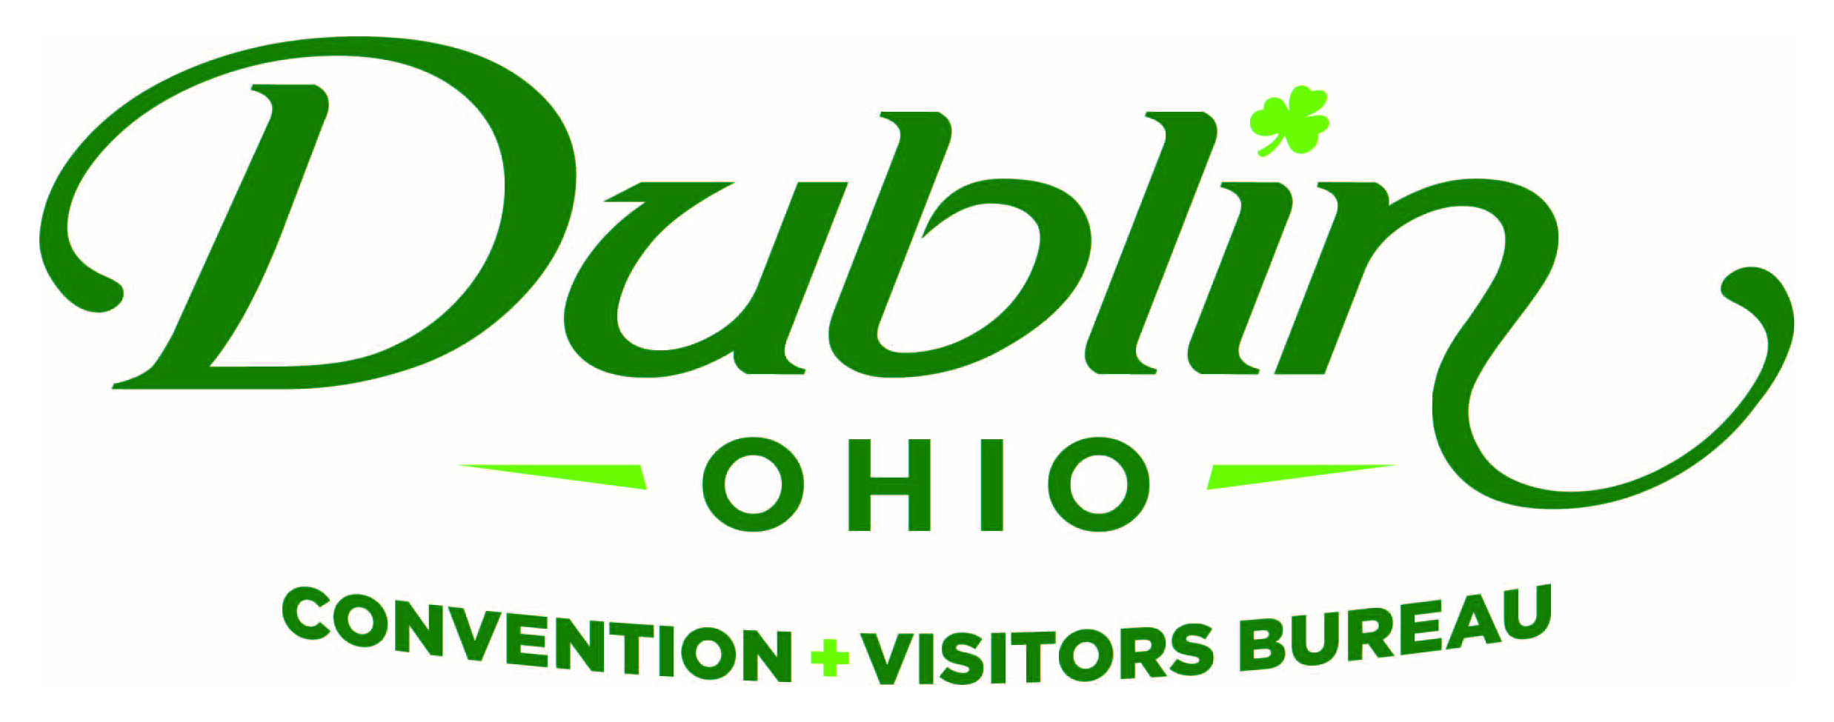
Board of Directors Meeting Minutes
February 12, 2018
Ohio University

Board Members Present: Phil Smith, Pete Fingerhut, Dave Cecutti, Gerrilyn Rozich, Frank Willson, Eric Belfrage, Nichole Brinker, Heather Baxter, Amy Numbers

Board Members Absent: Clay Rose, Bob Hoying, Sondra Kowaluk, Becky Miller, Craig Baldridge, Dr. David Lee, Michelle Crandall, Tim Wolfe

Guests: Tom Stalf, Columbus Zoo & Aquarium; Stephen Hawthorne, Crowne Plaza; Bo Bentele, Homewood Suites; Christina Kruse-Krupa, Holiday Inn Express;Tim Lecklider, Franklin County; Shelby Charles, Hilton Garden Inn

Staff: Scott Dring, Pat King, Allie Humes, Josh Bricker, Sara Blatnik, Katie Rich

Board Action Items:

- Gerrilyn made a motion to approve the Consent Agenda as presented. Dave seconded. All approved.

Detailed Minutes:

I. Welcome/Call Meeting to Order

- Welcome – Phil welcomed the Board and guests to the February Board Meeting.

II. Consent Agenda

- Consent Agenda Approval – Gerrilyn made a motion to approve the Consent Agenda, which included the December Board Meeting Minutes and January 2018 Financials. Dave seconded. All approved.

- Financials – A summary of the financials for February 2018: Staff provided the financials earlier in the week as part of the Consent Agenda. Fiscal Year-To-Date bed tax revenue thru December totaled $694,260, an increase of 4.48 percent over 2016 and a 2.1 percent increase over the YTD budget of $680,000. Staff provided the financials earlier in the week and the Executive Committee reviewed and discussed. The current total in the checking and saving accounts after January is $176,290.30. Account receivables total $60,000 due to the invoicing for 2018 partners. It is the Bureau policy to have at least 15 percent of the overall budget for the reserve fund and the reserve fund balance stands at $183,000. Through January, total expenses year-to-date stand at 51.9 percent and the total income year-to-date stand at 61.6 percent. All account lines are where they should be at this point of the fiscal year. The Bureau’s Executive Committee reviews and the Finance Committee receives detailed financials on a monthly basis.

- 2017-18 Sales & Marketing Plan Results – Josh provided results from the Group Tour Market. He noted that Group Tours (or Buses) usually hold 30-40 people. The Bureau has booked numerous tours this fiscal year including visitors from San Diego, Missouri, Pennsylvania, Indiana, Illinois and Ohio.

III. Executive Committee Report

- Mid-Year Results – The Bureau creates a Sales & Marketing Plan annually with nine measurable goals. Scott shared the progress of the goals through the first six months of the year. They included:

Organizational Measurements | Goal increase vs. 2016-17 | Mid-Year  Results
Increase unique website visits to www.visitdublinohio.com. | 20 Percent  (150,000 visits) | 60,570 Visits  (40% of Goal)
Increase Partnership Program revenue. | 10 Percent  ($70,000) | $68,650  (98% of Goal)
Secure partnership retention rate of the current 55 partners. | 93 Percent | Lost 13 Partners  Gained 13 Partners  (GOAL NOT ACHIEVED)
Increase social media reach for Facebook. | 15 percent increase  (1.5 million impressions) | 1.8 Million Impressions  (GOAL ACHIEVED)
Increase referral traffic to website from social media channels. | 20 percent increase  (14,000 sessions) | 11,826 Sessions  (84% of Goal)
Generate new, confirmed room nights. | 5,500 Room Nights | 2,401 Room Nights  (44% of Goal)
Generate qualified leads. | 150 Leads | 79 Leads  (53% of Goal)
Generate impressions through earned media. | 15 Percent  (7 Million Impressions) | 534,581 Impressions  (7% of Goal)
Generate impressions in key regional, feeder markets | 60 Percent  (4 million) | Regional Campaign to be Launched in April

Staff determined that outside assistance would needed in reaching the earned media goal of 7 million impressions. This type of work takes a lot of time and contacts and is best accomplished with outside help. Staff interviewed several Public Relations Firms and selected Belle Communications, which has developed an aggressive plan to generate media exposure in regional markets and in national media as well. The Bureau will work with Belle for the next four months and a future relationship will be determined at that time.

- STR Hotel Market Report – Scott provided an overview on the Smith Travel Research Hotel Report, which is what the Bureau uses to measure the hotel market’s overall occupancy rate, average daily rate, monthly and weekly patterns and other critical data that helps determine the Bureau’s overall sales and marketing strategy. For 2017, the Dublin hotel market’s occupancy rate was 69.5%, a decrease of 1% over last year; the average daily rate was $106.44, a decrease of 1% over last year.

- 2019-2022 Strategic Plan – Phil noted that staff successfully completed the 2015-18 Strategic Plan so the Board decided to begin work earlier than anticipated on the 2019-22 Strategic Plan. A survey has already been completed. The Strategic Planning Retreat will take place on Tuesday, February 13 from 2 – 5 p.m. at Brick House Blue. M.J. Clark from Integrated Leadership Systems will be the facilitator. Phil noted that M.J. will review the survey results and lead us on a discussion that will help shape the future of the Bureau. M.J. will take all the insight and create an easy-to-use 2019-2022 Strategic Plan with Strategic Initiatives, Tactics and Measurements. A draft of the plan will be completed by the end of March.

IV. Executive Director Report

- 2017 Annual Report – Staff showed the 90-second 2017 Annual Report video that can be viewed on the Bureau’s YouTube Page. Scott noted that video has received rave reviews and that it was shown to Dublin City Council during the Bureau’s Update in January.

- Celtic Cocktail Trail – Sara announced that the Celtic Cocktail Trail was officially launched on February 1. Scott noted that 19 media, bloggers and other influencers are in town as part of the Bureau’s launch. The results included the overall reach of 230,213 and social engagement 2,558. Several blog posts on the Trail included Drink Up Columbus, Columbus Foodie, 614Explored, Sweetly Cbus and Alicia Wanders. There are 11 local restaurants participating in the Trail, including RAM, VASO, Dublin Village Tavern, Matt the Millers, Tuccis, Bogey Inn, The Pint Room, 101 Beer Kitchen, J. Liu, Mezzo and Pins Mechanical.

- ShamROCKIN Grant Program – Scott briefed the Board on the new Irish Experience Grant Program. She noted that the recipients of the grants were determined last week. The new program will feature an “Irish Entertainment Series” offering local businesses the opportunity to host Irish music, dancers and other live performances throughout the year. Each month of the year will have one dedicated event. The calendar of concerts for each month will be released in the next few weeks – the Blarney Bash will be the site of the first concert on March 10.

- Regional Awareness Campaign – Staff received the initial strategy for the Bureau’s regional campaign from Fahlgren Mortine. The campaign will be released to the Board during its April 11 meeting at Muirfield Village Golf Club and will feature a mixture of digital and out-of-home media in Pittsburgh, Detroit, Indianapolis and Charleston/Huntington.

V. Guest Speaker

Tom Stalf, President & CEO from the Columbus Zoo & Aquarium, provided an overview of the Zoo and his vision for the future. Of note, his said the Zoo has a $100 million budget, 2,200 employees, 2.8 million guests annually. More than 56% of guests are members. There are a lot of new capital projects, including a new animal hospital, additions and lights at Zoombezi Bay, Adventure Cove, among others.

VI. Industry Roundtable/Other

- Board of Trustees Meeting – Wednesday, April 11, Noon, Muirfield Village Golf Club

“People in our places, feet on our streets, heads in beds”

