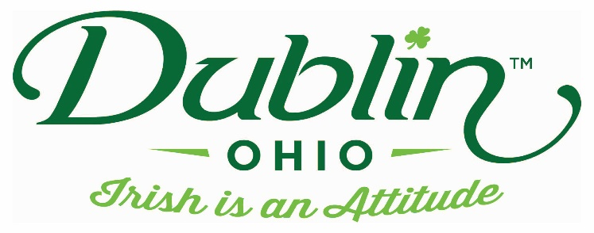

Experience Name: Irish Blessings to Take Home
Type of Experience: Storytelling/Hands on Activity
Length of Experience: 1 hour
Min. group number: No min. Max. group number: No Max
Cost: $150 for up to 25 ppl, then $2 pp after 25
Driver comp: Yes Escort Comp: Yes
Takeaway: paper bookmarks
Details: Author Cindy Thomson will discuss some Irish blessings, both those well known and some you may not have thought of. While researching her books, she has uncovered some Irish blessings and sayings that she’s quite fond of. Do some have deeper meaning? Are there specific blessings for your home, your pets, your journey? Let’s talk about some wee bits of Irish wisdom and wit, and then you can choose two to place on Irish bookmarks so you can take your blessings with you! Books will be available for purchase.
Parking Information: Depends upon location of Storytelling
Booking Information:
Contact – Cindy Thomson
Email – cindyswriting@gmail.com

Best “Day Of” Contact number
Phone – (614) 354-3904 (cell)

