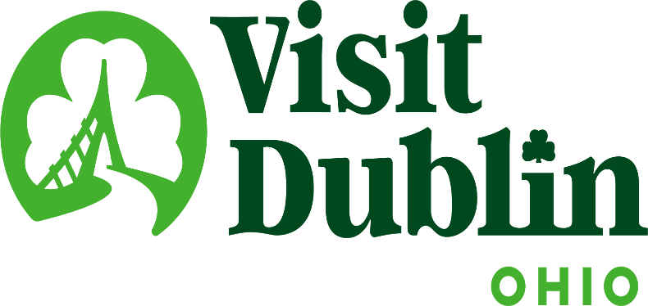
Executive Committee Meeting Minutes
January 15, 2025

Present: D. Cecutti, G. Rozich, C. Rose, J. Rexer, E. Belfrage

Absent: C. Baldridge

Staff: S. Dring

Executive Committee Action Items:

- Scott to email Dublin hotel general managers and director of sales positions seeking interest in filling the open Hotel Position on the Board.

Detailed Minutes:

I. Welcome/Call Meeting to Order

II. Financials

- Bed Tax Revenue – The November Bed Tax was $107,056 compared to $99,154 last November, an increase of 8 percent. The final 2024 Bed Tax was up 9.9 percent over 2023. The final budget surplus was $101,465.

- Balance Sheet – The current total in the checking and saving accounts through January 8 is $715,126. Account receivables total $35,700 – all related to the Partnership Program. It is policy to have at least six months of “hard” operating expenses for the reserve fund. The reserve fund balance stands at $332,114. To diversify, both CDs are located at separate banks – US Bank and Riverside Bank of Dublin. The US Bank CD matures on 1/21/25.

- Profit & Loss – Through January 8, total income year-to-date stand at 3.04 percent and the total expenses year-to-date stand at 3.43 percent.

III. Committee Discussion Items

- Board Structure / Hotel Positions – The committee reviewed the current Board Structure and discussed the opening for the position of Hotel Representative. Scott noted that there are two Hotel Representatives on the Board and they are elected to the Board by a vote of Dublin hotel general managers. The participation on the Board of General Managers has been minimal based on additional responsibilities placed on GMs. The Committee discussed several options moving forward with the Hotel board positions: 1) Keep as is and have local GMs vote two representatives on the Board; 2) Open the two positions up to Sales Directors at hotels as well as General Managers; 3) Reduce the representation of hotels from two to one board position and open up to both GMs and Sales Directors, which would free up a position for a Community Representative on the Board.

Scott to email Dublin hotel general managers and director of sales positions seeking interest in filling the open Hotel Position on the Board.

- President-Elect – The committee discussed possible options for the President-Elect position on the Board of Directors. President Cecutti’s position as Board President will end on December 31, 2025.

- Office Lease – The Visit Dublin lease at 9 S. High Street for its Visitor Center and Administrative Offices will expire December 2026. Currently, the administrative office has 1,850 sq. ft. for $13 per square feet and the Visitor Center has 398 sq. ft. for $30 per square feet. Scott completed research and is recommending that Visit Dublin remains at the current location and continue to search for ways to have a presence in Bridge Park in the future. Scott noted that the research indicated that the price point moving locations to Bridge Park was not feasible and that there would be some negative reaction from key stakeholders on moving from Historic Dublin. Scott also noted that the current location is more than adequate for the future needs of the organization. Based on research from like organizations across the nation, there has been a decrease in the amount of money and resources utilized for Visitor Centers in the post COVID era. There have been discussions with the North Market about a possible presence at that location in the future. Scott will present the findings to the full Board for discussion at its next meeting.

- President & CEO Goals – The Committee reviewed the President & CEO’s Goals for the past year. The following categories are utilized but specific metrics are revised annually depending on the current environment, needs of the organization and intentions of the Executive Committee.

Leadership

Will successfully ensure a positive work environment and properly manage Visit Dublin’s Board of Directors and subsequent committees.

- 2024 Metric – Obtain 100 percent approval rating as part of the Board of Director’s Survey relating to the performance of the President & CEO.
- 2024 Metric – Positive feedback from Staff based on feedback to the Board President.
- 2024 Metric – Continue leadership mentoring / succession planning for Sara Blatnik.

Positive Community Relations

Represent the Bureau in a positive and professional manner within the City of Dublin and Visit Dublin’s key stakeholders.

- 2024 Metric – Facilitate up to three presentations to Dublin City Council.
- 2024 Metric – Serve on at least three Dublin Community Boards and/or Committees further raising awareness and relevance of the organization.
- 2024 Metric – Develop and present funding options to the City of Dublin for the Athletic Complex at Darree Fields.

Financial
Oversee the financial stability and success of Visit Dublin.

- 2024 Metric – The final 2024 budget reaches the percentage of expenses to at least 75% for marketing purposes (industry average is 60% marketing, 40% administrative).
- 2024 Metric – Receive approval and positive reviews from the State of Ohio’s 2024 Audit.

Sales/Marketing
Execute the sales and marketing plan that helps to meet the organization’s overall mission and goals.

- 2024 Metric – Successful achievement of at least 6 of the 7 organizational measurements as noted in the 2024 Sales & Marketing Plan.

Funding
Oversight of the organization’s bed tax revenue and other sources of income.

- 2024 Metric – Maintain City Council’s bed tax allocation of 35 percent with effective, ongoing reporting of Visit Dublin results to Dublin City Council.
- 2024 Metric – Continue to build upon the “Corporate Sponsor” Program by renewing current partners and providing new leads for future partners.

The Committee was comfortable with continuing the current categories and Scott will provide specific metrics for each in the upcoming year.

IV. President & CEO Report

- SportsOhio Steering Committee – Scott updated the Committee on the City of Dublin’s purchase of SportsOhio. There has been two City of Dublin SportsOhio Steering Committee meetings. Scott is serving on the committee that also includes representatives from Dublin Youth Athletics, Dublin Soccer League, the Memorial Tournament, Columbus Sports Commission, the Chiller and various staff. Dr. David Lee and Dr. Bill Burke, former and current Board Members at Visit Dublin, are community representatives on the committee. The committee agreed that the goals of the committee are: 1) Financial sustainability through effective revenue generation, cost management, and strategic partnerships; 2) Community Engagement to foster strong community engagement by offering programs, events and activities that benefit the community and encourage participation; and 3) Economic impact to attract regional and national events and tournaments, driving tourism and stimulating local business growth. The Committee will be hearing presentations from two Management Companies to run SportsOhio – a selection will be made by the end of the month.

- Adrian Award – Visit Dublin’s the “Other Dublin” campaign has been recognized as one of the top travel marketing campaigns in the World! The campaign will receive an Adrian Award – this is equivalent to the “Oscars” in the industry competing against the likes of Disney, Marriott, Las Vegas, Paris, etc. Scott and Sara will be attending the awards gala in February with the agency and Lindsay from the City to accept the award.

- Shoulder Season Marketing – Staff continues to be very aggressive in marketing the City during “shoulder seasons” (winter and fall). A unique campaign has been created to sell the city this winter called “Love in Dublin.” The campaign features a quiz that residents and visitors take on their ideal romantic day and then Visit Dublin provides them with a Dublin itinerary that matches their interests. There is also a romantic getaway package offered for those that participate. There have already been 53,000 couples signed up for the contest in just two weeks.

- Staff Presentations – Scott noted that staff are often asked to present to various organizations throughout the year. Just this month, Scott is teaching classes for the Ohio Tourism Leadership Academy, the Young Professionals Club as part of the City of Dublin tour and others. Sara is speaking to an organization on Bridge Park and new product being developed in the future.

- Everything Dublin Merchandise – The vendor for the City of Dublin’s and Visit Dublin’s online merchandise store (Shout Out Loud) went out of business in December. The City and Visit Dublin hired Zilla in Dublin to fulfill the needs of the “Everything Dublin” merchandise store.

V. Other

- Board Meeting – Monday, February 10 @ noon, Emerald Campus

- Executive Committee Meeting – Wednesday, March 12 @ 4 p.m., Gallo’s Tap Room

“Visit Dublin enhances the Quality of Life for residents by attracting visitor spending, consumer interest and entrepreneurial investment into the community.”

