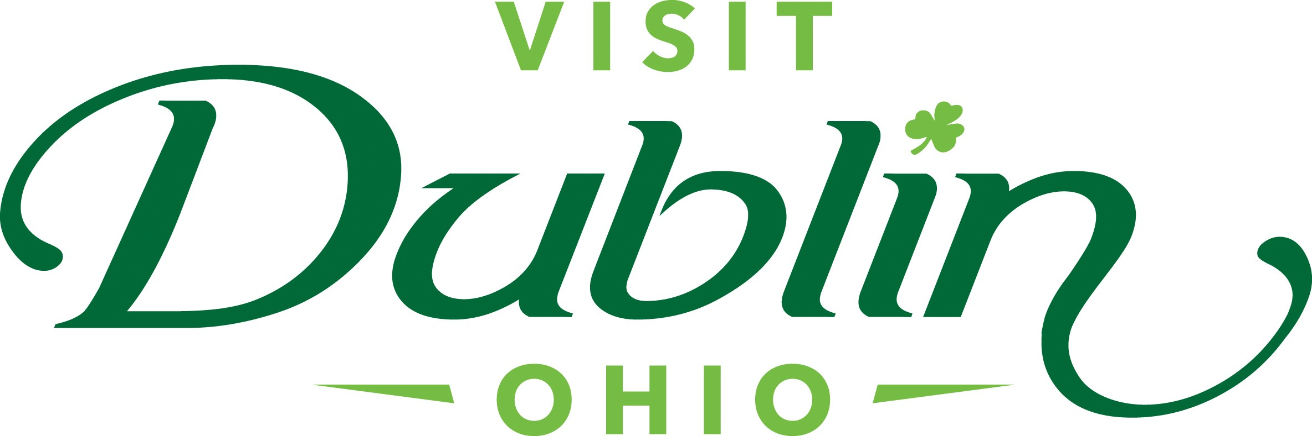
Executive Committee Meeting Minutes
July 10, 2024

Present: D. Cecutti, J. Rexer, C. Rose, C. Baldridge, E. Belfrage

Absent: G. Rozich

Staff: S. Dring

Executive Committee Action Items:

- Jessica Rexer made a motion to approve the meeting minutes for the May 2024 meeting. Dave Cecutti seconded. All approved.

Detailed Minutes:

I. Welcome/Call Meeting to Order

- Approval of May 2024 Meeting Minutes – Dave welcomed the group to the July Executive Committee Meeting. Jessica Rexer made a motion to approve the meeting minutes for the May 2024 meeting. Dave Cecutti seconded. All approved.

II. Financials

- Bed Tax Revenue – The May Bed Tax was $119,313 compared to $131,733 last May, a decrease of 9.4 percent. Bed Tax year-to-date is up 9.1 percent over the same period in 2023. There is a current budget surplus of $28,828.

- Balance Sheet – The current total in the checking and saving accounts through July 2 is $506,128. Account receivables total $2,200 – all related to the Partnership Program. It is policy to have at least six months of “hard” operating expenses for the reserve fund. The reserve fund balance stands at $322,359. To diversify, both CDs are located at separate banks – US Bank and Riverside Bank of Dublin. The US Bank CD was extended through 1/21/25. The CD generated $7,798 during the last 9-month term.

- Profit & Loss – Through July 2, total expenses year-to-date stand at 54.6 percent and the total income year-to-date stand at 34 percent. The gap between the expenses and income is primarily due to the costs incurred from the Regional Campaign and the Website Redesign, which were recorded at the start of the year. New income and expense line items have been created to accurately track the new Everything Dublin Merchandise Store. To date, the additional revenue from the store is $2,558.

III. Committee Discussion Items

- New Board Member Orientation –The Committee discussed the inaugural Board Orientation session provided virtually by Bill Geist. Scott noted the feedback he received was very positive with Board Members commenting it was informative and helpful to assist with their roles. The Orientation will be offered once a year. Scott noted that the initial strategy was to offer the orientation in two parts with Bill providing a very high-level perspective and then Scott providing more of a Dublin-specific view. Scott will schedule the second virtual call for the fall.

- Sports Ohio Acquisition / Committee – Scott noted that the City of Dublin purchased SportsOhio. The purchase includes three parcels at the price tag of $44.6 million. This will not only be a tremendous amenity for Dublin residents, but the acquisition provides a tremendous economic development opportunity and aligns with our vision for future athletic facilities. Much more to discuss in the future but I’ve already had in-depth conversations with the City Manager, and we will have a seat at the table for discussions on the future development of the purchased land. Scott will serve on a committee created by the City that will provide input on how the property should be used for recreational purposes. The Committee will also include representatives from Dublin Youth Athletics, Dublin Soccer League, the Memorial Tournament, Columbus Sports Commission and others.

Dave noted that he would like to create a Visit Dublin Committee to help develop a strategy and provide insight and direction for staff to proceed. Dave will be contacting a few Board Members in the next few weeks to ask them to serve on the committee.

- Strategic Alliance Future – Scott noted that ground was broken back in 2015 for the Bridge Park development and historic Dublin restaurants, shops and attractions were very apprehensive and not supportive – there quickly became a Us vs. Them mentality. Visit Dublin always believed that a high tide would raise all boats and everyone would benefit from the new development. In an effort to unify everyone for the greater good and eliminate the friction between Bridge Park and Historic Dublin, Visit Dublin created the Downtown Dublin Strategic Alliance that would bring all sides together for a common goal of marketing the area as one destination vs. two destinations. Received buy-in from the Visit Dublin Board, City of Dublin, Crawford Hoying (representing Bridge Park), Historic Dublin Business Association, Dublin Historical Society and the Arts Council. The initial goal was to “create and implement a cohesive and strategic sales and marketing plan with the ultimate goal of attracting visitors and economic growth to the area.” Visit Dublin then retained a strategic marketing agency (The Peebles Group) at the cost of $25,000 to create an aggressive sales and marketing strategy that would serve as a roadmap.

Visit Dublin continues to lead the group and Sara has done a great job representing Visit Dublin. There has been great success over the past 8 years with numerous collaborative efforts, such as Pub Crawls, marketing campaigns, creation and support of DORA among others. Organizations have asked to be part of the Alliance and the Dublin Chamber of Commerce was added several years ago.

Over the years, City Leadership has inquired about the Alliance taking more of a formal role and expanding its initial goal of selling and marketing the area. Staff even researched with the city on creating a Special Improvement District (SID) as a funding source. With Dublin City Council’s goal of being a destination of choice for world-class events and the recent push to activate Riverside Crossing Park, there is initial discussion on the Alliance taking a role in creating and managing events.

IV. President & CEO Report

- City Leadership Tour – The City of Dublin leadership team, which consists of 35 staff members, meets several times a year as a group to discuss various items. For its next meeting in the fall, the city asked that Scott present an overview of Visit Dublin and provide the team with its Hospitality Bus Tour. The popular tour begins in Downtown Dublin (Shoppes at River Ridge) with brief stops at the Columbus Zoo, Bridge Park and other attractions. The goal of the tour is to educate attendees on all the great things visitors can experience in the city. Missy and Scott will customize the tour to fit the needs of the city staff and will be a great opportunity to further raise awareness of Visit Dublin to this key audience.

- Destinations International National Conference – Scott, Sara and Missy will be attending the annual Destinations International Conference next week. The Conference focuses on education and networking with DMO colleagues from across the world and a great opportunity to further learn best practices for the organization. Missy has been asked to participate in a session on how Visitor Centers have evolved over the past 10 years. Missy will share the success of the Dublin Visitor Information Center and the unique strategies used to engage both visitors and residents.

- Dublin Irish Festival – Staff is working with the City of Dublin on several initiatives to help market and sell the Dublin Irish Festival – staff will be hosting 5-7 influencers from across the state during the festival and is marketing its annual Dublin Irish Festival Package. The package features several hotels with an offer of free tickets and swag bag. Last year, there were more than 200 packages sold. Staff will also be hosting a reception in Downtown Dublin on Thursday, August 1 before the Festival’s 5K Race. It will be an Open House format between 5 – 8 p.m. The race starts at 7 p.m. and there will be entertainment in our parking lot afterwards. Invites include the Board, City Leadership, Partners, Hoteliers and other key stakeholders.

- Trail Experiences – Staff continues to build upon its successful Pass Program with the addition of the new Art in Public Places Pass last month. Partnering with Dublin Arts Council, the public art pass that encourages visitors and residents to explore must-see public art installations and redeem points to win a public art sticker pack created by local artist Bryan Moss. The Art pass is the third Dublin-based experience pass created by Visit Dublin and available to residents and visitors. The first pass, the Celtic Cocktail Trail, leads users to 17 different Dublin bars and restaurants to sample Irish-themed cocktails and redeem exclusive discounts and offers. Complete three stops to win a commemorative koozie and 10 stops to win a Celtic Cocktail Trail t-shirt. The Dublin Park Pass in partnership with OhioHealth was launched two years ago and serves as a resource and guide to Dublin’s 60+ parks. Users can find which parks have common amenities like playgrounds and restrooms along with Dublin’s unique park attributes like historical assets and waterfalls. The 2024 pass will offer a belt bag prize with sunscreen and suncare information from OhioHealth. All passes are fully digital and delivered via text and email upon sign up. They can be saved directly to the home screen of any smartphone for easy access. This year, the three digital passes collectively have nearly 3,000 passholders.

V. Other

- Executive Committee Meeting – Wednesday, August 7 at 4 p.m., Fado

- Board Meeting – Monday, August 19 at noon, Dublin Library

“Visit Dublin enhances the Quality of Life for residents by attracting visitor spending, consumer interest and entrepreneurial investment into the community.”

