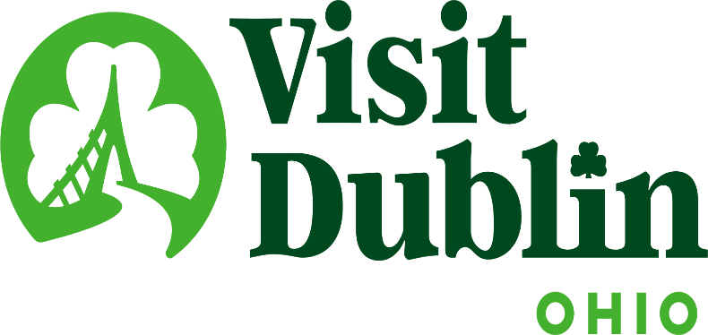
Executive Committee Meeting Minutes
July 16, 2025

Present: D. Cecutti, G. Rozich, B. Clark, C. Baldridge, E. Belfrage

Absent: C. Rose, J. Rexer

Staff: S. Dring

Executive Committee Action Items:

- Gerrilyn Rozich made a motion to approve July’s Executive Committee Meeting Minutes. Betty Clark seconded. All approved.
- The Executive Committee directed Scott to reach out the Crawford Hoying to inquire about lease opportunities based on the proposed rate increase from the current landlord at 9 S. High Street.
- Scott to provide information to the Executive Committee on best practices of how Destination Marketing Organization’s Board of Directors review their President & CEO via a Committee Structure.

Detailed Minutes:

I. Welcome/Call Meeting to Order

II. Financials

- Bed Tax Revenue – The May Bed Tax was $154,746 compared to $119,313 last May, an increase of 30 percent. Bed tax year-to-date is up 10 percent vs. the same period last year. There is a current budget surplus of $48,745.

- Balance Sheet – The current total in the checking and saving accounts through July 1 is $521,009. Account receivables total $1,402 – all related to the Partnership Program. It is policy to have at least six months of “hard” operating expenses for the reserve fund. The fund balance stands at $346,035 and held within two CDs. To diversify, CDs are located at separate banks – US Bank and Riverside Bank of Dublin.

- Profit & Loss – Through July 1, total income year-to-date stands at 33.5 percent and the total expenses year-to-date stand at 53.5 percent.

III. Committee Discussion Items

- Lease Extension – The Visit Dublin lease for both the Administration Offices and Visitors Center expires in December 2026. Scott contacted the landlord, and he has provided a proposal which includes a 23 percent increase for the Visitor Center and a 40 percent increase for the Administration Offices. The proposal also includes a 3 percent annual increase. In terms of price, the total annual expense (excluding CAM charges) is $36,915 and the new annual price is $49,876, plus a 3 percent increase.

Scott noted that he has spoken with several agents and market experts and feedback is that the "market rates" proposed by the landlord are high for our building compared to a new building at Bridge Park. Visit Dublin’s building is 26 years old and is showing some age. Visit Dublin should not worry too much about the first floor with that space being so small the rate per square foot is not that relevant. It is common for landlords to ask for 3 percent annual bumps, but that was when inflation was higher.

With that said, Scott is recommending the following counter proposal: Accept the first floor at the proposed $37psf (currently $30); recommend a $16psf vs. the proposed $19psf and a 2 percent annual increase; propose a 5-year lease extension. Also, note that Visit Dublin is not asking for any improvement dollars and are unrepresented in this transaction which both save the Landlord money. The committee discussed and determined to complete additional research prior to responding to the landlord.

The Executive Committee directed Scott to reach out the Crawford Hoying to inquire about lease opportunities based on the proposed rate increase from the current landlord at 9 S. High Street.

- Compensation Committee (President & CEO) – Per Destinations International, the umbrella organization for DMOs, there are three major Board of Directors functions: 1) Financial Oversight; 2) Having influence serving as advocates and champions of the organization; 3) Hiring and reviewing the President & CEO. Scott provided some historical perspective on hiring and reviewing the President & CEO noting that there was a Compensation Committee that included the Executive Committee with the goal of reviewing all aspects of the position. When COVID arrived, the committee disbanded and those responsibilities were given to the Board President with assistance from the Past President and President-Elect. Based on several factors, staff is recommending returning to the previous model. The factors include that Visit Dublin’s international accreditation mandates the action as industry standards, transitioning to Betty as President in 2026 and succession planning. Scott noted that Dr. Lee, Gerrilyn and Dave have done an amazing job but taken on too much of the burden in the past few years post COVID.

Scott said the goal of the Board President is to manage Board Meetings and lead the process of reviewing the CEO by compiling comments, feedback, goals, etc. and then the compensation committee discusses the final review including merit increases.

Scott to provide information to the Executive Committee on best practices of how Destination Marketing Organization’s Board of Directors review their President & CEO via a Committee Structure.

- Strategic Planning – The Board will continue to build on the momentum created by developing the 2026–2028 Strategic Plan. Longtime facilitator, Bill Geist, will be returning to guide the process. Scott said that thanks to the Board’s significant groundwork completed during the last Strategic Plan, where it established the mission, vision, and purpose, this session will focus exclusively on refining our primary strategic goals. The meeting will take place on Friday, September 19 at 9 a.m. – noon at VASO. Scott thanked Deniz and his team for hosting us.

- 2026 Board Candidates – Scott provided an update on filling the two anticipated openings on the Board in 2026. The Board directed staff to determine the interest from Jennifer Reimer, OhioHealth, who is very interested. Scott also spoke with Emily Sandman from Cardinal Health and they would like to continue the tradition of having someone to serve on the Board. Emily will provide names later this summer.

IV. President & CEO Report

- Partnership Program – Based on feedback from the Executive Committee, staff has increased the based partnership fee to $500 from $300 annually. Staff sent a notice of the increase to all of its partners and there was no negative feedback. It is the first increase in 8 years. The Organization current has 85 partners and 7 corporate partners that this year will generate a record of $66,750 with the goal of reaching $80,000 in 2026.

- SportsOhio Master Planning – The City of Dublin continues to work on the management agreement with Sports Facilities Companies (SFC). The company is in Dublin this week for a variety of meetings as it orients itself to the community. Visit Dublin staff are participating in the majority of meetings, including marketing, sales, PR, community relations, tournaments, event booking, sponsorships and with the Steering Committee. Visit Dublin staff continues to aggressively market the new facility through generating new leads via trade shows and ongoing marketing efforts.

- Audit / Re-Accreditation – Scott noted that there will be two major administrative projects for 2026, including a full audit and accreditation with Destinations International.

- Zoombezi Bay Board of Directors – Columbus Zoo CEO Tom Schmid has appointed Scott to the Columbus Zoo’s Zoombezi Bay Board of Directors. The Board consists of four regional leaders with the term starting this month. Looking forward to continuing our great partnership with Tom, Nicolle and the entire Zoo team. Scott noted that it has been a goal the past few years to grow the partnership with the Columbus Zoo as a result of the aftermath of the Pete Fingerhut criminal case. He noted that the partnership has never been stronger.

V. Other

- Board Meeting – Monday, August 11 @ noon, Dublin Library

- Executive Committee Meeting – Wednesday, September 10 @ 4 p.m., Shawnee Station

“Visit Dublin enhances the Quality of Life for residents by attracting visitor spending, consumer interest and entrepreneurial investment into the community.”

