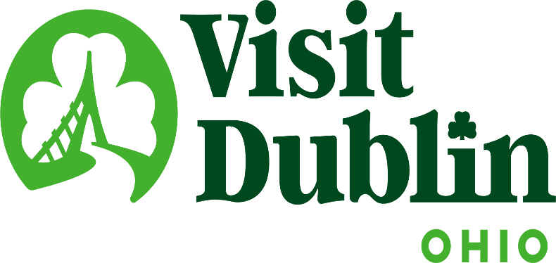
Executive Committee Meeting Minutes
March 12, 2025

Present: D. Cecutti, G. Rozich, C. Rose, C. Baldridge

Absent: E. Belfrage, J. Rexer

Staff: S. Dring

Executive Committee Action Items:

- Dave Cecutti made a motion to approve January’s Executive Committee Meeting Minutes. Gerrilyn Rozich seconded. All approved.

Detailed Minutes:

I. Welcome/Call Meeting to Order

II. Financials

- Bed Tax Revenue – The January Bed Tax was $80,905 compared to $72,175 last January, an increase of 12 percent. Bed tax year-to-date is up 13 percent vs. the same period last year. There is a current budget surplus of $17,850.

- Balance Sheet – The current total in the checking and saving accounts through March 4 is $700,312. Account receivables total $23,100 – all related to the Partnership Program. It is policy to have at least six months of “hard” operating expenses for the reserve fund. To meet this policy, an additional $10,000 was added to the reserve fund. The fund balance stands at $346,035 and held within two CDs. To diversify, CDs are located at separate banks – US Bank and Riverside Bank of Dublin.

- Profit & Loss – Through March 4, total income year-to-date stands at 9.07 percent and the total expenses year-to-date stand at 16.86 percent.

III. Committee Discussion Items

- Board Composition & Expertise Overview – Scott shared results from a Board Composition & Expertise overview that will help in selecting future Board Members. The overview included an inventory of board skills, business sectors and demographics. The committee agreed there is a good balance in regard to the skills and business sectors on the Board and that some work could be done addressing diversity.

- 2026 Board Candidates – President Cecutti’s role as Board President will expire at the end of 2025. The committee discussed potential candidates for the opening -- Betty Clark and Jessica Rexer have shown an interest in serving as Board President next year and beyond. Betty’s term as Dublin City Council Representative expires on May 31 but is eligible to fill a Community or At-Large Representative position on the Board. Scott noted that both would be fantastic leaders of the organization. The committee will discuss at the next Executive Committee Meeting.

- Local Relevancy, Visibility Efforts – Staff continues to work on one of the organization’s strategic initiatives to raise Visit Dublin’s profile and relevancy locally to Dubin residents. Details are being finalized for Visit Dublin to be the exclusive and presenting sponsor of the newly created Music Wednesdays, which is part of the City of Dublin’s Summertime Series. The series is aimed at activating Riverside Crossing Park and includes music, movies and exercise to be held May – August. Scott noted that Visit Dublin will be able to “own” the music series and staff is working on additional tactics to leverage the sponsorship. Staff is also discussing ways to have a presence at the Farmers Market at Bridge Park.

- SportsOhio – The SportsOhio Steering Committee concluded its work with the recommendation that Dublin City Council direct city staff to negotiate and formulate a Management Agreement for SportsOhio with Sports Facilities Companies (SFC) – Dr. Burke and Scott served on the committee. It was unanimous among the committee that SFC was the best choice. From a Visit Dublin perspective, Scott said staff are excited about the selection of SFC since they are viewed as the very best in the nation at managing athletic facilities. In fact, SportsEvents Media Group's Reader’s Choice Awards just named its annual Top 10 U.S. athletic facilities - The Sports Facilities Companies manages 7 of the Top 10. After city Staff completes negotiations with SFC, Visit Dublin will quickly begin its collaboration with SFC and the City to ensure the facility is one of the best in the nation for Dublin’s residents and visitors.

Scott noted that he is serving on a panel discussion at Dublin’s State of the City that will discuss the SportsOhio purchase and initiative. The event will be held Thursday night.

IV. President & CEO Report

- Insurance Policies, 990 Taxes – Scott updated the Committee on the various insurance policies that is needed for the organization on an annual basis. Policies include Liability for the office and Visitor Information Center; D&O (Director & Officer) for the Board of Directors and a ERISA Fidelity Bond for the organization’s 401K Program. Staff successfully completed its 990 Tax Form for 2024 and it was submitted by PW & Partners. Next year will be a full audit year for Visit Dublin.

- Corporate Sponsors – Staff successfully secured its 7th corporate sponsor with the addition of Mount Carmel Dublin, which will be the presenting sponsor of the annual Voters’ Choice Awards. Scott noted that the cost for the annual sponsorship was $7,500 and that staff will be re-evaluating pricing structures for 2026.

- St. Patrick’s Day – Visit Dublin markets and sells Dublin’s St. Patrick’s Day festivities year-round helping to position the City of Dublin on the global stage, a sampling of efforts that staff is focusing on this week that will not only generate awareness but economic impact for the City as well, include:

- The Luckiest Pat – Patrick Klinger will serve as Visit Dublin’s inaugural “Luckiest Pat.” Nearly 300 Pats were nominated for the designation that offered a VIP experience, including a hotel stay, Irish Festival/Zoo tickets, dining and spot in Dublin’s St. Patrick’s Day Parade. Good Morning Columbus show featured the campaign last weekend.
- Bus Tours – Staff attracted six Bus Tours from Ohio, Indiana, Michigan and Illinois to enjoy the St. Patrick’s Day festivities and spend money in the city.
- Fairy Door Trail – The Trail is back with 11 locations in Downtown Dublin. More than 10,000 participants have enjoyed the Trail spending money at participating Dublin businesses.
- Celtic Cocktail Trail – The 2025 Celtic Cocktail Trail features 18 local bars and restaurants offering unique, Irish-themed cocktails and exclusive discounts.
- Pub Crawl – Held on Saturday in Downtown Dublin, the St. Paddy’s Pub Crawl offers specials, entertainment and prizes for those that complete the Pub Crawl Passport.
- Visitor Inquiries – Our email, phone requests and Visitor Center are at a fever pitch answering all types of questions from residents and visitors.
- Media Relations – Proactively market Dublin and St. Patrick’s Day to media across the globe. Staff will be a live guest on Good Morning Columbus several times on Saturday.
- Social Media – Leading up to and during St. Patrick’s Day, our Marketing Team promotes all aspects of the events and the City on all social media platforms.
- Hospitality Industry – We’ve made sure all our hotels, restaurants and attractions have a full supply of Destination Guides and other collateral promoting the city.

- Elected Officials – Scott and Jeff Kasler met with newly elected Ohio Representative Crystal Lett last week. She was very educated on Visit Dublin’s mission and past successes. Scott noted he will be traveling to Washington, DC in a few weeks as part of the travel and tourism industry’s national lobbying efforts with federal officials.

- Scott’s Business Travel – Scott will have several business trips in the next few weeks, including Destinations International’s CEO Forum, US Travel’s Destination Capital Hill and ETourism Marketing Summit.

V. Other

- Board Meeting – Wednesday, April 9 @ noon, Muirfield Village Golf Club

- Executive Committee Meeting – Wednesday, May 14 @ 4 p.m., VASO

“Visit Dublin enhances the Quality of Life for residents by attracting visitor spending, consumer interest and entrepreneurial investment into the community.”

