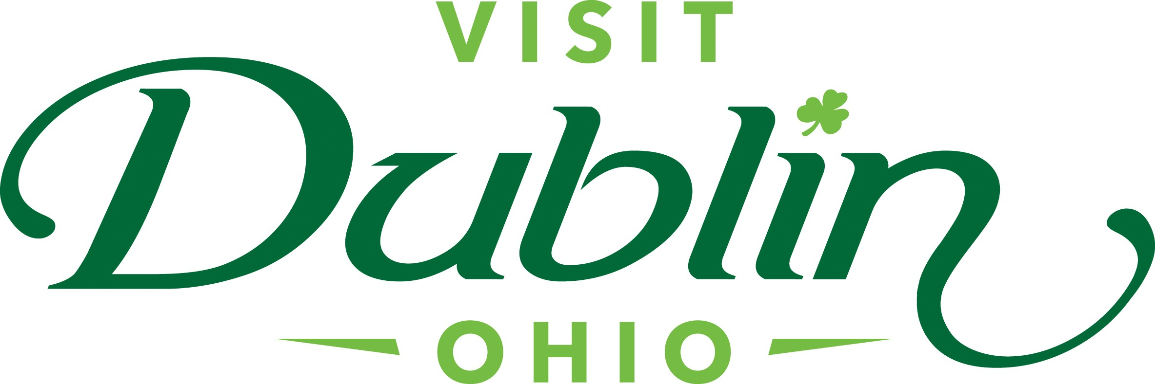
Executive Committee Meeting Minutes
May 8, 2024

Present: D. Cecutti, G. Rozich, J. Rexer, E. Belfrage, C. Rose, C. Baldridge

Absent: None

Staff: S. Dring

Executive Committee Action Items:

- Gerrilyn Rozich made a motion to approve the meeting minutes for the April 2024 meeting. Jessica Rexer seconded. All approved.
- Scott to finalize the new Board Orientation budget and timeline with Bill Geist this week and present it to the Board at its June meeting.
- The Committee directed that Visit Dublin’s attorney cease all negotiations with the legal firm requesting compensation for the Copyright Image claim in the amount of $2,750.

Detailed Minutes:

I. Welcome/Call Meeting to Order

- Approval of April 2024 Meeting Minutes – Dave welcomed the group to the May Executive Committee Meeting. Gerrilyn Rozich made a motion to approve the meeting minutes for the April 2024 meeting. Jessica Rexer seconded. All approved.

II. Financials

- Bed Tax Revenue – The March Bed Tax was $107,358 compared to $101,026 last March, an increase of 6.3 percent. Bed Tax year-to-date is 12.6 percent over the same period in 2023. There is a current budget surplus of $26,821.

- Balance Sheet – The current total in the checking and saving accounts through May 3 is $421,301. Account receivables total $12,262 – all related to the Partnership Program. It is policy to have at least six months of “hard” operating expenses for the reserve fund. The reserve fund balance stands at $314,561. To diversify, both CDs are located at separate banks – US Bank and Riverside Bank of Dublin.

- Profit & Loss – Through May 3, total expenses year-to-date stand at 44.1 percent and the total income year-to-date stand at 18.9 percent. New income and expense line items have been created to accurately track the new Everything Dublin Merchandise Store. To date, the additional net revenue from the store is $1,062.

- “Everything Dublin” Merchandise Store -- The first month of the “Everything Dublin” merchandise store has been a tremendous success. To date, Visit Dublin has netted $2,424, there was no revenue budgeted for 2024. Scott noted that staff has spent $3,362 on current inventory but expects the revenue to surpass the total expenses in the coming months. Staff are working with the Memorial Tournament presented by Workday and the City of Dublin on a co-branded shirt to sell on the site for the tournament.

III. Committee Discussion Items

- New Board Members – There are two recommended Board Members to fill the opening of Attraction Representative and Hotel Representative – Dr. John Marschhausen, Dublin City Schools Superintendent; and Clint Deaton, General Manager at the Embassy Suites Dublin. Dave and Scott have already met with Dr. Marschhausen and are scheduled to meet with Clint next week. The nominations will be presented to the full Board for approval at its June 10 Board Meeting at the Columbus Zoo. Scott also noted that Sharon Baker Magee has been re-appointed by Dublin City Council for a second 3-year term.

- New Board Member Orientation –The current Orientation includes several elements such as meeting with the Board Chair and CEO, meeting with staff for operational overview, review Board of Director’s Web Page and attend one Executive Committee Meeting. Scott noted that 11 of the 15 current Board Members are in their 1st or 2nd term, meaning it’s a very young Board. The Board agreed that a new Orientation process would be beneficial to Board Members and the organization.

Scott provided a draft outline for a new Board Member Orientation after consulting with Bill Geist, Visit Dublin’s Strategic Planning facilitator. The Orientation will be 60-90 minutes in length and held virtually. It will provide a much larger view of the organization and the benefits to the community as well as Board Member expectations. The Orientation would be offered throughout the year as needed with the first one requiring all Board Members to participate. Scott to finalize the budget and timeline with Bill Geist this week and present it to the Board at its June meeting.

- Copyright Image Claim – Scott reviewed the copyright issue previously discussed -- in 2014 Visit Dublin posted a photo that was taken from the internet for the purpose of creating a blog posted on the Visit Dublin website – not our policy but an honest mistake. The image was not used anyplace else and not used for any financial gain. Last month, we received a notice from a legal firm in California that the photo was copyrighted and asked for $3,000. After discussing with our legal team, there are legal firms out there that specialize in searching for photos that are used without permission – referred as “copyright ambulance chasers.” It’s getting so sophisticated that there are bots out there searching websites and even photos created for the sole purpose of entrapping companies to use them. This is not unique to us – the same thing happened to Experience Columbus and CVBs across the country. After research, it was determined that the image was not officially registered yet by the firm requesting payment. They have noted that it is their intent to do so.

During April’s Meeting, the Committee recommended that Visit Dublin’s attorney continue to negotiate the organization’s offer of $200 to the legal firm requesting compensation for the Copyright Image claim. The following was the update provided by Visit Dublin’s Attorney – “I did speak with the paralegal at the Higbee firm and made a final offer. I was promised a call back but received none. To be frank, there’s not much incentive for them to settle the matter for $250. In my opinion it’s going to take $1,000 to $1,500, but that’s just my guestimate. So, if the Board doesn’t want to raise the settlement offer, it’s probably best to cease communications and hope they are bluffing when they indicate an intent to register the image and sue for copyright infringement.”

The Committee directed that Visit Dublin’s attorney cease all negotiations with the legal firm requesting compensation for the Copyright Image claim in the amount of $2,750. Jessica offered to share with Crawford Hoying’s legal counsel for feedback as well.

- Dublin City Council Goals – Scott shared the preliminary goals for Dublin City Council in 2024:

  - Goal 1: Become the Most Connected Community in the U.S. Mr. Brown provided the update that the construction of Altafiber’s network will take place in four phases with Phase 1 beginning as anticipated in April 2024. It is anticipated that the first release of services to customers will occur in the fourth quarter of 2024.
  - Goal 2: Realize the Metro Center Revitalization Vision. Ms. Rauch stated that three unique scenarios will be presented to Council at the May work session. These options explore an alternate urban design framework based on feedback that has been received. Council will select a preferred scenario, which will define a final project approach. The project team will finalize the plan and present to Council in September 2024. Discussion was held regarding public input sessions and stakeholder meetings.
  - Goal 3: Strengthen the Stewardship and Vitality of our Historic Dublin Core. Ms. Rauch provided an update on the work that has been done on this goal, including: o Historic District Code and Guidelines – updated in 2021 and amended in 2023; o Commercial façade program – Partnership with Dublin CIC; o Historic Dublin Business Association – Supports business growth; and o Staff Stewardship and Support – Monthly office hours and Economic Development Administrator recently hired with focus on Historic District. Staff recommended that this goal be considered completed.
  - Goal 4: Develop Dublin’s “Destination of Choice” Next Generation Community Events. Mr. Earman listed the work that has been done toward this goal. He provided an update on the Holiday Market proposals (five have been received) and a selection committee will meet to evaluate the responses. An RFP was issued for firms to develop an events and management roadmap and four responses were received. The consultant that is selected will look at all current events. Council requested that when costs are evaluated that they are fully loaded costs (including staffing). Council consensus to vitalize Riverside Crossing Park with smaller activity such as art, food trucks, etc.

Council consensus was that Goal #3 was completed. Discussion was held regarding adding another goal, such as implementation of the Parks and Recreation Master Plan with a focus on cultivating an environment that embodies both recreation and economic vibrancy.

Scott noted that staff will work to incorporate Dublin City Council’s goals within its Sales & Marketing Plan.

IV. President & CEO Report

- City Events / Holiday Market RFP Selection Committees – The City of Dublin has appointed Scott to serve on two separate Selection Committees to review RFPs, selection finalists for presentations and recommendations on which firm to retain for the work. The two RFPs include “Community Events Roadmap Consulting Services” and “The Dublin Holiday Market.” The meetings begin this week.

- America 250 Celebration – In 2026, the state of Ohio will be part of a nationwide celebration for America’s 250th anniversary. America 250-Ohio is a multi-year commemoration where Ohioans from all 88 counties will be in the spotlight of the impact Ohio’s unique role in our nation’s story. The mission is to plan, encourage, develop, and coordinate the commemoration of the 250th anniversary of the founding of the United States and the impact of Ohioans on the nation’s past, present, and future. The City of Dublin has been designated as an official community for the celebration and Visit Dublin is working closely with the City and Dublin Historical Society to plan events and promotion for the celebration.

- 10,000th Fairy Door Participant – Visit Dublin will host its 10,000th Fairy Door Trail visitor this summer. Staff are planning a celebration that will award the recipient with a “shopping spree” at the Dublin Toy Emporium as well as other gifts. Staff will use the opportunity to promote the successful trail via its multiple social media channels.

- New Federal Overtime Rule – The U.S. Department of Labor last month increased the salary thresholds for the Fair Labor Standards Act white-collar exemptions from overtime pay requirements. On July 1, the minimum annual salary threshold for an exempt employee will be $43,888 ($844 per week), up from $35,568 ($684 per week). This threshold will increase to $58,656 ($1,128 per week) on Jan. 1, 2025. To qualify for the FLSA’s highly compensated employee exemption, employees will now have to earn $132,964 per year effective July 1, and $151,164 per year effective Jan. 1, 2025. Scott noted that this will only impact one employee on the Visit Dublin staff and that he will monitor hours in the future.

- IRS Form 990 Completion – Staff successfully completed its annual 990 as required by the Internal Revenue Service for non-profits.

V. Other

- Executive Committee Meeting – No June Meeting

- Board Meeting – Monday, June 10 at noon, Columbus Zoo & Aquarium

“Visit Dublin enhances the Quality of Life for residents by attracting visitor spending, consumer interest and entrepreneurial investment into the community.”

