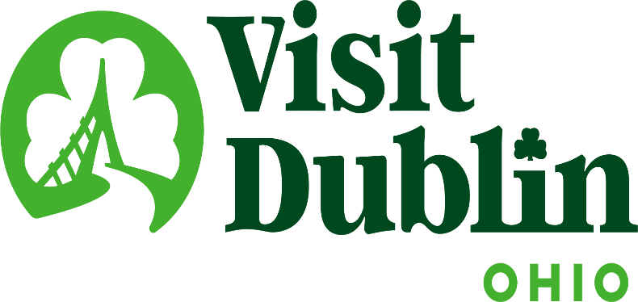
Executive Committee Meeting Minutes
May 14, 2025

Present: D. Cecutti, G. Rozich, B. Clark, J. Rexer, C. Rose, C. Baldridge, E. Belfrage

Absent: None

Staff: S. Dring

Executive Committee Action Items:

- Gerrilyn Rozich made a motion to approve May’s Executive Committee Meeting Minutes. Dave Cecutti seconded. All approved.
- Scott will provide the Executive Committee a list of current partners as well as the sales sheet listing all the partner benefits.

Detailed Minutes:

I. Welcome/Call Meeting to Order

II. Financials

- Bed Tax Revenue – The March Bed Tax was $105,187 compared to $107,358 last March, a decrease of 2 percent. Bed tax year-to-date is up 8.4 percent vs. the same period last year. There is a current budget surplus of $23,391.

- Balance Sheet – The current total in the checking and saving accounts through May 6 is $638,975. Account receivables total $2,702 – all related to the Partnership Program. It is policy to have at least six months of “hard” operating expenses for the reserve fund. The fund balance stands at $346,035 and held within two CDs. To diversify, CDs are located at separate banks – US Bank and Riverside Bank of Dublin.

- Profit & Loss – Through May 6, total income year-to-date stands at 19.84 percent and the total expenses year-to-date stand at 32.65 percent.

III. Committee Discussion Items

- 2026 Board Candidates – Scott noted that there will be four anticipated openings on the Board for 2026. 1) Community Representative (to be filled by Betty Clark, President-Elect); 2) City Council Representative (appointed by City Council in June); 3) Corporate Representative; 4) At-Large Representative. Scott shared an initial list of potential candidates and organizations to be considered for the two openings in 2026:

  - Cardinal Health
  - Cameron Mitchell
  - Mount Carmel Dublin
  - Wendy’s International
  - Past Dublin City Council Member
  - MORPC / Columbus Partnership (Barbara Benham - Huntington Bank?)
  - Amy Wald (Dublin Resident / Sustainability)
  - Mitchell Briant (DYA Executive Director)
  - Peter Coratola Jr. (Ease Logistics)
  - Cherie Smith (President of OhioHealth Dublin Methodist Hospital)

The committee discussed and will help create a list of candidates to present to the Board. Jessica will research a possible addition from Crawford Hoying and Gerrilyn from Cardinal Health.

- Bylaw Revisions – Scott noted that every other year he has the organization’s legal team review the current bylaws for any revisions or additions. He shared the minor revisions that will be presented to the Board of Directors for approval at the June Board Meeting. The revisions include:
  - Secretary – Although Scott handles all the secretarial duties, it is recommended that a member on the Executive Committee be appointed Secretary.
  - Name changed to Dublin Convention & Visitors Bureau DBA Visit Dublin Ohio.
  - Article II, Section 2 --- Add the word voting.
  - Article II, Section 2 (C) – Add director of sales
  - Article II, Section 2 (I) – Revise to (G)
  - Article II, Section 5 – Delete or fax

- Partnership Program – The Organization current has 85 partners and 7 corporate partners that this year will generate a record of $66,750. In 2023, the Corporate Partnership Program was launched and includes the following organizations: Cardinal Health, Crawford Hoying, Bridge Park, OhioHealth, Ohio State Wexner Medical Center, Mount Carmel Dublin and the City of Dublin. The 85 partners are mostly represented by businesses in the Hospitality Industry. Since 2021, the partnership fee has not changed from $1,000 for hotels and meeting venues and $300 for all other partners. Staff is reviewing an increase for the first time in its partnership program – the increase will be determined by the fall. Scott asked for any input from the Committee and they agreed that an increase is fair and acceptable. Scott will provide a list of current partners as well as the sales sheet listing all the partner benefits.

- SportsOhio Master Planning – The City of Dublin continues to work on the management agreement with Sports Facilities Companies (SFC). In the meantime, Scott has been participating with City leadership on Master Planning for the West Innovation District and the new athletic facility. There have been several meetings that have included City Staff, current master planning vendors, SFC and Hunden Partners, which completed the Darree Fields Feasibility Study for Visit Dublin. It appears the City is interested in retaining Hunden to complete a Tourism and Placemaking Action Plan. The action plan could take up to 9-12 months.

Visit Dublin Staff continues to aggressively market the new facility through generating new leads via trade shows and ongoing marketing efforts. Staff are currently working with the transition team for SportsOhio to host a national Flag Football Tournament and an indoor Archery event.

IV. President & CEO Report

- Holiday Market Review Committee – Scott and Jessica are serving on a Holiday Market Committee for the City of Dublin. The committee reviewed and distributed an RFP looking for an organization to run the market. The Committee interviewed candidates and have made a recommendation that will be presented to Dublin City Council in the coming weeks. The vision of the annual market is for it to start in 2026 during the Thanksgiving Holiday and run for 6 weeks. It is estimated that approximately 10,000 visitors a day will attend the market.

- City Council Update – Scott will provide a Dublin Hospitality Update to Dublin City Council this Monday at 7 p.m. As part of the presentation, as directed by the Board of Directors, Scott will provide an overview of the organization’s public and private revenue sources and discuss the 501c6 non-profit status and some of its limitations.

- Accreditation – Visit Dublin will be embarking on its re-accreditation starting at the end of this year. The organization has been accredited since 2008. Only an elite six percent of Destination Marketing Organizations worldwide have been accredited.

- Midweek Music Series – The Organization is sponsoring the first-ever Midweek Music Series, which will be held every Wednesday starting in June for 9 weeks at Riverside Crossing Park.

V. Other

- Board Meeting – Monday, June 16 @ noon, Columbus Zoo & Aquarium

- Executive Committee Meeting – Wednesday, July 16 @ 4 p.m., Country Club @ Muirfield

“Visit Dublin enhances the Quality of Life for residents by attracting visitor spending, consumer interest and entrepreneurial investment into the community.”

