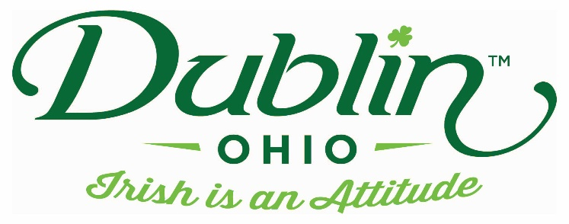

Experience Name: Morgan House Restaurant
Type of Experience: Dining
Length of Experience: 60-90 minutes
Min. group number: 25 (or $200 room rental) Max. group number: 100
Cost: $28pp + tax & gratuity
Driver comp: yes (with 25ppl) Escort Comp: yes (with 25ppl)
Takeaway: N/A
Details: The Morgan House as we know it was established in 1985. It was erected from the original log cabin named after famed Civil War Veteran John Hunt Morgan. Shortly after the Civil War, the log cabin was dismantled and reassembled on Glick Road at the entrance to Dublin, Ohio. Centrally located on a 5 acre lot in Dublin Ohio, The Morgan House is quite the departure from the log cabin it used to be in that it now boasts a virtual mini-mall of boutiques, shops and stores within a building that spans over 18,000 square feet.
Menu includes – Salad, Irish Stew, Steamed Vegetables, Rolls, Dessert & non-alcoholic beverage
Parking Information: On site parking
Booking Information:
Contact – Shannon Terry
Cell – (740) 417-3313 (can call or text)
Best “Day Of” Contact number
Phone – (740) 417-3313

