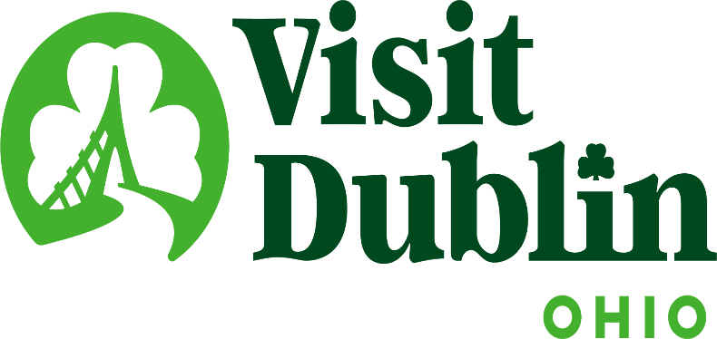
Executive Committee Meeting Minutes
October 9, 2024

Present: D. Cecutti, G. Rozich, C. Rose, C. Baldridge, J. Rexer

Absent: E. Belfrage

Staff: S. Dring

Executive Committee Action Items:

- Gerrilyn Rozich made a motion to approve the meeting minutes for the September 2024 meeting. Dave Cecutti seconded. All approved.
- The December Executive Committee Meeting was cancelled, and the December 4 meeting will be extended to 90 minutes.

Detailed Minutes:

I. Welcome/Call Meeting to Order

- Approval of September 2024 Meeting Minutes – Dave welcomed the group to the October Executive Committee Meeting. Gerrilyn Rozich made a motion to approve the meeting minutes for the August 2024 meeting. Dave Cecutti seconded. All approved.

II. Financials

- Bed Tax Revenue – The August Bed Tax was $130,565 compared to $123,379 last August, an increase of 6 percent. Bed Tax year-to-date is up 10 percent over the same period in 2023. There is a current budget surplus of $58,788.

- Balance Sheet – The current total in the checking and saving accounts through October 8 is $689,485. Account receivables total $12,900 – all related to the Partnership Program. It is policy to have at least six months of “hard” operating expenses for the reserve fund. The reserve fund balance stands at $322,359. To diversify, both CDs are located at separate banks – US Bank and Riverside Bank of Dublin. The US Bank CD was extended through 1/21/25.

- Profit & Loss – Through October 8, total expenses year-to-date stand at 72 percent and the total income year-to-date stand at 61 percent. Visit Dublin received a check for $28,074.12 from the Federal Government for the Employee Retention Credit (ERC) Program. New income and expense line items have been created to accurately track the new Everything Dublin Merchandise Store. To date, the additional revenue from the store is $3,618. All other expense line items are as anticipated.

- Employee Retention Credit (ERC) – Visit Dublin received $28,074 from the Federal Government as part of COVID’s Employee Retention Credit program. Scott said the application was rigorous and that the organization’s CPA and Congressman Mike Carey’s office were helpful in retaining the funding. The $28,074 was for one-year so there may be another check forthcoming if there are funds available. Scott noted that this revenue was not included in the 2024 budget.

III. Committee Discussion Items

- 2025 Budget Preview – Scott reviewed the process for creation of the 2025 Budget. Staff will be on its retreat in early November to create the Budget and the Sales & Marketing Plan. Scott will send a draft of the 2025 Budget to the Executive Committee on November 25 with a review of the plan at the December 4 Executive Committee Meeting. Staff will seek final approval of the Budget at the December 9 Board Meeting. Scott projected that bed tax will experience a slow growth of 2-4 percent in 2025 based on discussions with Dublin hoteliers and industry leaders. He also anticipates carrying dollars over from the current budget.

- 2025 Board Structure – The committee reviewed the current Board Structure and had initial conversations about the Board make-up in 2025. Scott noted that there are four Board Members whose current terms expire at the end of 2024, but all could continue on the Board for another term. Scott will contact those Board Members and ask if they are willing to serve another term. Scott also noted that the Executive Committee should begin to discuss filling the President-Elect position.

- SportsOhio Steering Committee – Scott updated the Committee on the City of Dublin’s purchase of SportsOhio. The purchase became official last week for three parcels at the price tag of $44.6 million. The first City of Dublin SportsOhio Steering Committee was also held. Scott is serving on the committee that also includes representatives from Dublin Youth Athletics, Dublin Soccer League, the Memorial Tournament, Columbus Sports Commission, the Chiller and various staff. Dr. David Lee, former Board President at Visit Dublin, is a community representative on the committee. The committee agreed that the goals of the committee are: 1) Financial sustainability through effective revenue generation, cost management, and strategic partnerships; 2) Community Engagement to foster strong community engagement by offering programs, events and activities that benefit the community and encourage participation; and 3) Economic impact to attract regional and national events and tournaments, driving tourism and stimulating local business growth.

The second meeting will be held this upcoming Friday and will focus on creating an RFP for a Management Company to oversee the facility among other topics.

- Office Lease – The Visit Dublin lease at 9 S. High Street for its Visitor Center and Administrative Offices will expire December 2026. Currently, the administrative office has 1,850 sq. ft. for $13 per square feet and the Visitor Center has 398 sq. ft. for $30 per square feet. The topic will be discussed at Monday’s Board Meeting and Scott asked the committee for any recommendations on information that should be provided to the Board.

IV. President & CEO Report

- Everything Dublin Merchandise – The vendor for the City of Dublin’s and Visit Dublin’s online merchandise store (Shout Out Loud) abruptly went out of business last month. All unsold merchandise was recovered and there was no loss of revenue. Scott noted that both organizations are working to identify another vendor that can fulfill the needs of the “Everything Dublin” merchandise store. The goal is to have a new vendor in place by the holiday season.

- City Leadership Retreat – Staff hosted a successful City of Dublin’s Leadership Retreat on September 26. The retreat included 30 of the City’s top executives with Scott providing an overview of Visit Dublin and then Missy joined the group to assist with a 90-minute bus tour of the City’s Destination product. The tour provided an opportunity to educate the city on all facets of the organization and Dublin’s Travel and Tourism Industry. The tour also featured a stop at the Dublin Visitor Information Center. Scott noted that the Dublin City Manager said she is going to include the tour as a requirement for onboarding new city employees.

- Voters’ Choice Awards – The Visit Dublin Voters’ Choice Awards launched last week showcasing the best of the best in Dublin. The community-driven contest recognizes and celebrates local businesses and experiences that make our city thrive. The first phase was nominations and then daily voting for the 17 different categories – voting continues until October 31. There have already been more than 6,000 votes cast vs. a total of 11,000 last year. The Awards event will again be held at North Market on Thursday, November 14. Scott noted that Mayor Amorose Groomes and City Manager Megan O’Callaghan will be presenters of the awards during the event.

- Holiday Market Study – Scott was interviewed as part of the ongoing research to create a new Holiday Market in the City of Dublin. There were several other key stakeholders in the community that participated in the initial research including City Council, Jessica Rexer, City Staff and others. The final recommendation for the market will be made by the end of the year. Scott noted that Dublin hotel occupancy rates are lowest during the holidays and a Holiday Market would be a great boost for the local economy.

- CDME Re-Certification – Scott received his re-certification for Destination International’s CDME certification. The Certified Destination Marketing Executive (CDME) is the highest professional certification in the travel and tourism industry. Scott initially received the certification in 2008.

V. Other

The November Executive Committee was cancelled. The next meeting will focus on the 2025 Budget and be held on December 4 and be extended to 90 minutes.

- Board Meeting – Monday, October 14 at noon, Crawford Hoying

- Executive Committee Meeting – Wednesday, December 4 at 4 p.m., No Soliciting (November Meeting is Cancelled)

“Visit Dublin enhances the Quality of Life for residents by attracting visitor spending, consumer interest and entrepreneurial investment into the community.”

