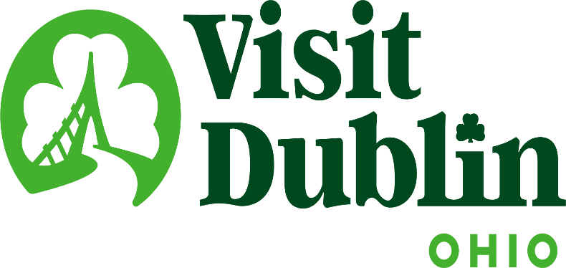
Executive Committee Meeting Minutes
September 4, 2024

Present: D. Cecutti, G. Rozich, C. Rose

Absent: J. Rexer, E. Belfrage, C. Baldridge

Staff: S. Dring

Executive Committee Action Items:

- Gerrilyn Rozich made a motion to approve the meeting minutes for the August 2024 meeting. Dave Cecutti seconded. All approved.

Detailed Minutes:

I. Welcome/Call Meeting to Order

- Approval of August 2024 Meeting Minutes – Dave welcomed the group to the September Executive Committee Meeting. Gerrilyn Rozich made a motion to approve the meeting minutes for the August 2024 meeting. Dave Cecutti seconded. All approved.

II. Financials

- Bed Tax Revenue – The June Bed Tax was $161,069 compared to $136,081 last June, an increase of 18 percent. Bed Tax year-to-date is up 11 percent over the same period in 2023. There is a current budget surplus of $49,897.

- Balance Sheet – The current total in the checking and saving accounts through September 3 is $627,099. Account receivables total $14,900 – all related to the Partnership Program. It is policy to have at least six months of “hard” operating expenses for the reserve fund. The reserve fund balance stands at $322,359. To diversify, both CDs are located at separate banks – US Bank and Riverside Bank of Dublin. The US Bank CD was extended through 1/21/25.

- Profit & Loss – Through September 3, total expenses year-to-date stand at 64.89 percent and the total income year-to-date stand at 52.06 percent. New income and expense line items have been created to accurately track the new Everything Dublin Merchandise Store. To date, the additional revenue from the store is $2,927. All other expense line items are as anticipated.

III. Committee Discussion Items

- Strategic Plan Review – The Committee reviewed current results and status of the 2023-25 Strategic Plan. Scott noted that this plan was developed by the Board of Directors in the fall of 2022 to map out a strategy for the evolution of the organization and destination over the next three years. Staff has created a “scorecard” to track the progress and results of the plan. The three key goals of the plan are: 1) Advocate for destination defining development; 2) Support enhancements for the Dublin experience; and 3) Enhance the awareness, appreciation & support of Dublin’s tourism economy. The committee discussed some of the results thus far for each of the key goals, including:

GOALS | MOST RECENT COMPLETED RESULTS
Advocate for Destination-Defining Development | - City agreed in terms of purchasing SportsOhio. City Manager Megan O’Callaghan said “This acquisition presents the opportunity to leverage both Darree Fields and SportsOhio to further establish Dublin as a premier sports destination that will host various recreational sports, events and tournaments to serve the needs of our community and attract investors and visitors from all over the country.”  - Will be member of City’s Steering Committee to determine future athletic facilities at SportsOhio.  - Serving as resource for City with proposed new hotel in Bridge Park with accompanying meeting space.
Support Enhancements to the Dublin Experience | - Staff served on two City RFP selections to create an overall event strategy and develop a Holiday Market. Scott having ongoing discussions with Yard & Co. to help develop a future strategy to manage current and attract new world-class events to Dublin.  - City created “Dublin Summer Fun Series at Riverside Crossing Park.” Staff continuing to lobby for future programming.  - Dublin City Schools will launch Dublin Travel and Tourism Academy this fall. Working with schools and industry.
Enhance the Awareness, Appreciation & Support of Dublin’s Tourism Economy | - Launched a new Brand Identity project with logo, graphic standards manual and more.  - Participating and supporting the City’s “Metro Center Revitalization” efforts and plan, which will be completed this summer.

The committee agreed the plan was on target halfway through and that staff should continue working on each goal equally in the next 18 months.

- 2025 Board Structure – The committee reviewed the current Board Structure and began initial conversations about the Board make-up in 2025. Scott noted that there are four Board Members whose current terms expire at the end of 2024 but all have the ability to continue on the Board for another term. Scott said there had been discussions at his national conference on the role of hotel and restaurant representatives on DMO Boards and how those positions have decreased over the past few years because of the workload being placed in those positions. Visit Dublin currently has 15 voting board members with two hotel representatives and two restaurant representatives. Scott also noted that the Executive Committee should begin to discuss filling the President-Elect position.

- Board Member Orientation – The second part of the new Board Orientation will be held on September 11 at noon via TEAMS. Scott noted the feedback he received from the first Orientation was very positive with Board Members commenting it was informative and helpful to assist with their roles. Scott’s presentation will be no longer than 30 minutes with Q&A and he provided an outline of his presentation and asked for feedback from the Committee. The topics to be covered include: Board Structure/Expectations, Key Stakeholders, Bed Tax History, Dublin’s Bed Tax, Partnership Program, Strategic Plan, Sales & Marketing Plan, Staffing/Leadership, Partners (Vendors), Working in the Non-Profit world and Board Resources.

- Partnership Program – Scott noted that partnership revenue is critical to the organization because “private funding” is needed to help sell and market the City of Dublin. Private monies are used for entertaining media, site visits of meeting planners and sports organizers, a variety of campaigns and other initiatives that cannot utilize taxpayer or “public” monies. Scott also said the engagement from partners to help reinforce Visit Dublin’s messaging on marketing Dublin as a world-class destination is critical as well. Visit Dublin has a total of 88 partners representing all sectors of the industry – attractions, restaurants, hotels, meeting partners, etc. He also highlighted the Corporate Sponsors which have a huge impact on Visit Dublin – Crawford Hoying, Bridge Park, OSU Wexner Medical Center, OhioHealth and Cardinal Health.

IV. President & CEO Report

- City Leadership Retreat – Staff are excited to be part of the City of Dublin’s Leadership Retreat on September 26. The retreat will include up to 30 of the City’s top executives and Scott will be providing an overview of Visit Dublin and afterwards Visit Dublin will host a bus tour of the City’s Destination product. The 90-minute tour will feature various destinations across the city including the Dublin Visitor Information Center.

- Visit Dublin Week – This year’s Visit Dublin Week will be held September 16-22. Staff celebrated the first-ever Visit Dublin Week last year, which highlighted Dublin’s hospitality industry, local businesses and Dublin residents who make our city a great place to work, live and visit. Activities will include a partner appreciation day, Visitor & Information Center Open House, presence at the Dublin Farmers Market, staycation giveaways for Dublin residents, launch of the Voters’ Choice Awards and more. A new addition is that Johnson’s will be launching a new “Visit Dublin Sundae” for the week. Staff will be giving sundae coupons as prizes during the week. Scott will be sending out a schedule of events to the Board next week.

- Voter’s Choice Awards – The Visit Dublin Voters’ Choice Awards will launch during Visit Dublin Week in September to showcase the best of the best in Dublin. The community-driven contest recognizes and celebrates the local businesses and experiences that make our city thrive. The first phase will be nominations and then daily voting for the 17 different categories. The Awards event will again be held at North Market on Thursday, November 14.

- Sports Ohio Acquisition / Committee – Scott updated the Committee on the City of Dublin’s purchased of SportsOhio. The purchase includes three parcels at the price tag of $44.6 million. This will not only be a tremendous amenity for Dublin residents, but the acquisition provides a tremendous economic development opportunity and aligns with our vision for future athletic facilities. Scott continues to have discussions with the city and others on the next steps. Scott will serve on a steering committee created by the City that will provide input on how the property should be used for recreational purposes. The Committee will also include representatives from Dublin Youth Athletics, Dublin Soccer League, the Memorial Tournament, Columbus Sports Commission and others. The first meeting is scheduled for the next few weeks.

As noted at last month’s meeting, Visit Dublin will create a similar committee to help develop a strategy and provide insight and direction for staff to proceed.

- Staff Retreat – Staff are scheduled to go on their annual retreat to Indianapolis in early November. The two-day retreat will be spent developing the 2025 Sales & Marketing Plan as well as team building and education. Staff will meet with representatives from Visit Indy and the Hamilton County CVB. Last year’s retreat was held in Lexington.

V. Other

- Executive Committee Meeting – Wednesday, October 9 at 4 p.m., VASO

- Board Meeting – Monday, October 14 at noon, Crawford Hoying

“Visit Dublin enhances the Quality of Life for residents by attracting visitor spending, consumer interest and entrepreneurial investment into the community.”

