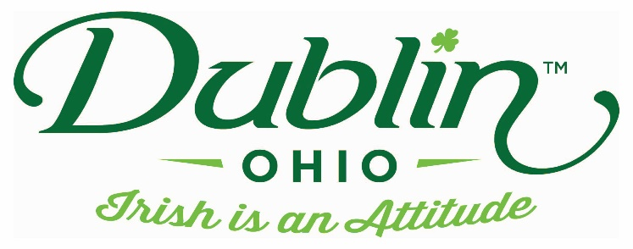

Experience Name: Shamrock Sundaes
Type of Experience: Dessert
Length of Experience: 30 minutes
Min. group number: No min. Max. group number: 43 seats indoor/37 outdoor
Cost: $4.50 per person
Driver comp: Yes Escort Comp: Yes
Takeaway: N/A
Details: Come enjoy Graeter’s Ice Cream, the best ice cream you’ll ever taste! The Graeter’s family has been making ice cream since 1870; still using the same methods and the highest quality ingredients! On your tour, try a Shamrock Sundae – our Dublin special!
Parking Information: Motorcoaches can use either the back of our lot closest to the building, or the separate lot behind.
Booking Information:
Contact – Ben Stephens
Phone – (614) 799-2663
Email – dublin@graeters.com

Best “Day Of” Contact number
Phone – (614) 799-2663

