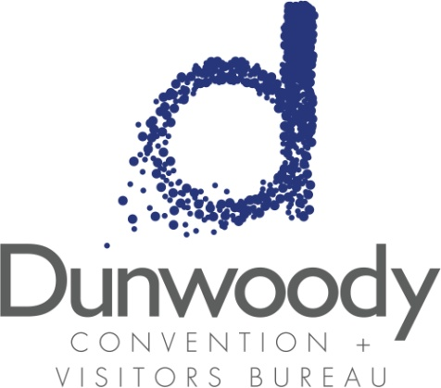

Third Quarter Board Meeting
August 5, 2015
11:30 a.m. – 1:00 p.m.

Meeting Agenda:

- Meeting Called to Order

- Minutes
- April 22 Board Meeting
- May 14 Special Called Meeting

- Committee Reports
  - Executive Peter Dunn
  - Personnel Michael Bryan
  - Finance Bill Grant

- Director’s Report Katie Bishop

- Old Business
  - Research update Katie Bishop

- New Business
  - Budget Adjustment Bill Grant
  - 2016 Board Meeting Schedule Peter Dunn

- Adjourn

