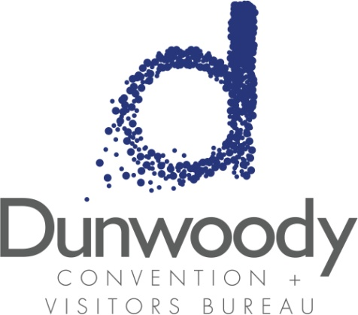

Third Quarter Board Meeting
August 4, 2016
11:30 a.m. – 1:00 p.m.
Meeting Agenda:

- Meeting Called to Order

- Minutes
- May 5, 2016 Board Meeting
- May 23, 2016 Special Called Conference Call
- June 13, 2016 Special Called Conference Call
- July 8, 2016 Special Called Conference Call

- Committee Reports
  - Executive Michael Bryan
  - Personnel Nancy Musselwhite
  - Finance Bill Grant

- Director’s Report Katie Williams

- Old Business

- New Business
  - Mid-Year Marketing Report Kimberly Trawick Franz
  - Mid-Year Budget Projections
  - Neutrality Policy
  - Upcoming board meeting dates and 2017 budget planning

- Adjourn

