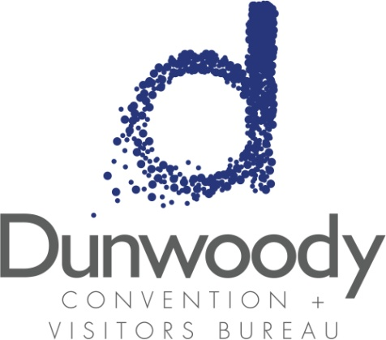

**Fourth Quarter Board Meeting**

**December 4, 2018**

**11:30 a.m. – 1:00 p.m.**

**Meeting Agenda:**

1. Meeting Called to Order
2. Minutes

* August 9 Board Meeting

1. Committee Reports
   * Executive
   * Personnel
   * Finance
2. City of Dunwoody Update Michael Starling

1. Executive Director’s Report Katie Williams
2. Old Business

* Strategic Plan Update

1. New Business

* 2019 Budget and Business Plan
* 2019 Board and Executive Committee Nominations
* Organization name change

1. Adjourn