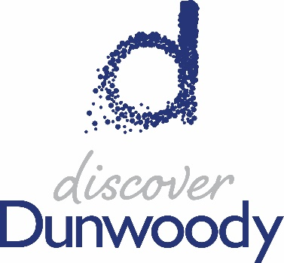

2021 Sponsorship Incentive Plan

The following document outlines the types of business that would qualify for Discover Dunwoody’s 2021 Sponsorship Incentive Plan. All items are subject to change and final approval by the Executive Director and/or board of directors.
Objective: to incentivize the decision maker with financial support to offset spending costs incurred during the meeting or program held at a Dunwoody hotel property during a COVID-19 recovery year.

Lead Qualifications:
- To qualify for incentive dollars, the RFP/Lead must:
  - originate from the Discover Dunwoody Sales Team via Steven Schumacher or Race Roberts OR
  - originate from a Dunwoody hotel with documented proof that the bid is up against a market that competes with Dunwoody for group business.
- These leads can come from CVENT, Simpleview or a direct email from a client/planner.
- RFP’s/Leads that are already being bid on by the hotel partners CAN qualify for incentive dollars IF the hotel contact can show that by “adding value” of these dollars to their proposal, it will help close/secure the business for them. This means the hotel sales manager cannot simply add our incentive dollars at the beginning of the lead, rather wait and use as a final resource to secure the business from another destination.
- The RFP/Lead can peak on ANY day of the week (no longer required for weekend peak only).
- BOOKING MUST CONSUME IN 2021; 2022 & beyond RFP’s/Leads can be discussed with the Sales Team regarding a future Sponsorship Incentive Plan.

Group Qualifications
Qualified groups are available to the following dollar amounts based on the total amount of guestrooms that actualize. Pre-approval will be based on the contracted amount of rooms, but the actual dollar amount will be based on actualized rooms and after the group has made final payment to the hotel. Upon receiving a copy of total guestroom pick up, Discover Dunwoody will submit payment via a check to the group/organization only; checks will not be written to individuals nor to hotels (Family Reunion exceptions can be made at the discretion of Discover Dunwoody). For rooms-only groups, the decision maker has the option of a Visa gift card instead of a check; this option is subject to prior approval of the Executive Director.

100+ total guestrooms = up to $500 in sponsorship incentives
250+ total guestrooms = up to $1,000 in sponsorship incentives

*All leads/RFP’s are subject to qualifying based on the discretion of Discover Dunwoody
**Sponsorship levels are as follows:
- 100+ total guestrooms must mention Discover Dunwoody when attendees book a room
- 250+ total guestrooms must have Discover Dunwoody logo on website of hosted event

