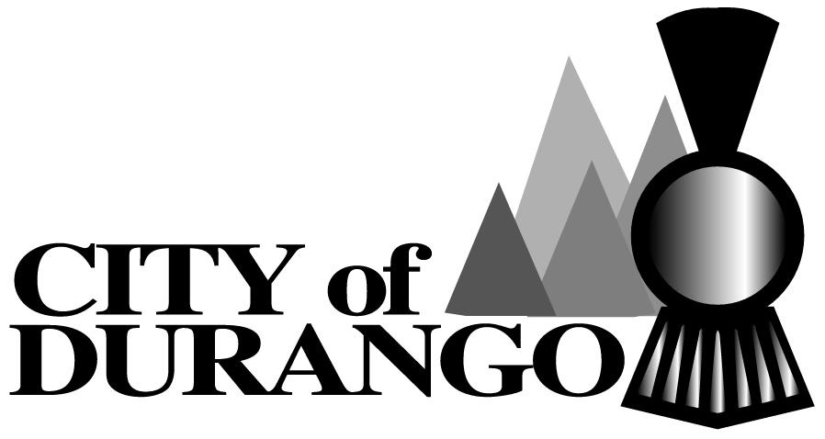
Community Events Film Registration Form
Parks and Recreation Department
2700 N Main Avenue
Durango, Colorado 81301

Tel: (970) 375-7325 Fax: (970) 375-7337

PLEASE PRINT
Name of Applicant/Production Company:__________________________________________________

Date(s) of Filming______________________ Time(s) of Filming______________________________

Location(s) of Filming (within the City of Durango and La Plata County) ___________________________________________________________________________________
___________________________________________________________________________________

Name of Producer (If different from Applicant)_____________________________________________

Organization: Non-profit For-profit Government Corporation Other:_______________

Daytime Phone #_________________ E-mail________________________________________________

Cell Phone # ____________________

Please attach a copy of Liability Insurance. For questions, contact the Community Events Supervisor at 970-375-7325.

Filming Description:
Film Title of Project:__________________________________________________________________

Production type: Still Film Video Multimedia Other: __________________________

Classification: Feature Short Commercial Television Music Video Documentary Educational Student Other: _____________________________________________________
Location Details:

Physical Address(es) if possible:__________________________________________________________
____________________________________________________________________________________
____________________________________________________________________________________
____________________________________________________________________________________
Please attach a narrative of filming including the following information:
- Sets to be built
- Special effects planned (including firearms, explosions, road work, etc.)
- The use of stunts
- Use of vehicles, aircraft, watercraft, etc.
- Use of Animals
- Number of Crew Members
Upon submittal of this form the City of Durango Community Events Supervisor will forward the above information to the necessary agencies and organizations for notification. Applicants will be notified of any required permits and fees by the Community Events Supervisor.

Applicant’s Signature:______________________________ Date:____________________

Print Name and Title:___________________________________________________________

Community Events Supervisor: _____________________________ Date:_________________

CC:
Durango Area Tourism Office:
Business Improvement District:
Four Corners Film Office:
City Manager’s Office:
La Plata County:
Colorado Department of Transportation:
Director of Parks and Recreation:
Durango Fire Protection District:

