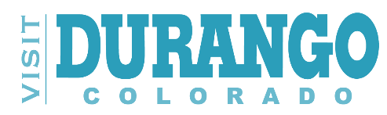
OPEN Board Seat Announcement Applications Are Accepted Until Seat Is Filled
Visit Durango is accepting nominations for the Board of Director’s seat representing the Outdoor Sector for the Tourism/Hospitality Industry of the Durango/La Plata County.
The mission of Visit Durango is to generate demand in visitation and overnight stays in Durango and La Plata County through strategic marketing programs and sales promoting the area for the benefit of visitors and local stakeholders:
• Promote the Durango Brand
• Support a positive visitor experience
• Drive positive economic impact
Eligibility: The nominee(s) must be an active participant/employee/owner in the local Tourism/Hospitality Industry with operations based in Durango/La Plata County. The role of every board member is to provide insight, guidance, and support to the Visit Durango organization, as well as promote overall tourism in the Durango area.

Basic Responsibilities:
• Represent, in an equal and fair manner both the interests of Visit Durango and Specialty Lodging establishments within the city and county.
• Maintain regular communication with industry peers to receive and share their input.
• Attend the Visit Durango monthly Board meetings.
• Participate in one of the Visit Durango Board committees.
• Attend at least one tourism industry event annually.
• Attend annual Board retreat, when applicable.

Visit Durango Applicant Information
Name:
Title(s):
Business/Organization:
Address:
Phone Number:
Email:
Please answer all the following questions:
- What unique qualifications will you bring to the Visit Durango Board?

- What is your interest and motivation for serving as a Board member?

3. Describe your experience in community organizations, including service on boards or advisory committees.

4. How will you communicate with and maintain communication with the sector you represent on the Visit Durango Board in La Plata County?

Mail or Email your completed application form with a copy of your resume to: Rachel Brown – Visit Durango, 802 Main Ave., Durango, CO 81301 or email to director@durango.org

