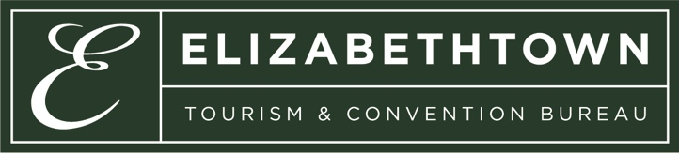
Event Grant
Application

I. Introduction
The Elizabethtown Tourism & Convention Bureau administers funds collected from a two percent (2%) restaurant tax on prepared meals. The funds will be applied to programs designed to promote Elizabethtown as an ideal business, convention, sports tournament, and vacation travel destination.

The ETCB has set aside a portion of the overall budget in a grant program to work with local event organizers that are coordinating events in Elizabethtown. The ETCB Executive Director will receive requests for funding of events. Events will be evaluated by established criteria that are consistent with the ETCB's purpose to serve local residents and visitors as a premiere destination. The financial extent of a grant will be dependent upon the availability of designated funds.

Ideally, the funds allocated by ETCB will eventually be returned through an increase in future opportunities for increased tourism events, which create incremental transient lodging occupancy and increased meals eaten in local restaurants.

II. Statement of Policies

- To be considered for funding, applicants must complete the appropriate application for Event Funding.
- Applications must be submitted with original signatures at least 60 days prior to event.
- Grant funds from ETCB are intended to supplement the sponsoring organization's budget, not replace it.
- Any funds granted will be subject to audit.
- Grant requests should not exceed $500.

This grant fund agreement may be terminated with 24 hours by written notice by the ETCB for breach or failure of the applicant to perform pursuant to any of the provisions or requirements set forth herein. If grant funds have already been disbursed before the breach occurs, the applicant will be responsible for full repayment.

APPLICANT: I, _____________________________, _____________________
(Name - Print or Type) (Title)

____________________________________________________ understand and comply
(Organization)

with the above conditions should the request for funds be granted.

______________________________ _____________________
(Signature: must be handwritten) (Date)

Application for Funding
(Please use as much space as needed or additional paper to answer each question.)

Today’s date___________ Amount requesting from ETCB $____________

- Name of event:

- Local contact person: Address:
Telephone number:
E-Mail address:

- Non-profit organization? Yes No Tax ID number:

- Where in E-town will the event be held?

- Date/s of event and day/s of the week:

- Estimated number of:

Teams (if applicable):
Participants:
Spectators:
Other (visiting coaches, celebrities, dignitaries, etc.):

- Sanctioning body or association being represented, if applicable (for example: AAU, USTA, etc.):

- Contact information for sanctioning body or association:

Name:
Address:
Telephone:
E-mail Address:

- Is there a local planning committee or volunteer board for this event? If so, please list names and positions of members:

- Estimated number of personnel onsite (referees, tournament captains, first-aid, etc.) Please specify paid positions OR volunteers.

- Describe in DETAIL each day’s planned activities during the event:

- List each source of INCOME and each EXPENSE for the event:

- How will ETCB funds be spent?

- Is there an opportunity to display the ETCB logo? (Please describe.)

- How will your event be promoted?

- Will participants or spectators be staying overnight? If so, at which hotel/s have you reserved rooms, and how many rooms at each?

- How many opportunities will your participants have to eat out in E-town?

If you have questions concerning the application or funding process, you may contact ETCB at (270) 765-2175. Applications should be returned to ETCB at 1030 N. Mulberry St. Elizabethtown, KY 42701 or e-mailed to jclark@touretown.com.

Updated 6/2023

