Vail Resorts promises to fight Town of Vail after council condemns parcel planned for affordable housing
Vail council blasted Vail Resorts for “dismal” negotiations as town pushed to relocate workforce housing away from a local bighorn sheep herd
https://coloradosun.com/2022/05/04/vail-resorts-town-council-condemnation-affordable-housing/?mc_cid=d0105fb645&mc_eid=de86f21716
Jason Blevins 4:10 AM MDT on May 4, 2022 The Colorado Sun

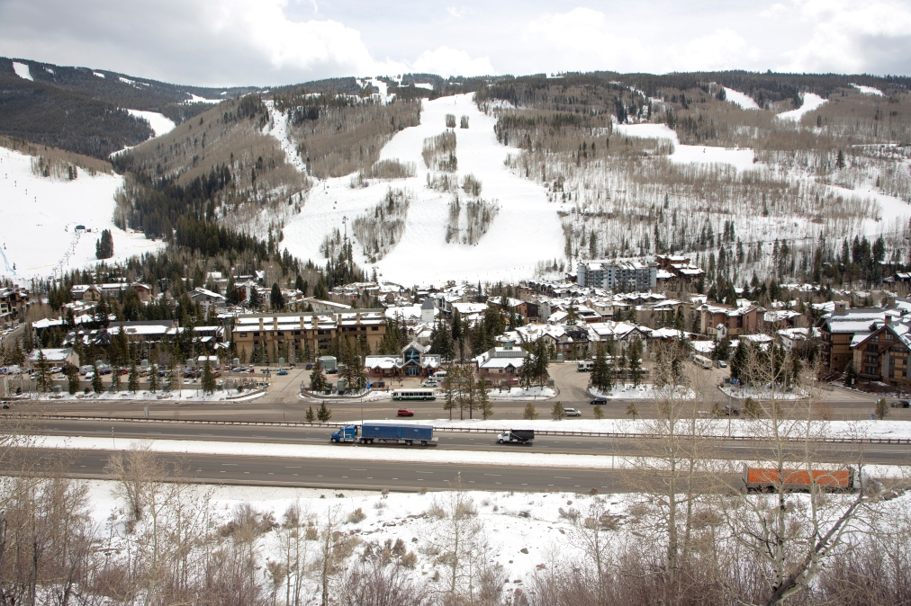
Vail ski resort and the Town of Vail along Interstate 70 on Apr. 14, 2022. (Hugh Carey, The Colorado Sun)
The largest resort operator in North America is going to war with its namesake town.
The Vail town council late Tuesday voted to condemn a parcel where Vail Resorts plans to spend $17 million to build affordable housing for 165 workers. Dozens of Vail Resorts executives, employees and managers crammed into the council’s chambers Tuesday night as the council heard passionate support for both housing and wildlife. Ultimately the council voted 4-3 to approve a resolution that gives the town the ability to seize ownership of the 23-acre parcel and prevent any development as a way to protect a bighorn herd that winters in the south-facing aspen groves along Interstate 70.
“I’m disappointed you’ve been backed into a corner and have to consider this resolution tonight,” said Terry Meyers, the executive director of the Rocky Mountain Bighorn Society. “Please make the decision to protect the bighorn sheep herd and move forward to find other options for affordable housing in the Vail Valley. The sheep have to have this. They can’t go anywhere else.”
The council fielded more than 100 emailed statements — 200 pages in the council’s meeting packet — from local business owners and residents in the last two weeks, with about 80 of them urging council members to not condemn the parcel and support housing. The council counted about 20 emails supporting the condemnation.
Former Vail council member Jenn Bruno, who voted to approve the Vail Resorts housing project in 2019, questioned the council’s push to condemn the land for “the health, safety and welfare of the public.”
“What public is being referenced? It’s not the workers,” Bruno said. “We are in a housing crisis that is affecting not only our guest experiences but the very make-up of our community. If we are really thinking about the welfare and safety of our neighbors, we would want to make sure they have homes.”

Recommended

Town of Vail moves to condemn parcel where Vail Resorts plans affordable housing project
Chris Romer, the head of the 920-business Vail Valley Partnership, focused on the role of government, saying eminent domain and government seizure of private property is an “extreme action.”
“The idea of what is mine is mine and what is yours is mine is bad government policy,” Romer said.
Frances Hartogh, a Vail resident and volunteer wilderness ranger for the Eagle Summit Wilderness Alliance, said she has seen the detrimental impacts of crowds, dogs and climate on the valley’s wildlife.
“It’s time to stop violating wildlife in the name of our sport,” Hartogh said.
Robyn Smith, a resident and business owner in West Vail, presented a map she assembled from town data showing 17 short-term rental homes, two luxury homes under construction, two trailheads, the town’s public works building and Vail Mountain School among more than 100 buildings in the bighorn herd’s winter range on the south-facing slopes in East Vail.
Smith said condemning the affordable housing project while allowing all the other activity in the winter habitat “is a textbook example of redlining.”
“The consequences of this action are clearly discriminatory,” said Smith, adding that state wildlife officials are in charge of protecting bighorn “but you are uniquely responsible for us.”
Vail Resorts also brought a map showing more than 100 homes in the habitat, many of the homes awash in red dots indicating the homes owned by people who have spoken publicly against the affordable housing project near their neighborhood.
Many residents urged Vail Resorts to direct employee housing to its Ever Vail parcel in the valley. The company years ago proposed a new chairlift and luxury village on the land adjacent to the ski area. John Dawsey, the vice president of hospitality for Vail Resorts, said Ever Vail is three to five years away from approval.
“And we need this housing now,” Dawsey said. “One gets us housing now and one will get us housing in the future and we need both.”
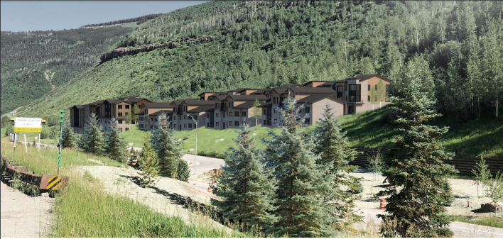Vail Resorts wants to build affordable housing for 165 workers on about five acres in East Vail on Interstate 70, seen here in an artist rendering. A herd of bighorn sheep winter in the area and local leaders oppose the plan, urging the company to look elsewhere for housing. (Provided by the Town of Vail)
Vail Resorts, and most mountain businesses, are enduring a painful shortage of workers caused by a lack of affordable housing. The ski area operator struggled this season to open lifts and terrain at understaffed resorts. Bill Rock, the chief operating officer of Vail Resort’s Rocky Mountain Region, said condemnation “will be detrimental to the health and sustainability of the community … it will have an adverse impact for decades.”
Rock also said the company “will vigorously defend our right to go forward with this project.”
After hearing three hours of testimony, all of the council members lambasted Vail Resorts for difficult negotiations in recent years as the town pushed the company to pursue different locations for housing in the valley. They all noted the town’s recent investment in an expansion of employee apartments and the new 70-unit Residences at Main Vail project, which Vail Resorts is not supporting.
“We have tried to collaborate with Vail Resorts for the last two years. It’s been a very dismal process,” said councilwoman Jen Mason, who said eminent domain could help improve negotiations with Vail Resorts. “I do not want to condemn this land but for two years they would not even respond to us.”
Vail Mayor Kim Langmaid, who grew up in Vail, defended the council’s support for affordable housing.
“It’s been a struggle to stay here and live here. It’s been very sad to see what was once a very vibrant community implode on itself over the lack of affordable housing,” said Langmaid, adding that she grew up watching the bighorn herd in East Vail. “I’m not willing to risk their demise because I do believe there is a better solution out there. I know we can do this. This resolution does not preclude us from finding a solution. We don’t have to use eminent domain. We are just saying we can do it.”

Town of Vail moves to condemn parcel where Vail Resorts plans affordable housing project
The Vail town council moved toward preventing any development on the acreage where Vail Resorts plans to spend $17 million on affordable housing, citing impacts to a herd of bighorn sheep
https://coloradosun.com/2022/04/20/vail-council-condems-parcel-vail-resorts-affordable-housing/

Jason Blevins 4:10 AM MDT on Apr 20, 2022 Colorado Sun
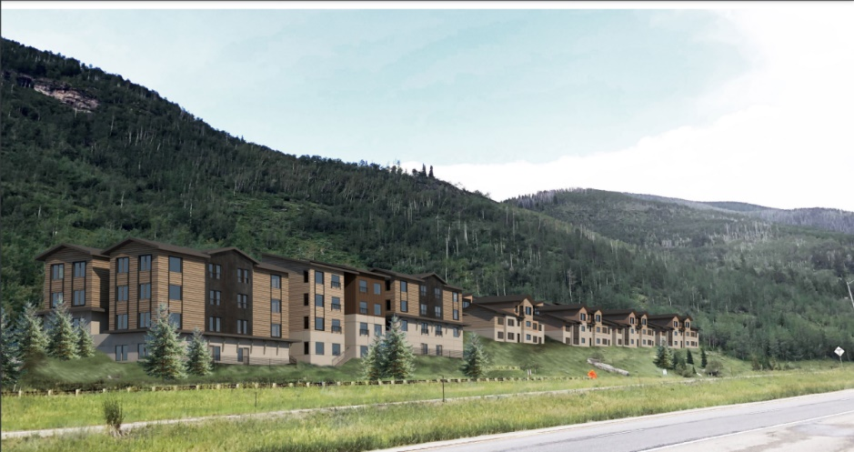
The Town of Vail council is promising to reject a plan by Vail Resorts to build an affordable housing project -- seen here in an artist rendering -- on land the company owns in East Vail on Interstate 70. (Provided by the Town of Vail)
VAIL — The Vail town council on Tuesday voted 4-3 to condemn a parcel where Vail Resorts plans to build affordable housing, citing concerns over the impact of development in winter habitat for a herd of bighorn sheep. A final vote in early May could prevent any development on the 23 acres owned by the ski area operator.
The project has stirred passionate opposition from neighbors who want to protect the bighorn and workers who can’t find a place to live during a housing crisis that has impacted Vail Resorts’ ability to staff its operations.
Dozens of Vail Resorts employees, all wearing their name tags, showed up at the council chambers Tuesday night in support of the worker housing plan.
“We are in a crisis. We all know about it. We see it. We live it. We must address this crisis now if Vail is to continue being Vail,” said Beth Howard, the head of Vail ski area. “Look at the people in this room. These are my team members. Now tell them they can’t live in East Vail while many of the luxury homeowners do live in bighorn habitat.”
The Vail town council approved the plan to develop worker apartments and townhomes for 165 employees in 2019. An Eagle County District Court judge affirmed the decision, dismissing a lawsuit brought by neighbors of the project. Then Vail Resorts paused the project in 2020, along with much of its capital spending during the pandemic.
A new council was elected in 2020 and this one had the votes to condemn the property. The council met in executive session for two hours on Tuesday before the evening meeting and held its vote on the condemnation with no discussion.
The council received more than 140 emails from residents and workers, Vail Mayor Kim Langmaid told the packed chambers on Tuesday.
Vail Resorts proposes spending $100,000 to mitigate impacts to the bighorn herd. It plans to protect about 17 acres of the property from any development. The town and company’s impact report studying the project suggests the plan’s 42 apartments and 31 townhomes could be built without impacting the herd.
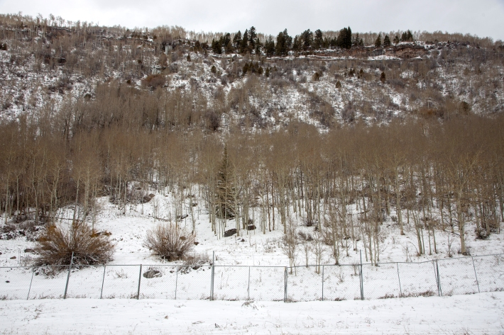

The Town of Vail and wildlife officials erected fencing around bighorn habitat in East Vail along Interstate 70 in April 2020 after two sheep were struck by vehicles. Vail Resorts wants to build workforce housing on the parcel it owns in East Vail, but town officials do not want housing in the area where a bighorn herd spends every winter. (Hugh Carey, The Colorado Sun)
One of the arguments raised by Vail Resorts points to home development near the parcel that abuts Interstate 70. The company passed out maps compiled by Colorado Parks and Wildlife showing 107 structures – many of them homes built decades ago – in the area defined as bighorn sheep winter range.
“So why are all these luxury homes OK but the affordable housing is not?” Howard asked the council.
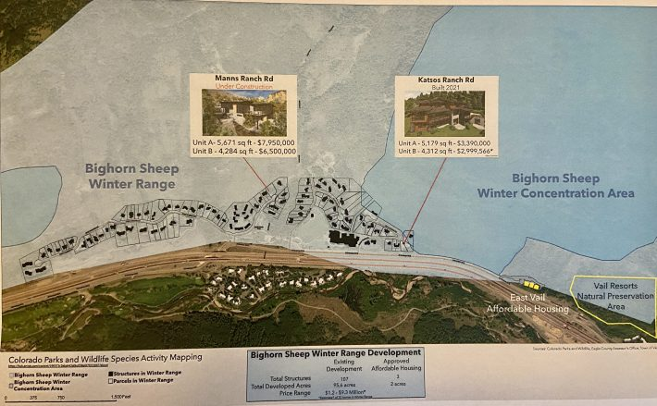Vail Resorts provided this map by Colorado Parks and Wildlife to the Vail town council, showing its proposed housing plan and existing homes in the winter habitat for bighorn sheep. (Provided by Vail Resorts)
Merv Lapin, who has lived in Vail since 1966 and served eight years on the town council, said attainable housing has been an issue in the town since the late 1960s, with demand always outstripping supply.
Lapin suggested the town hire an eminent domain firm to pursue the condemnation of the East Vail parcel and another 10 acres near Lionshead Village where the company a decade ago proposed a village development with luxury homes.
“Vail Resorts and other large, profitable organizations have taken advantage of subsidized housing the town has built over the years,” Lapin said. “Vail Resorts could easily donate its land and do the right thing, either to a conservation fund or the town.”
Several residents spoke in support of the town’s condemnation of the property, voicing support for affordable housing, but not at the expense of wildlife.
Vail ski area spokesman John Plack said the company is undaunted by the first step toward condemnation. There’s still a couple weeks until the next council meeting to change the mind of at least once council member.
“We are optimistic that the town council did not take it to a vote today and and we are confident that affordable housing not only is much needed, but that we will have affordable housing in East Vail on schedule with this project,” Plack said.

Vail Resorts plans big investment in affordable housing. Town of Vail promises a fight.
Vail Resorts’ project in Vail joins several other proposals around the high country facing stiff opposition as communities balance density in rural settings with a need for workforce housing.
Jason Blevins 4:15 AM MDT on Apr 18, 2022 Colorado Sun
https://coloradosun.com/2022/04/18/vail-resorts-mountain-affordable-housing-opposition/
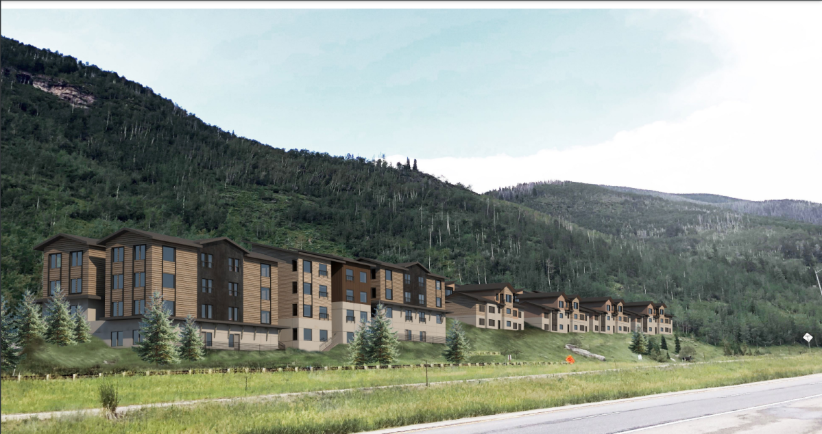
The Town of Vail council is promising to reject a plan by Vail Resorts to build an affordable housing project -- seen here in an artist rendering -- on land the company owns in East Vail on Interstate 70. (Provided by the Town of Vail)
Vail Resorts last week announced plans to fast-track four housing projects at resorts in Utah, British Columbia, Vermont and Vail, adding 875 units for the company’s workers as part of a promise made last month to refocus on employees with more pay and housing.
The projects will be somewhat easy at Park City Mountain Resort, Whistler and Okemo in Vermont. But in Vail, North America’s largest ski resort operator will face angry opposition as it returns to the business of real estate development with a proposed $17 million complex for 165 workers. Vail Resorts plans to protect 17 acres of the 23 acres it owns from development and spend $100,000 to improve habitat for bighorn sheep that winter there. But the town council does not want any development in the habitat.
“I’m ready to go to war with Vail Resorts over this if we have to,” said Vail town councilman Kevin Foley, who expects the council will vote to condemn the property — which would prevent any development — if Vail Resorts applies for a building permit for its Booth Heights property in East Vail. (The council’s agenda for its Tuesday meeting includes an executive session with the town attorney to “develop a strategy for negotiations” with Vail Resorts.)
Vail Resorts discovered it owned the property in 2016. (It had been listed in county records for decades as owned by the Colorado Department of Transportation.) Vail Resorts asked the town to rezone the property on Interstate 70 from allowing duplexes on every acre to higher-density housing on about 5 acres. The town council narrowly approved the plan in 2019, despite ardent opposition from a minority of council members and neighbors concerned about the herd. An Eagle County District Court in 2020 dismissed a lawsuit filed by neighbors challenging the town’s approval of the project.
There’s a new council now, and the votes are there to stop development of Booth Heights, Foley said.
The council points to other parcels in the valley owned by Vail Resorts where housing would be a better fit. The operator has 12 acres near Lionshead Village where it once proposed — and won initial approval for in 2012 — a third village for the Vail ski area.
“I don’t see them acting in our best interest or the town’s best interest,” Foley said. “Look, we need employees and we need housing but we don’t need it at the expense of a herd of sheep who have been here longer than any of us have been here.”
The Town of Vail and wildlife officials erected fencing around bighorn habitat in East Vail along Interstate 70 in April 2020 after two sheep were struck by vehicles. Vail Resorts wants to build workforce housing on the parcel it owns in East Vail, but town officials do not want housing in the area where a bighorn herd spends every winter. (Hugh Carey, The Colorado Sun)
A Vail Resorts spokesman provided a statement saying “any effort to delay affordable housing that is already approved and ready to be built is inappropriate, especially given the urgency of the affordable housing crisis in Vail, and as high-end homes in this same area are built without interference from the town.”
Vail Mayor Kim Langmaid is quick to point out that council opposition to development at the East Vail parcel has nothing to do with vocal neighbors opposing the housing project.
“Booth Heights would have been built right now and town probably would have been funding it were it not for the bighorn sheep,” Langmaid said. “Vail Resorts has had multiple opportunities to build housing with us and we have tried and tried again to get them to pursue other alternatives. We are very concerned about the bighorn sheep there and we don’t want to lose them.”

Fixing labor struggles with housing
Vail Resorts struggled this season to staff its resorts after selling 2.1 million advance tickets and passes. The company was lambasted for its inability to open lifts and terrain during the busy holiday season last year. Last month, Vail Resorts chief Kirsten Lynch pledged $175 million to bump the starting wage for seasonal employees to $20 an hour. Lynch also pledged to develop more housing for its workers. The plan announced last week includes 441 units at Park City Mountain Resort, 240 units at Whistler-Blackcomb and 30 units at Okemo.
Beth Howard, the chief operating officer at the Vail ski area, said in a statement that the company’s $17 million Booth Heights plan will be “met with concern and opposition from some in the community.”
Vail Resorts has steadily shed its real estate business in the past decade but plans to build Booth Heights itself and has hired Denver-based OZ Architecture to design the housing. (The previous plan involved Vail Resorts selling the parcel to a developer.) The company said it expects to open Booth Heights by December 2023.
Howard said Vail Resorts will spend $100,000 for habitat improvements for the bighorn herd. She said the company “developed extensive wildlife protections” for bighorn after working for three years with Colorado Parks and Wildlife on the property.
“Every new development brings environmental concerns, and we took seriously those raised in regard to this project,” Howard said in the statement. “In addition to doing our part to mitigate environmental impacts, we must also balance those concerns with the urgent need for affordable housing.”
Vail Resorts officials noted town approvals for mansions near the property, including luxury duplexes on nearby Katsos Ranch Road built in 2020.
“We, as a community, need to be careful not to give the green light on high-end expensive homes, but then block affordable housing in the same area,” Howard said.

Opposition to affordable housing across Colorado’s high country
There is a long history of opposition to projects that increase housing density in Colorado’s high country. Even as skyrocketing prices push out more workers, that time-worn anger continues. Local papers are swollen with letters to the editor and columns warning of impacts to traffic, roads, schools and “community character” from higher-density, multi-family development.
There are very few high-density housing development projects in mountain valleys that do not generate opposition. Here’s a list of a few projects stirring opposition right now:
* Last November, the Glenwood Springs city council voted to annex and rezone 16 acres in West Glenwood, where a developer wants to build 300 units next to a tired mall. The 480 Donegan plan calls for 60 rentals for locals earning close to median income, 200 more affordable workforce rentals and 40 market-rate townhomes, with donated land for a park and a fire station. Neighbors opposed to the annexation pushed the plan onto the city’s May election ballot, arguing voters should repeal the annexation over concerns that the added population could clog evacuation in case of a fire.
The Glenwood Springs Citizens for Responsible Development group urges voters to remember when a pre-evacuation warning due to fire in August 2020 led to gridlock in West Glenwood.
“Fresh in our minds, as we sat in our stationary vehicles, were the images of people burning to death” while fleeing California’s Camp Fire in 2018, reads the group’s plea to voters.
* A hearing earlier this month with the Roaring Fork Valley Regional Planning Commission saw neighbors of a proposed affordable housing project along Colorado 82 near Basalt lined up in opposition.
“Eagle County is responsible when the first kid gets killed on this road,” one neighbor said, opposing the 7-year-old plan — called The Fields — to build up to 135 residences on 19 acres now zoned for nine homes. (There is a lot of support for the project, too, with the planning commission receiving dozens of emails supporting the development plan.)
* In Telluride, the town and San Miguel County plan to buy three 35-acre parcels — each zoned to allow one home — where the municipalities propose a rezoning to “community housing,” which allows for more density.
“How would you react if you paid $1 million for a lot next to this proposal and you built a $2 million house? You followed the HOA rules and now the county wants to build 400 local housing units next to you? Think about that,” said a longtime Telluride real estate broker who asked not to be named, worrying that community members would blast them for opposing affordable housing.
* The Telluride Historic and Architectural Review Commission is struggling to adjust plans for the town’s proposed 29-unit Voodoo Lounge affordable housing project to fit the town’s design guidelines for buildings in a National Landmark District. The town council has called the project up for review before the historic review commission has finished its work with the architects.
“That is creating a lot of stress in our community,” said Sherri Harvey, a 12-year member of the commission. “People say as the developer they shouldn’t stop the review process or be the ones to step in to apply the design guidelines. Our board is threatening to quit, and lawsuits are already being whispered.”
*Fire and police officials are raising safety concerns around a proposed 50-unit affordable housing complex in downtown Rifle. The Rifle town council has expressed support for the project.

Supply chain, labor crisis, high interest rates challenging builders
Local opposition and zoning challenges surrounding housing density are not the only headwinds facing builders of affordable housing in Colorado’s high country.
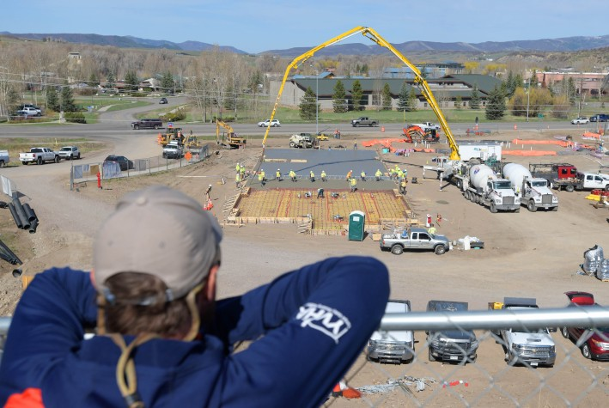
Yampa Valley Housing Authority Executive Director Jason Peasley watches as the first slab is poured at his organization’s latest affordable housing project along U.S. Highway 40 in Steamboat Springs on May 7, 2021. The Sunlight Crossing development, built by Gorman & Co, will have 90 rental units priced for residents earning between 80 and 120 percent of the area median income. (Matt Stensland, Special to The Colorado Sun)
New residents are remodeling and booking contractors for the next several years. Supply chain issues are making it difficult to find building materials. A critical lack of trade workers — largely due to the lack of workforce housing in mountain communities — is challenging builders. And in recent months the cost of borrowing has doubled as the Federal Reserve tackles inflation with increased interest rates.
“I don’t know if any community in the high country is immune to all this right now,” said Kimball Crangle, who heads Gorman & Co.’s Colorado projects and has built 900 affordable units in the Front Range, Summit County and Steamboat Springs.
Developers are navigating what Crangle called “a very unprecedented time,” with shifting forces that could lead to project delays, re-designs, postponed approvals and spiking costs.
In communities where residents are fighting development plans, these challenges can be “fuel for their fire” as projects stall, Crangle said.
“For NIMBYs, this is going to feel like a win at a time when the ones who are losing are workers commuting long distances and living in overcrowded conditions,” Crangle said. “And the employers, big and small, including ski resorts, hospitals and school districts, that are struggling to find staff.”
Legislative help with housing is coming. A new law allows more than two dozen Colorado communities to possibly redirect tourism taxes toward housing. There’s a flood of federal money coming into the state, too — as much as $400 million for affordable housing — that could fast-track projects. But communities will be battling each other for a share of that money.
“Communities have an opportunity if they are working together to leverage those funds and make a big impact, but it’s going to be competitive between communities, based on who can access that money and deploy a plan within the timelines that are required,” Crangle said.
High interest rates and the rising cost of new construction could drive more developers toward converting existing buildings, like hotels, into workforce housing. But as communities crack down on short-term rentals, taking hotels out of the lodging mix could impact tourist-based economies.
“I hope the name of the game will be finding a balanced approach that works for the community and balancing the supply of housing and lodging,” Crangle said. “Communities that block housing are going to stifle that balance.”
George Ruther, the director of the Town of Vail’s housing department, said rising construction costs, interest rates and inflation have made the housing problem in his town even more acute.
He’s glad to see Vail Resorts stepping up with a plan, noting that the last housing project built by the resort operator is almost 20 years old.
“And that came about purely as an obligation to meet a housing mitigation requirement,” Ruther said. “As the largest employer in Vail, housing solutions from Vail Resorts are much needed and long overdue.”

