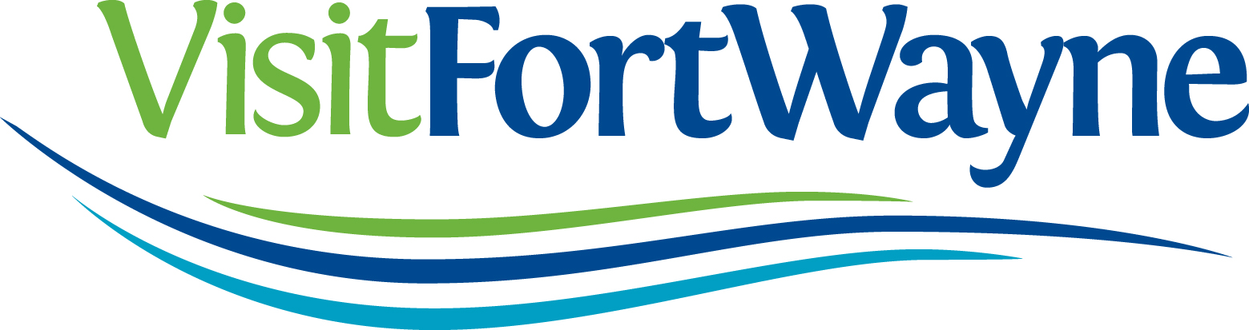

Visit Fort Wayne is looking for a group of students to help us promote Fort Wayne in our target markets at events like the Indiana State Fair and attractions like the Indianapolis Zoo.
We are looking for a group of students that are enthusiastic about Fort Wayne, and able to commit to working 10 summer weekends. Street Team members will be paid $10/hour.
If interested, please fill out the application below, or print an application and submit it to:
Jessa Campbell
Marketing Communications Coordinator
Visit Fort Wayne
927 S. Harrison Street Fort Wayne, IN 46802
jessa@visitfortwayne.com
(260)424-3700
_________________________________________________________________________________________________

General Information
Name
Email Address
Primary Phone
Personal
How would you describe yourself in three words?
Please explain why you would be a good fit for the Street Team?

How familiar are you with Fort Wayne’s attractions, restaurants, hotels, events, and things to do?

Fort Wayne Experience
What is your favorite Fort Wayne Attraction?

What is your favorite thing to do in Fort Wayne?

How would you encourage people to visit Fort Wayne?

If you are speaking to a Mom of three children, what would you encourage her to do in Fort Wayne?

If you are speaking to a couple in their 60’s, what would you encourage them to do in Fort Wayne?

If you are speaking to a twenty-something, what would you encourage them to do in Fort Wayne?

Other
Which of the following weekends are you available to work? We are looking for individuals willing to work 8 of these 12 weekends.

- May 19, 20, 21(Indy zoo)
- May 26, 27, 28 (South Bend)
- June 2, 3, 4
- June 9, 10, 11 (Indy Zoo)
- June 16, 17, 18 (Toledo Mud Hens)
- June 23, 24, 25 (Toledo Art Fair/Mishawaka)
- July 7, 8, 9
- July 14, 15, 16
- July 21, 22, 23 (Elkhart)
- July 28, 29, 30 (Elkhart)
- August 4, 5, 6
- August 11, 12, 13 (Maumee/IN State Fair)

*Please note, you will most likely only have to work either Friday, Saturday or Sunday, but there may be a weekend you are asked to work on Friday, Saturday, and Sunday.

Anything else you would like us to know?

Please attach your resume along with this application.

Thank you very much for your interest in Visit Fort Wayne
and in promoting our community!

