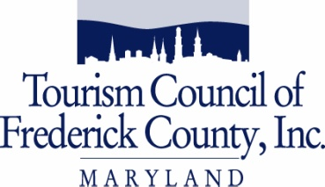
FY23 Frederick County Tourism
Reinvestment in Promotion & Product (TRIPP) Program

Workshop RSVP

Location of workshop:
Frederick Visitor Center Theater, 151 S. East St., Frederick, MD 21701

Let us know which workshop you are planning to attend by choosing one workshop date:

Friday, February 11, 2022 – 1:30 pm
Submit form no later than February 10, 2022

Monday, February 14, 2022– 1:30pm
Submit form no later than February 11, 2022
Name(s) of attendee(s): 1) _____________________________________________
2) _____________________________________________

Please note that attendance to one of the workshops is strongly encouraged for all applicants. The person responsible for applying for the grant AND the person administering the grant and related project are both encouraged to attend.

Please provide accurate contact information and RSVP by the deadline in case we need to cancel the workshop due to inclement weather. If the first workshop is cancelled, the make-up workshop will be Monday, February 14, 2022.

Organization: ___________________________________________________________
Contact telephone: ___________________________________________________________
Contact email: ___________________________________________________________

Please fax (301-600-4044); Email: pensminger@fredco-md.net; or mail to
Tourism Council of Frederick County, 151 S. East St., Frederick, MD 21701

Parking for the Frederick Visitor Center - The closest options for parking are the E. All Saints Street parking garage ($1 per hour), or parking meters on E. All Saints St. (25 cents per 15 min.). If you are from outside of Frederick County, we can validate your parking deck ticket if you bring it to the Visitor Center desk.

Please do not park in the small number of 45 min. spaces reserved for Visitors to the Visitor Center in the surface lot next to our building. The remainder of that lot is permit-only on weekdays for Frederick County Public Schools employees.

151 S. East Street/Frederick, Maryland 21701 • 301-600-2888/ 800-999-3613/ Fax 301-600-4044

www.visitfrederick.org • email: pensminger@fredco-md.net

