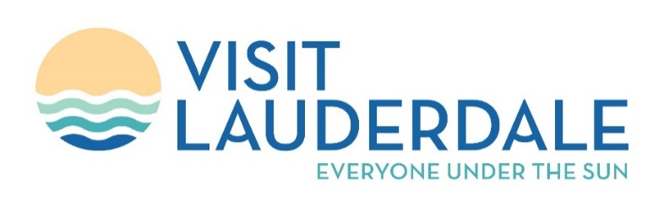
MEETING MINUTES April 12, 2023
GFLCVB Marketing Advisory Committee (MAC)
10:00am – 12:00pm
Broward County Convention Center
Members Present:
Arianne Glassman, Bobby Rodriguez, Chris Bielski, Christine Soverns, David Muir, Elaine Fitzgerald, James Pancallo, Jenni Morejon, Joellyn Fellmeth, Kara Lundgren, Keith Blackburn, Marie McKenzie, Matthew McNeil, Melissa Milroy, Meredith McCleary, Michael Cook, Raelin Storey, Robert Kessler, Ron Drew, Tim Petrillo, Von Freeman
Members Absent:
Ina Lee, Thomas Parke
Intro:
Tim Petrillo called the meeting to order at 10:05 a.m. Roll call was conducted. Camila Clark did welcomes and introductions.
Overview:
Steve Belleme, representing the Fort Lauderdale International Airport was introduced to the Committee. He presented us with a status report and updates at the Airport.
- International passenger traffic has increased due to increased service by several existing carriers and new service by Azul, Norse, Flair and Western Air.
- Airlines are flying bigger planes, allowing for more seats.
- As of April 2023, we are flying to 91 countries.
- Norse now has new service to London; El Al has new service to Tel Aviv and Jet Blue to introduce service to Tallahassee in 2024.
- Terminal 5 has an estimated completion of 2026.
- Connectors for T1, 2 and 3 has an estimated completion date of 2027.
- Airport hotel construction to begin in 2024, people move completion in 2026.
Travis McClure from Aqua presented an update on our marketing plan.
- Paid media spend is at $3.4 million, with 272 million total impressions.
- GMA segment was presented to the Committee.
- Digital billboards were purchased in New York and 10 other markets.
- Live Nation provided two influencers to experience Tortuga Music Festival, resulting in an additional 1,000,000 impressions.
- Life on the Water was presented to the Committee.
- Avi Rahm had his first project at Sea Trade.
- We will be introducing 101 Days of Summer, beginning Memorial Day Weekend, and concluding on Labor Day Weekend.
- Visit Lauderdale is sponsoring Pride of the Americas.
- Inclusion and accessibility marketing on YouTube, Google, The New York Times, AFAR, Facebook, Instagram, Clear Channel, ABC, Departures and Travel Weekly.
- Visit Lauderdale will be featured on Travelling with Denella.
- Visit Lauderdale is also sponsoring Winterfest Boat Parade, Visit Lauderdale Food & Wine Festival, NHL All-Star, Fort Lauderdale Air Show, Florida Renaissance Festival, Fort Lauderdale International Boat Show and Tortuga Music Festival.
Monica Ruiz of Monetize presented social media Q1 update.
- Q1 Social Reach 8.5 million.
- 51% increase in social media.
- Visit Lauderdale’s Instagram grew +9%, higher than Visit Tampa Bay, Visit St. Pete/Clearwater and much higher than Greater Miami and Beaches.
Michael Pouey & Eduardo Zuniga were then introduced to the Committee. They presented the following:
- Update on the Visit Lauderdale Sales Team and progress in Convention Sales efforts.
- Overcoming Sales Hurdles. Convention Center was closed for two years due to the pandemic and Convention Center’s construction.
- Groups Returning: CLIA, Cruiseworld, PriMed, Cheney Bros, AAU Karate, AAU JUDO, AAU Taekwando and Cruise Planners.
- Strategies and Tactics to amp up and pique interest in our expansion.
INDUSTRY UPDATE:
- How will we handle Spring Break moving forward? We need to look at it and manage it. Visit Lauderdale is currently marketing away from Spring Break.
- The trend for restaurants is that there is a higher spend in 2023.
- Lodging Association for Pompano Beach and Lauderdale by the Sea – Small Lodges are sold out for next winter. Pompano Beach is creating a new downtown from scratch. A meeting to determine which master developers will be creating the new downtown. Meeting is on May 33rd at 5:30p at the Pompano Beach Cultural Center.
- Carnival is trending above 2019 revenue. Princess Cruises is making Port Everglades their home.
- Hollywood is making a 14-million-dollar beach investment. Street scape improvement is in progress for the downtown area.
- Island Caribbean Museum, located in the Broward Mall, re-opened on April 8. It had a great turnout. Pirate Fest coming up April 29th.
- Lago Mar – Q1 was good. Seaweed comes in about this time every year.
- Growth for Harbor Beach Marriott has strong group, shorter stays. ADR growth not as strong as previous years.
- Alliance has created Fort Lauderdale to the rescue, targeting tech employees that have been laid off to come here to work.
- Parker live events and Broward Center attendance is robust. November until April is the busiest time of the year. Broadway Season through 2024 is at 80%.
- Sawgrass Mills business is good. Interior Sawgrass is also very good. Brazil, Columbia, Argentina, Ecuador and Israel coming in to shop. New group business is coming back as well.
- Galleria is doing well.
- Margaritaville doing well and made budget. Just finished Savor SoFlo, with about 1,600 in attendance.
- Renaissance Festival was extremely successful, with over 100,000 in attendance.
- Revenues are increasing above and beyond 2019.
Port Everglades was discussed as to why they didn’t change their name. The Port people felt that it would cause more confusion. More than 70% percent of the Port is in the City of Hollywood, and it merits more conversation. Recognize that the Port is doing very well. Cruises are doing very good, Disney is coming to the Port and the container cargo is setting record levels. It should be consistent in our marketing. Broward County has an identity crisis.
The bill was going to the house to eliminate Visit Florida. Florida Chamber of Commerce spoke against the bill, every tourism Commission spoke against the bill and the only group that spoke in favor was Prosperity for America. It is gaining more strength than usual. There is current no Senate bill at the moment.
Meeting Adjourned 11:47 am

