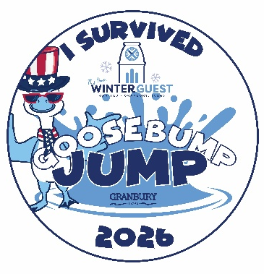

Granbury Goosebump Jump
Waiver and Indemnity Agreement

Date: Saturday, January 17, 2026
Location: Lake Granbury Conference Center
Registration Fee: $10
Participant Name:________________________________________________ Date of Birth:_____________________
Emergency Contact:_______________________________________________ Phone:____________________________

Risks
Jumping into a body of near-freezing water is not an activity to be taken lightly, and in deciding to do so, you should understand the many risks of this activity can include:

- Cold water will generate shock to your system. This may leave you gasping for air and unable to hold your breath. Blood vessels along your outer body will constrict, attempting to shift blood to your inner organs. Your muscles will get very cold and may become temporarily paralyzed or weak. Drowning is a very real risk if you are not careful.

- A cold-water plunge may increase your risk of heart attack. For those at risk of stroke, aneurysm, blood pressure problems, or heart disease, the constricting of blood vessels and extra stress on your body can be especially dangerous. Even among healthy people, the adrenaline release that occurs during a polar plunge can lead to irregular heart rhythms.

- A cold-water plunge may increase your risk of stroke. When temperatures decline, your blood pressure tends to go up, particularly in older persons. When you are cold, your arteries may constrict, which means your blood must be pumped with greater pressure in order to reach all areas of your body. The higher blood pressure is one of the largest risk factors for stroke. Exposure to such change in the cold temperatures may lead to a rise in your blood pressure that in turn, raises your stroke risk.

If you know you have high blood pressure, are at an increased risk of stroke, or are elderly, cold-water plunges may pose too much of a risk for you.

Even if you are healthy, you should prepare yourself for this cold-water plunge by immersing yourself on a regular basis, or “prime” your body for the plunge by taking gradually colder showers for a few days. This may help you develop a tolerance to cold water. It is also important to immerse yourself in the water gradually before you take the complete plunge, such as walking in as opposed to fully jumping in which leads to such a sudden change in your body temperature that may cause health problems.

Primary Assumption of Risk
I understand the nature of this event and risks associated with a cold-water plunge. If I have any concerns about my fitness to participate, I will consult with my physician prior to the event. I understand that Visit Granbury/the City of Granbury will not evaluate my fitness for participation in this event and that I am solely responsible for determining my fitness to participate in the event. By participating in the event, I understand that I am assuming all the risks of harm that are associated with this activity. If I have any reason to believe that it is not safe for me to participate in the event for any reason, I will immediately discontinue my participation. If I choose to participate in the event, I understand that Visit Granbury/the City of Granbury will not be liable to me or any other person for harm or damages I may sustain as a result of the risks of harm that are associated with this activity.

Age
I agree that I am 18 years of age or older. Yes _________

I agree that as a minor, I have my parent/legal guardian to accompany me and acknowledge and agree to the terms and conditions of the registration form. Yes _______

Photo Release
I understand Visit Granbury may take video and photographs of me before, during, or after I plunge. I authorize these videos and photographs in their promotional materials, including, but not limited to, website and social media.

_____________________________________________________________________ Date: ____________________
Signature of plunger, parent, or legal guardian

_____________________________________________________________________ Date: ____________________
Printed name of plunger, parent, or legal guardian

Participant Information:

Address: _____________________________________________________________________________________

City: __________________________________________ State _____________ Zip: _______________

Phone: ______________________________ E-Mail: _______________________________________________________

Team Representing: ________________________________________________________________________________

Charity I am Jumping to Support: ______________________________________________________________________

$10 Chili on the Beach Tasting Add On: Yes_______ No_________

Total amount paid: _________

