Burgundy

Brigade

Handbook

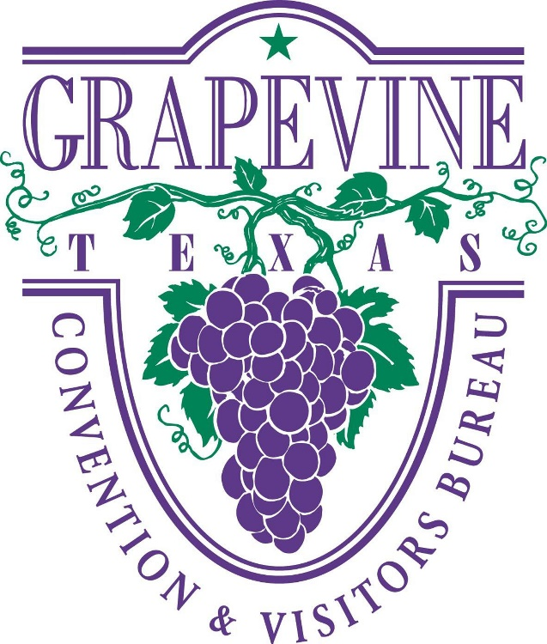

**November 2022GRAPEVINE CVB’S MISSION STATEMENT**:

The Convention & Visitors Bureau acts as the promotional arm of the City of Grapevine and is responsible for actively selling, marketing and publicizing Grapevine globally. The Bureau promotes the city’s hotels, meeting facilities, historic and family attractions, festivals and events, dining establishments and retail businesses to the group meetings and leisure markets.

**GRAPEVINE CVB’S BRAND PROMISE**

Grapevine is the premier destination city in North Texas. We offer visitors a unique blend of historic Texas heritage, combined with contemporary amenities. Whether in Grapevine for business or pleasure, visitors will find world-class hotels, excellent dining options, abundant live entertainment, diverse retail shopping, historic and family attractions and internationally award-winning festivals, all delivered with the finest in Texas hospitality.

**BURGUNDY BRIGADE MISSION STATEMENT:**

As members of the Burgundy Brigade Registration Assistance Team, our goal is to fulfill the Grapevine CVB’s mission statement. In addition, we are an extension of the hotel staff and meeting planner(s) whom we serve, as well as ambassadors for the City of Grapevine. Our actions must be beyond reproach, at all times.

MCj04350450000[1]

WELCOME!

**TABLE OF CONTENTS**

MCj04135520000[1]

* **BURGUNDY BRIGADE’S ROLE: Pages 4-6**
* **HUMAN RESOURCES: Pages 7-14**
* **KIOSK/CONCIERGE TABLE: Page 15-17**
* **SAFETY & OTHER ITEMS: Page 18-20**
* **GRAPEVINE HOTEL INFORMATION: Pages 21-30**

**-KNOW YOUR HOTELS**

* **HELPFUL WEBSITES: Page 31**

**The Burgundy Brigade’s Role**

The Burgundy Brigade is a vital link between meeting planners, convention delegates, exhibitors, visitors, hotels and the City of Grapevine. Often, the Burgundy Brigade may be the one contact that a visitor has with Destination Grapevine. We are hospitality specialists who serve in different capacities and extend the hand of friendship to our visitors while being an extension of the organization that hires our team.

The Burgundy Brigade offers individuals a wide-variety of tasks that change from day-to-day and group to group.

**Know Your Job**

The Burgundy Brigade’s position is to be on board to take direction for a plan that the meeting planner has spent months, or maybe years designing for their convention, meeting or event. In other words, we are foot soldiers. It is important to refrain from critiquing or evaluating how the meeting could work better. Since we do not know any of the behind the scenes goals, functions or budgets that must be achieved, input from us is inappropriate.

We are not working in executive positions nor are we the research & development consultants. If there is a problem within the meeting, we are only slowing down the process by making the meeting planners listen to our unsolicited brainstorming. In the past, each of us may have had jobs where we were the movers & shakers. However, the Burgundy Brigade position is not that job. Our job is to perform the tasks that have been outlined on our schedule; ready to be a second pair of hands.

**DO**:

* …Be ready to be trained and learn our client’s way. Be flexible, be focused, hospitable and have fun.
* …Be personable – the host/hostess with the mostess.
* …Be positive, about Grapevine and everything…at all times. You never know with whom you are speaking.
* …Read every issue of Grapevine Today as it has comprehensive and pertinent information.
* …Review and be knowledgeable about our CVB web site: [www.GrapevineTexasUSA.com](http://www.grapevinetexasusa.com/).
* …Treat the delegates and meeting planning staff as if they are guests in your home. Tell them about Grapevine’s history, landmarks and favorite places. Share your enthusiasm for Grapevine with them.
* …Be helpful. Go above and beyond to provide extraordinary service, without putting yourself in harm’s way.
* …Tell our guests about the Grapevine Visitors Shuttle (for shopping, dining and entertainment only, **NOT** for airport transfers) and other transportation options, i.e. Gaylord’s Executive SUV service, Hertz, etc. Some hotels offer complimentary airport transportation and complimentary shuttle service within a designated distance of their property.
* …Tell our guests about the Shop, Wine & Dine Grapevine brochure.
* …Tell our guests about hotel services (business center, restaurants, other services, etc.)
* …Tell our guests about Grapevine’s Kiosks (if at Gaylord) two locations hotel front lobby servicing Vineyard Tower meetings/guests and Convention Center or the Concierge Table provided upon request at other hotels, if applicable. NEVER RECOMMEND a specific restaurant or business. Offer suggestions in the category and price range that interests the guest. Additional information is available in the information book to help guests with their decision.

Your job is to satisfy the guest’s need with services provided within the city limits of Grapevine. As Ambassadors of the City of Grapevine, our job is to ensure a return on investment (ROI) to those businesses that are in Grapevine.

* …Watch your body language: Smile…even if your hair is on fire!

* …Learn when to speak and when to refrain from speaking.
* …Be a good worker, a great plan follower, a gracious and knowledgeable Ambassador for Grapevine. Most of all, be a good friend: one who refrains from giving unsolicited advice especially during the trying moments.
* …Attend all training classes i.e. Destination Grapevine, Workplace Standards etc. as required by the City and/or CVB.

**DO NOT**:

* …Think of better ways to organize the meeting.
* …Interrupt or be overzealous. Listen carefully to the client’s explanation and ask only relevant questions after receiving instructions.
* …Change a procedure because you think there is a better way. A meeting planner has a reason for asking that a job be executed in a certain manner, which is not always evident to our team.
* …Discuss the last good or bad meeting.
* …Give your executive advice from a previous job.
* …Discuss how planners or participants look or dress.
* …Ever hint that you desire anything (working tools, promotional items, food, etc.) provided for the delegates.
* …Take sides or discuss “inner conflicts” among the planners. Always remain neutral.
* …Protest or expect to remain on the job if you are released early. Schedules are subject to adjustment. The person with the most hours or overtime hours should be first to volunteer to leave early.
* …Discuss politics, sex or religion – ever.
* …Use cell phones while on the job unless you are assisting a guest. Cell phones are to be turned on vibrate mode during your assigned shift. Check your messages **during breaks only**.
* …Gossip. It is unacceptable. Keep your personal comments regarding other Burgundy Brigade members out of the workplace. If it is an issue that requires discussion, please contact Human Resources.

**HUMAN**

**RESOURCES**



**Human Resources**

Burgundy Brigade staff is classified by the City of Grapevine as ‘casual’ or ‘as-needed’ employees. This means that all legally-mandated benefits i.e. workers’ compensation, Employee Assistance Program (EAP) are extended. However, this position is not eligible for city sponsored benefit programs. A casual employee may work up to 1,000 hours within a year which begins on January 1. **Each member of the Burgundy Brigade is expected to work at least 150 hours per year. Please visit with us if you are not able to make this commitment.**

**PRE AND POST ASSIGNMENT ACTIVITIES**

**Training**

Orientation will be provided as well as a guided tour of the Gaylord Texan. All training will be “on the job” training. You will be assigned with a more experienced staff member for a minimum of five jobs.

**Required Training**

At times it will be mandatory for you to complete training that is require by the City of Grapevine i.e. Work Place Standards or other types required training. You will be required to clock in and out when you start and finish the training. A comment code will be provided in advance for you to enter in Paycom.

**Communication**

Email is the primary and most effective method of communication when working with a staff as large as the Burgundy Brigade. Please be sure to check your email **daily** since it is the Burgundy Brigade’s lifeline. It is also wise to check your spam folders as sometimes emails are mysteriously redirected to spam.

**Texting**

Used in most cases for last minutes job request or possible Paycom action needed items. Your cell phone provider is needed in order to set this up. If you change your cell phone provider, please let us know so we can update your provided.

**Scheduling**

Be sure to promptly submit your availability when it is requested. It is our goal to fairly distribute the work opportunities. Individuals who have submitted their schedules will be contacted first for positions. Everyone needs to submit their availability whether they are available or not.

You will be contacted **primarily via email** about an assignment. **Be sure to reply within 24-48 hours**. If a response is not received within 48 hours, the opportunity will be offered to another team member. If time is of the essence, you will be given a response deadline.

When last minute staffing requests are received, an email blast and/or text message are the fastest ways to notify you. Calls to the home phone, and then to the cell phone (unless we have been instructed not to use the cell phone) are last resorts. Since time is of the essence, if you cannot be reached, we will continue calling other team members until all the positions are filled.

For larger groups we may ask for your availability to hold certain dates well in advance of the 6 week staffing time frame. If we do, and you say you are available, we ask that you keep your commitment (unless an unforeseen emergency arises) since we are making a commitment to the group that we have the available staff to fill their requested shifts.

**If you have accepted an assignment and have not received your work confirmation at least 3 days prior to your assignment (unless it was a last-minute request) contact either Betty Torres at 817.410.3538 or Margaret MacGregor at 817-410-3121 based on who sent you the email asking you to work the assignment. Never assume you are working or not working an event if you have not received your confirmation. Always expect a confirmation email with full assignment details.**

If you accept an assignment and it is canceled, you will be notified by either email or phone/voice message depending on how far out it is. A reply back is needed to ensure your received the cancellation. If the planner cancels your shift 48 hours or less, you will be paid the 4-hour minimum**. If your ability to fulfill a shift is in question, please do not accept the assignment.**

**Canceling Your Shift**

If you are unable to fulfill your commitment to work your shift, please provide as much advance notice as possible in order to find a replacement.

**Canceling your shift if MORE than 24 hours prior** - If you need to cancel your shift and it is during normal office hours, Monday-Friday, 8am-5pm contact Betty Torres at 817.410.3538 or Margaret MacGregor 817-410-3121 based on who appears on your confirmation first or who scheduled you. If you cannot reach either of us then contact David Taylor, Destination Services Director at 817.410.3191. You can email or leave a voice message; **however, it is important** **you receive a response** to let you know that your voice message/email was received. If not, it is your responsibility to follow-up with Betty, Margaret or David.

*Emailing in **SUBJECT**: Cancel Shift for XYZ for June 21 & 22.

**Canceling your shift if LESS than 24 hours or on Saturday or Sunday-**

**DO NOT SEND AN EMAIL. You must call**.Please do the following as listed on your work confirmation:

**1st the Destination Services Director is your first point of contact on weekends and after office hours**

If the Destination Services Director cannot be reached, check your work confirmation for your **second point of contact** listed.

Always leave a message. If you don’t reach the person you are calling allow ample time, 20 minutes or so for the call to be returned, before calling the next person.

If David or Joe cannot be reached, then call/text Betty at 972.948.3224.

If time permits, we will try to find a replacement and will notify the planner.

**Running late or sick -** if you are running late for your shift or are sick on the **day of your** **shift, YOU are to call the meeting planner,** listed on your confirmation papers,to let them know your expected time of arrival. If you are sick, please ask the planner if a replacement is needed and if so, follow the instructions above regarding whom to contact.

**Overtime Policy**

The City of Grapevine work week begins on Sunday and ends on Saturday. Hours worked over 40 including any CVB or City assignments during that week is overtime. Overtime is not permitted without approval in advance of the occurrence. **It is important that you know the total number of hours that you are scheduled to work within a week (sum of all assignments that week).**

If a planner asks you to stay, causing you to incur overtime, then the planner must agree to pay the overtime. A note in Paycom must be entered: name of the planner who authorized the overtime, with date and time you were asked to extend. If there are any concerns regarding this procedure/policy, please call.

**Prior approval is not needed if the request to stay longer does not put you into overtime or if the planner is willing to pay overtime.** A note in Paycom as described above is still required. If you cannot stay as requested, politely tell the meeting planner that you have other commitments and are unable to stay. Be gracious. Avoid any abrupt or curt tones.

If you worked other jobs during the same week, those hours must be considered if you are being asked to extend your shift. If this is the case and the planner asks you to extend your shift, please let them know that you will be in overtime and need their approval to pay it. When scheduling, the hours of each team member are tracked to avoid overtime. **However, it is your responsibility to know your schedule and to avoid overtime.**

Sometimes groups are willing to pay overtime in order to keep the same people. In this case, if the planner asks for volunteers to leave early, those people that have overtime should be the first to offer to leave.

**Paycom**

Please see Paycom Handbook – Show Me How.

**ON THE JOB - PREPARING FOR YOUR ASSIGNMENT DAY(S)**

Preparation means that you are physically and mentally ready to work. Once you accept the assignment, please be prepared to work. While the Burgundy Brigade works in the hospitality industry which naturally creates a social environment, the client, guests and work come first. Socializing is for breaks and personal time.

**Review your paperwork…**

**Read the email** that is sent with your schedule/work confirmation it contains important information about your assignment. Review your schedule when received to verify the day(s) and time you are to report to work.

**The Day of…**

* **Be sure to have yourself well-nourished before you start your day**. You should be prepared to work five (5) hours before expecting a 15-minute break. If the onsite contact or their designee asks you to take a break sooner or later than you would prefer, please accept their request graciously and abide by their meeting schedule.
* **Check your email prior to leaving for your shift.** Last minute shift changes may be communicated later in the evening, so always a good idea to check your email.
* **Always arrive at the work location at least 15 minutes before your shift begins**. This is to allow extra time for unexpected “Red Flag” days, heavy traffic or other unexpected occurrences. You must be in place and ready to start at the designated time on your schedule. You can clock in 5 minutes prior to your scheduled start time. You should always wait for the planner (first day only) to get there before you go behind the counter and start working. **Never** dismiss the security guard.
* **Know where to check-in**. Your schedule states your designated area and

on-site contact’s name and cell phone number. You have officially reported for your assignment once you have checked-in with the on-site contact. Present yourself. If you are having difficulty finding the on-site contact, call their cell phone, or find a hotel staff member and ask them to help you. Do not expect the on-site contact to look for you. We are proactive not reactive.

* **Be ready to find your position and task for the assignment**. Visit with other team members before arriving at the work area. It is not appropriate to visit with other work buddies while on task. If you need to “catch-up” call your friend the day before, get together for lunch the week before or meet before your shift starts. While our team enjoys each other’s company, it needs to be done on your own time, and not on the client’s or CVB’s dollar.
* **Break and meal policy (this is a guideline)**
  + ▪ 5 hours: one 15-minute break
  + ▪ 6 hours: one 30-minute break
  + ▪ 7-8 hours: one 15-minute break and one 30-minute meal break
  + ▪ 9 hours: two 15-minute breaks and one 30-minute meal break
  + ▪ 10 or more hours: two 15-minute breaks and two 30-minute meal breaks
  + *NOTE: Vineyard Tower assignments at Gaylord receive a 40-minute meal break to allow time to and from Gaylord’s employee cafeteria. 15-minute break remains the same.
* Staff may not partake in delegate coffee breaks in any public areas, meeting

rooms, etc. even if the client offers. This is because the Burgundy Brigade is an extension of the hotel/facility staff. If invited, staff may partake in coffee breaks in the client’s private office or break area.

* All groups receive our break and meal policy information. The planner is

told that our staff relieves each other for breaks. However, if an organization has a different arrangement for breaks or meals, we have asked them to let us

know in advance so we may inform the staff. If the information is not received

from the planner, normal policy is to work it out amongst each other. Breaks

are only to be taken during **non-peak times** and must be staggered to ensure

there is appropriate coverage, at all times. You cannot take your break at the

end and leave early.

* Always be considerate of your co-workers by returning from your breaks on time. Before leaving, confirm your return time with your co-workers. Do not stay beyond your committed time as others are waiting for your return. If a meeting planner is so kind as to invite you into a private staff area to lunch, please stay within your timeframe. If needed, the bathroom break is to be scheduled inside the meal break period. This applies to all meals, in all areas.
* Do not eat or drink in public. Water is ok, if authorized by the on-site contact. Be sure to keep the water out of sight and out of the way since you may be working around electrical equipment. Use your discretion. If water is delivered to you, please be discreet.
* Supervisors – supervision is provided primarily by each organization’s on-site contact. When an organization insists on a supervisor, one will be designated to be the planner’s single-point-of contact.

On occasion, an onsite contact may designate one of our staff to be the point of contact after the program begins. In either case, please be respectful of your co-worker who has been appointed this position, and give them your full support as they have been asked to handle a directive from the planner.

* Gifts/convention promotional items – occasionally, a meeting planner may give you promotional items. For security purposes and to protect you, be sure to obtain the meeting planner’s business card and note stating that the item was given to you as a gift.
* Excess convention materials at the end of the meeting – occasionally, convention bags or other premiums are left over at the end of the meeting. The shipping expense often exceeds the value of the items. In some cases, the meeting planner is interested in donating the items to a local charity (i.e. GRACE, GCISD, etc.) if our staff will facilitate the donation. Get a detailed note from the meeting planner stating he is donating these goods to local charity. The note should include his name, title and cell phone number in case Gaylord security personnel has questions. Bring the items through the convention center security exit and meet your party there to load the donations (or load them in your own vehicle to be dropped off to the charity). Do not take the items through the guest hotel entrance.

**REGISTRATION ASSISTANT-UNIFORM AGREEMENT**

Burgundy Brigade has a uniform that is professional and makes our team easily identifiable to meeting planners, delegates and hotel staff. You will be asked to sign a form agreeing to the below as part of your onboarding.

* Standard Uniform: Burgundy blazer, long-sleeved white collared shirt, black or navy slacks or skirt, dark-colored (black, brown or navy) shoes –comfortable, closed toed, good condition and Grapevine CVB Gold name badge.
  + The official uniform is as follows:
  + Burgundy blazer (provided). Black is acceptable, until one is provided for you.
  + A long-sleeved white and a long sleeve black collared shirt. Collarless shirts/blouses acceptable when specified by the client (no t-shirts). All shirts must be nicely pressed.
  + Black or navy slacks or skirt
  + Dark-colored (black, brown or navy) shoes –comfortable, closed toed, good condition.
  + Grapevine CVB Gold name badge (provided)
  + CVB staff polo shirt (provided)
  + Khaki slacks
* You will be issued (1) burgundy blazer and (1) CVB staff polo shirt you must sign for. Upon termination or resignation your last paycheck will be held until you return your blazer, CVB staff polo shirt, name badge and business cards. Blazers should be dry cleaned before returning it. If you lose any of the provided items, you will be required to replace it at your own expense.
* Employees are responsible for obtaining their own shirts (excluding CVB staff polo shirt) pants, and shoes.
* No substitutions (different colored shirts or slacks) in the dress code will be allowed.
* No jewelry on jackets except for a Grapevine cloisonné lapel pin, name badge or button(s) that you may be asked to wear while working a convention.
* Men do not have to wear ties unless the planner requests you to do so.
* The blazer is to remain on at all times, if possible. If taken off, your name badge should be worn on your blouse/shirt.
* Casual attire-nice jeans or khakis are acceptable provided the planner has approved. If approved, the information will be included on your confirmation email or detailed schedule. Crop pants, capris or open-toed-shoes are not acceptable.
* The Burgundy Brigade uniform is required for all jobs, unless otherwise noted.
* All attire is to be neatly pressed.

**GAYLORD** **KIOSK & CONCIERGE TABLE**

**Kiosks:** Front Lobby = Leisure Guests or Vineyard Tower Groups

FedEx Office = Convention Center Groups

**When working the kiosk**–being attentive to your surroundings is important. When people are in the vicinity, staff must be standing and ready to assist. Walk outside of the kiosk to engage guests in conversation and show that you are interested in helping them. NEVER recommend a specific restaurant. Guide the guest based on their preferred type of food and their budget. Let us know how the shift went by filling out the “Daily Kiosk Checklist.”

**~~Stocking the kiosk~~**~~–the kiosk is to be stocked at the beginning and the end of your shift. Additional inventory is located in the Convention Services Office Break Room on the Convention Center Mezzanine level.~~

~~To assist with moving inventory and for personal safety, there is a folding dolly stored and a rolling suitcase. Please obtain the needed inventory and use the elevator (not the escalator) to bring the supplies downstairs.~~

~~When restocking, please follow the labels for displaying literature and storing literature below the kiosk.~~

Personal books and magazines etc. are not to be left in the kiosk. Materials unrelated to kiosk or information desk operations are to be discarded at the end of the shift.

**~~Accessing the Convention Services office after hours or weekends:~~** ~~contact the Conference Coordinator (Teal Coat) who is assigned to the group you are working to ask for access to the Convention Services office. If a Conference Coordinator has not responded after waiting for a reasonable amount of time, 20-30 minutes, then call Security at 817-778-2480. In either instance, identify yourself as a Grapevine CVB Burgundy Brigade member who needs access to the CVB’s brochure inventories located in the Convention Services office.~~

**Additional Brochures**: The two visitor and convention services kiosks are stocked once per week, or as needed based on demand.  Surplus inventory is available upstairs.

If inventory in both the kiosk and the Convention Services supply area are low inventory or depleted please email [LDalton@GrapevineTexasUSA.com](mailto:LDalton@GrapevineTexasUSA.com) as soon as possible.   Please check racks to make sure you have the most up to date publications.  It can take up to one week to schedule a brochure delivery, so please don’t wait till stock is depleted, make note and email Lisa Dalton when inventory is low.  This prevents emergencies and helps streamline the brochure distribution team efficiencies.

The Visitor Information Center Concierge Desk telephone is 817-410-3189 and email is [GVMVC@GrapevineTexasUSA.com](mailto:GVMVC@GrapevineTexasUSA.com),  if you have any questions, please do not hesitate to contact one of our professional concierges, they are a tremendous resource and available to help you.

For the most up-to-date Visitor information visit: [www.grapevinetexasusa.com/plan/visitor-information](https://gcc02.safelinks.protection.outlook.com/?url=http%3A%2F%2Fwww.grapevinetexasusa.com%2Fplan%2Fvisitor-information&data=04%7C01%7Cdanderson%40grapevinetexasusa.com%7Cd90958ee2a204e1d543308d99ef30fcb%7Cf4c8bf84c7c145b490b1c7247654a6c0%7C1%7C0%7C637715589052739149%7CUnknown%7CTWFpbGZsb3d8eyJWIjoiMC4wLjAwMDAiLCJQIjoiV2luMzIiLCJBTiI6Ik1haWwiLCJXVCI6Mn0%3D%7C1000&sdata=bFAOm8UmcpsfO03cvRJawvelGUn1JZOmtU2FvXK%2BWp0%3D&reserved=0)

**Brochures: Obtain the following items from Gaylord:**

**-****Know Your Stuff (KYS) document:** If working theLeisure Kiosk or the Convention Center Kiosk please pick up this document at either security office, has the most up-to-date information taking place at the hotel.   
**-Gaylord Hotel Map**: Obtain maps at the Concierge Desk or Front Desk near front of hotel. Ask the person on duty for a shrink wrapped package. If not available, then a 4 inch stack (approx. 500). Fill the plastic holder on top of the kiosk with the map of the Convention Center visible. Put the extras in the kiosk.

**Satellite KIOSK/GRAPEVINE INFORMATION**

If at an alternate hotel we will need to recreate the Grapevine Information Kiosk. Please follow these steps when picking up the satellite kiosk suitcase.   
**Note:** instructions will be provided with your email confirmation/schedule.

**Current CVB Headquarter Hours**: **Mon. – Fri**. 8 a.m. – 5 p.m.

**Sat.** 10 a.m. – 4 p.m. (seasonal); **Sun.** – Closed. Hours may be adjusted during Festivals & CCOT.

**Picking UP the Suitcase/Banner:** If the time you are scheduled to work allows you to swing by the CVB first then head to your shift, please do the following:

* Once you arrive inside at the CVB HQ, please clock in using the group comment code provided on your schedule. Once you picked up the supplies, you will proceed to the location for your shift.
* If the shift time does not allow you to stop by prior OR you prefer to pick it prior we will get the suitcase/banner ready for you to pick up the day before your shift. We will add unit of 15 minutes to your time for picking up the supplies. If we see there is not enough time to pick it up prior to your shift, we will automatically have it ready the day before for you to pick up.

**Returning the Suitcase/Banner:**

If returning supplies back to the CVB HQ immediately after you shift, do the following:

* DO NOT CLOCK OUT. After packing up supplies/banner, you will remain clocked in when you return the supplies to CVB HQ. Once you have dropped of the supplies, then select **OUT DAY**. Remember to verify the CVB HQ hours if open on weekend(s) and/or there is enough time for you to return supplies before the CVB HQ closes. You can always call 817-410-3185 to verify.
* OR if you prefer to bring the suitcase/banner back the following day or the CVB HQ is closed you may do so the next day (Monday’s always after 9 a.m.) When doing so let Destination Services know once you dropped of the supplies so we can add a unit of time of 15 minutes for this.

**PACKING THE SUITCASE:**

When your shift is over, please repack the suitcase as you received it. Brochure racks should ALWAYS be place at the bottom where the wheels are, otherwise if at the other end, they will all fall out and be bent etc.

**SYB Sign** – best kept **OUT OF THE SUITCASE** and on the side pocket of the suitcase. Past experience has shown it usually comes back cracked/chipped etc. if packed inside.

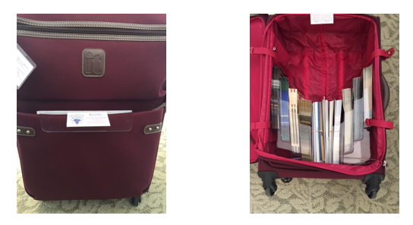

**SAFETY**

We work in large hotels and public venues with thousands of people. While we have the assurance of video cameras and security personnel to help maintain a safe environment, you are still in an area where thieves know people have more cash and valuables than usual due to travel. It is up to you to take responsibility for your personal safety and your belongings. Please have the same awareness as you would inside a mall or mall parking garage.

**At All Times:**

* Be aware, *watch your back.* If possible, enter and leave with someone you know. If you feel uneasy, ask for a security escort to or from the parking lots/garages.
* Secure your vehicle. Do not leave valuables in sight. Put them out of sight before you arrive at your assignment.
* Keep your belongings near you or in a designated secure place. Do not bring valuables i.e. unnecessary cash, credit cards, jewelry or sentimental items.
* Take your personal items with you for breaks, meals, etc. Do not leave them in the kiosk.
* Never leave food or beverages unattended. Do not consume if they have been out of your sight.
* Keep personal bags and totes zipped-up when walking in crowds.
* Do not go alone into empty corridors or rooms.
* Be selective about providing good deeds i.e. taking a guest for errands in your personal car. While this is very hospitable, we do not know the individuals with whom we are interacting and do not want to have our staff put in harm’s way. Politely review transportation options with the guest.
* For security reasons, do not watch a guest’s or anyone’s personal belongings. Have the guest check their belongings with the bell stand or coat check, if available.

**OTHER ITEMS**

**Winter weather/Ice Storms**-Regardless of the weather, our commitment to the client must be fulfilled. When an ice storm is being forecasted, staff should allow plenty of time to get to the work assignment safely. The CVB will make every effort to accommodate staff members who do not feel comfortable driving in winter weather conditions. Please follow your normal procedures for during office hours/and after office hours and contact the appropriate person if the need should arise.

**Direct deposit** - One of the most important services Finance provides is paying employees accurately and timely. We will no longer be **printing and distributing** payroll checks. We are requesting all employees who do not currently take advantage of direct deposit **to set up direct deposit in PAYCOM through the ESS app or online**.  This is a very easy process and should only take a minute of your time.

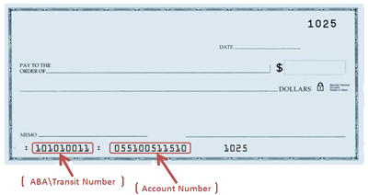

Below are the directions to follow in ESS to update your direct deposit information**.**

DIRECTIONS

Log in to your ESS profile on a computer or through the Paycom app on your phone.

In your ESS profile

Choose Payroll

Choose Direct Deposit

Select your account type (checking or savings)

Enter your bank name, routing number and account number.

Make sure and scroll to the bottom and click the box to agree to the terms and then click “update.”

**EAP**-As a city of Grapevine employee, you are eligible for the confidential Employee Assistance Program (EAP), Optum. For information, please go to liveandworkwell.com, access code: grapevine or 866-248-4096.

**Employee & Family Clinic**

The City of Grapevine provides a program for All Active City employees and their dependents are eligible to use the program. An eligible dependent is defined as a spouse and/or dependent children under the age of 26.

* Clinic ID card must be presented at the time of service
* Walk-in for a same day office visit; call ahead for same day appointment, if possible
* No copay for clinic visits
* Acute care includes coughs, colds, flu, sinus infections, sore throats, ear aches, and other minor illnesses

**Public Agency Retirement System (PARS-AR 457 Account)**

Part-time, casual and temporary employees who are not eligible to participate in the Texas Municipal Retirement System will contribute 6.2% of gross wages into their tax-deferred PARS-AR 457 Account. The City will contribute 1.3% of the employee’s gross wage into the employee’s account. Employees are 100% vested immediately in the PARS-AR 457 Account. [www.pars.org](http://www.pars.org)

**Address & Name Changes**-**you are required to make the updates in Paycom**. Once, updated you will also **need to advise Destination Services so we can update our system** also (CRM) if you have a change of address.

**KNOW YOUR HOTELS & GRAPEVINE**

It is important that you are familiar with all of Grapevine’s hotels: layout, restaurants, transportation options, etc. For the most up-to-date information, please visit

[www.GrapevineTexasUSA.com](http://www.GrapevineTexasUSA.com), hotel websites, [www.downtowngrapevinetexas.com](http://www.downtowngrapevinetexas.com)

and any resources that will be helpful to you in assisting Grapevine’s visitors.

**Gaylord Texan Resort & Convention Center**

**1501 Gaylord Trail**

**(817) 778-1000**

**(866) 782-7897 – toll free**

[http://www.gaylordhotels.com/gaylord-texan](http://www.gaylordhotels.com/gaylord-texan/)

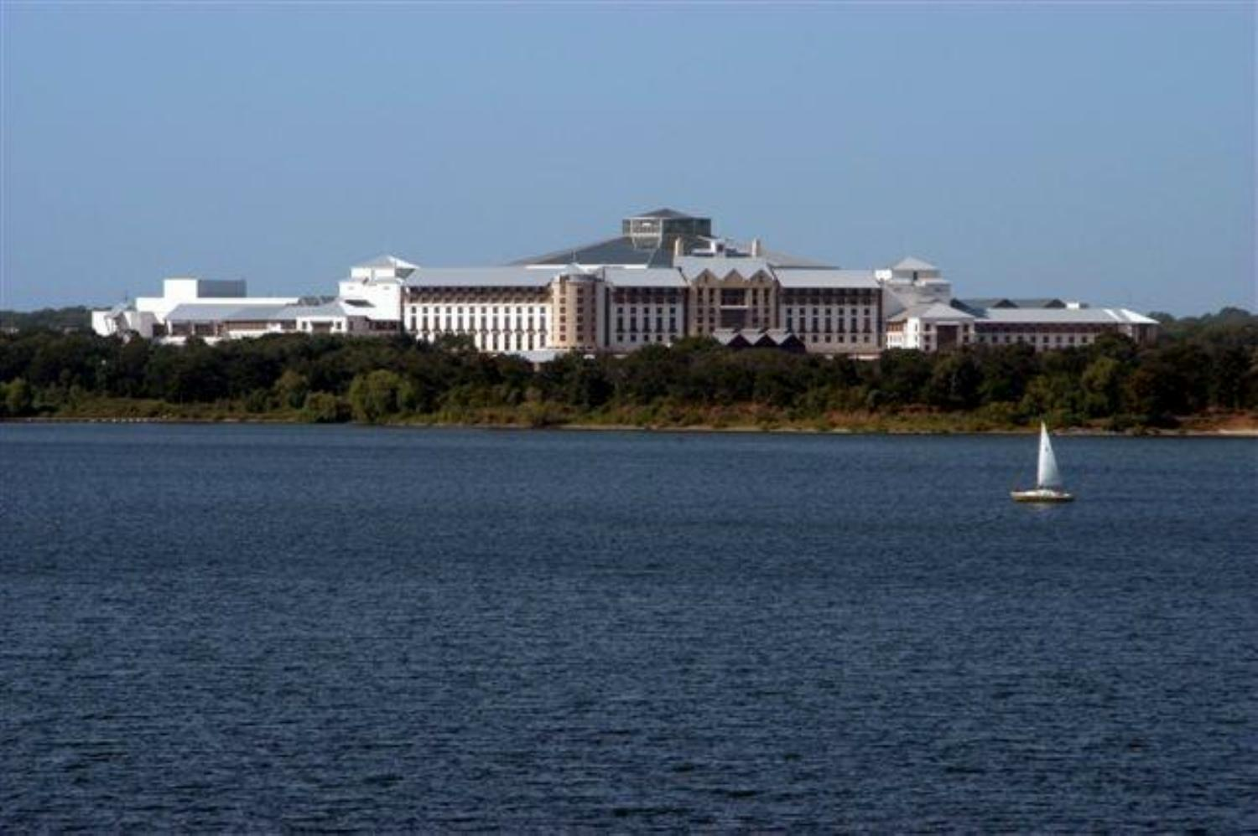

Brimming with authentic Texas style and hospitality, the awe-inspiring Gaylord Texan Hotel and Convention Center is Grapevine’s largest hotel with 1814 stylish [guest rooms](http://www.gaylordhotels.com/gaylord-texan/grapevine-dallas-hotel-rooms-suites/), including 127 [spectacular suites](http://www.gaylordhotels.com/gaylord-texan/grapevine-dallas-hotel-rooms-suites/suites), and 490,000 square feet of meeting space.

**Information for the Burgundy Brigade when working at Gaylord…**

**Gaylord Vendor I.D. –** All staff are issued an I.D. card from Gaylord which allows them to park in the parking garages and eat in the Chuck Wagon on assignment days. You must always show your Gaylord I.D. card when passing through security as well as at the Chuck Wagon. Have your Gaylord I.D. card with you at all times. If lost, you will be required to pay $25.00 to Gaylord to replace it.

**Parking:** Designated parking is in the convention center, close to the employee/security entrance (opposite side of the guest’s Convention Center entrance).

On occasion, there are “red flag days” when we are directed to park in the hotel’s parking garage **(3rd level or higher)** near the hotel’s front entrance.

If directed to park in Lot “R”, Gaylord will provide shuttle service to the hotel. There are four bus stops. Wait at the stop closest to where you parked your car. You will ride the shuttle to the employee/security entrance. Have your name badge visible so that Gaylord Security can see it.

If someone drives you to work, please have them drop you at the employee/security entrance.

**Smoking -** The only approved smoking area for STARS and Vendors is the area across from the Ice Tent area, near the storage shack. Please insure that all STARS and Vendors are aware that smoking is not allowed in any other area of the property, including parking lots, exit landings, stairwells, guest smoking areas, etc.

**Food Service:** The Chuck Wagon is the employee cafeteria and where we eat our meals. The cost is minimal. Simply show your Gaylord I.D. badge. Soft drinks, coffee and tea are complimentary. You are also welcome to bring your own meal.

**Lost and Found**: 817-778-2453

**Information for the guests...**

**ATM:** There are ATM’s located in both the convention center and the hotel.

In the Convention Center, an ATM is located on the Longhorn Exhibit Hall level (level one), near the escalators. Please look for the ATM symbol. In the hotel, the ATM is located across from Old Hickory Restaurant, adjacent to the guest elevators.

**Business Services:** The FedEx Business Center is located in the Convention Center on the Longhorn Exhibit Hall Level (level one) and across from the Grapevine CVB Information Kiosk.

The hotel’s shipping and receiving center is located in the Convention Center, on the Longhorn Exhibit Hall level (level one) along the corridor going towards Longhorn F.

**Transportation:** Gaylord Texan Shared Ride - This is a walkup service, no reservation required. For transportation needs, guests should visit the transportation desk on the front drive. The services depart on the hour and half hour from

5 a.m.-2 p.m. daily to Dallas/Fort Worth International Airport. Rate is $15.00 per person and includes all taxes, fees and tolls. Rate does not include driver gratuity. For groups with advance notice the hours can be adjusted as needed. Fleet includes: suburban’s, mini-buses and Gaylord’s driver team.

**Hertz Rental Car** is located in the convention center, garage level.

**Restaurants/Bars (hour’s subject to change):**

**Zeppole Restaurant -** Dinner 5-10pm; Bar 4:30-11pm

**Old Hickory Restaurant -** Dinner 5:30-10pm; Bar 4:30-10pm

**Texan Station Restaurant & Sports Bar -** Lunch and Dinner 11am-1:30am;

**Riverwalk Cantina -** Breakfast daily 6:30-11am; Brunch (Sun. only) 11:00am-3pm;

Lunch Sun.-Sat. 11am-4 pm; Dinner Sun.-Thu. 4-10pm Fri.-Sat. 4-11pm

**Mission Plaza Market Place –** 7am-9pm; light breakfast, lunch and light fare.

**Cocoa Bean Express** – Across from the Bell Stand; 6am-8pm.

**Silver Bar -** Daily 4pm-12am

**Glass Cactus Nightclub –** check website for hours and details

**Pool Bar and Grill -** seasonal, 11am-6pm

**Paradise Springs Pool Bar and Grill** – seasonal, 11am-6pm

**Hyatt Regency DFW**

**International Parkway (Terminal C)**

**DFW Airport, Texas**

**(972) 453-1234**

[www.hyattregencydfw.com](http://www.hyattregencydfw.com) or

<http://dfwairport.hyatt.com/hyatt/hotels-dfwairport/events/meetings/index.jsp>

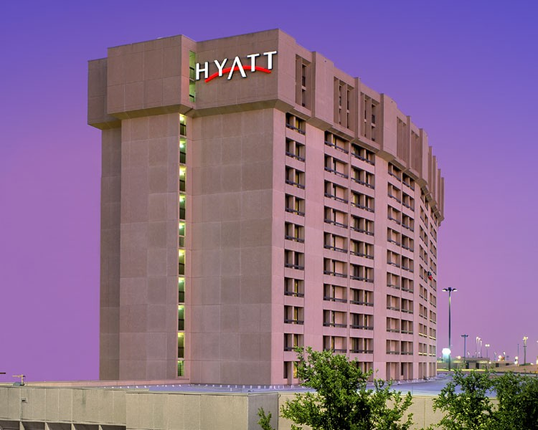

Hyatt Regency DFW is the second largest hotel in Grapevine with 811 rooms including 17 suites and 100,000 square feet of meeting space.

**Information for the Burgundy Brigade when working at Hyatt Regency….**

**Parking -** parking is complimentary for staff. Take your airport parking ticket to the bell stand/concierge desk, located to the left when you enter the front doors, to have it validated. Keep the ticket in a safe place so you do not lose it.

**Food Service**

**Option 1:** Eat at Jacob's Spring Grille and take advantage of the 50% off food items or 30% off at Jett's. The Hyatt Convention Services Manager who is responsible for the program you are working, will bring the discount voucher to you.

Jacob's Spring Grille hours are from 6 a.m. to 2 p.m. and from 6 p.m. to 10:30pm. So if your lunch break would fall after 2 pm you might want to bring a sandwich. There is also Jett's Coffee Bar open 24 hours a day, 7 days a week featuring sandwiches, salads, bagels, pastries, cookies and a variety of grab-n-go items to curb your hunger. A 30% discount will be given at Jett's. Times are subject to change.

**Option 2:** Bring your lunch and eat in Aces.

**Restaurants:**

**Jacob’s Spring Grille** – breakfast & lunch 6am-2pm, dinner 6-10:30pm

**Mr. G’s Steakhouse** – dinner, Mon. – Sat. 6-10pm

**Aces** – Lobby bar, daily; noon-2 AM.

**Jett’s Coffee Bar** – open 24 hours; light take-out fare.

**Great Wolf Lodge**

**100 Great Wolf Drive**

**817-488-6510 main, 800-693-9653 toll free**

[**www.greatwolf.com/grapevine**](http://www.greatwolf.com/grapevine)

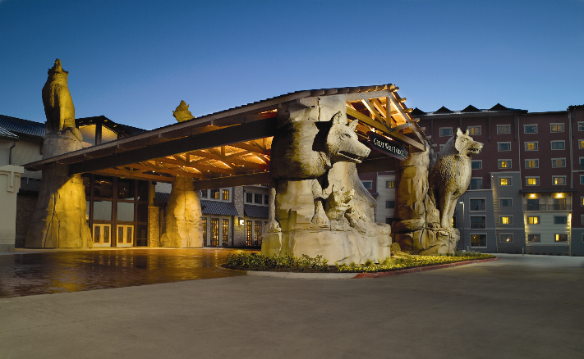

Great Wolf is a northwoods-themed all-suite family resort featuring an 80,000 square-foot indoor water park and a 100,000 square-foot outdoor water park. It has 605 suites and over 20,000 square feet of meeting space.

**Information for the Burgundy Brigade working Great Wolf Lodge:**

**Parking:** If you work on the hotel side, parking is allowed anywhere in Great Wolf’s main parking lot. As a courtesy, please leave the spaces that are closest to the hotel open for Great Wolf’s guests. If you work on the convention side drive in back of the hotel (follow the signs) to park and again, leave spaces closest for the hotel guests.

**Food Service:** work confirmation will state the location.

**Information for the guests:**

**ATM:** Lobby level by Starbucks and lower level by entrance to the water park.

**Business Services:** full range of supplies and services you've come to expect from the finest conference hotels. Just ask an associate to help you.

**Transportation:** Guests arrange their own.

**Restaurants:**

**Bear Paw Sweets & Eats** – daily. Specialty coffee, fresh baked pastries, ice cream, fudge & fresh fruit and more.

**Lodge Wood Fire Grill** – lunch and dinner, daily

**The Loose Moose Cottage** – breakfast and lunch, daily

**Grizzly Jack’s Bar and Grill** - daily. A variety of food and drinks to choose from.

**Starbucks** - just off the Grand Lobby

**Buckets Incredible Craveables** – daily. Snack, treats, lunch and drinks.

**Hungry as a Wolf** – daily. Quick and easy pizza, wings, sandwiches or salads also available for takeout.

**Hilton DFW Lakes Executive Conference Center**

**1800 State Highway 26 East**

**817-481-8444**

[www.hiltondfwlakesecc.com](http://www.hiltondfwlakesecc.com)



Hilton DFW Lakes has 393 guest rooms and 40,000 square feet of meeting space.

**Information for the Burgundy Brigade when working Hilton DFW Lakes….**

**Parking:** Parking is allowed anywhere in the Hilton’s main parking lot. As a courtesy, please leave the spaces that are closest to the hotel open for Hilton’s guests.

**Food Service:** The Oasis employee lounge has been designated for breaks & lunch. You may bring your lunch and eat in the team member cafeteria. The Oasis is located in the lower level (behind the scenes). From the lobby, go toward the conference center, passing by The Vineyard, take the staircase on the left, at the bottom of the stairs is a white service door, enter the door and take the right corridor. The Oasis is on the left. The Grapevine CVB name badge must be visible to the Hilton staff.

**Transportation:**

Complimentary 24-hour transportation to and from DFW International Airport. Complimentary shuttle service at 15 minutes after the hour to Grapevine Mills and restaurants close by. There is an additional charge to Historic Downtown.

**Restaurants:**

**The Vineyard** – breakfast Mon.-Fri. 6-10:30 am Sat & Sun 6am-noon, lunch 11am-3pm

**Bonnie & Clyde’s Hideout** – dinner and bar 3pm-midnight

**Meritage Grill –** dining room used for conferences and special events only.

**Windfall –** dining room used for conferences and special events only.**Embassy Suites by Hilton DFW Airport North**

**2401 Bass Pro Drive**

**972-724-2600**

[**www.embassysuitesdfwnorth.com**](http://www.embassysuitesdfwnorth.com)

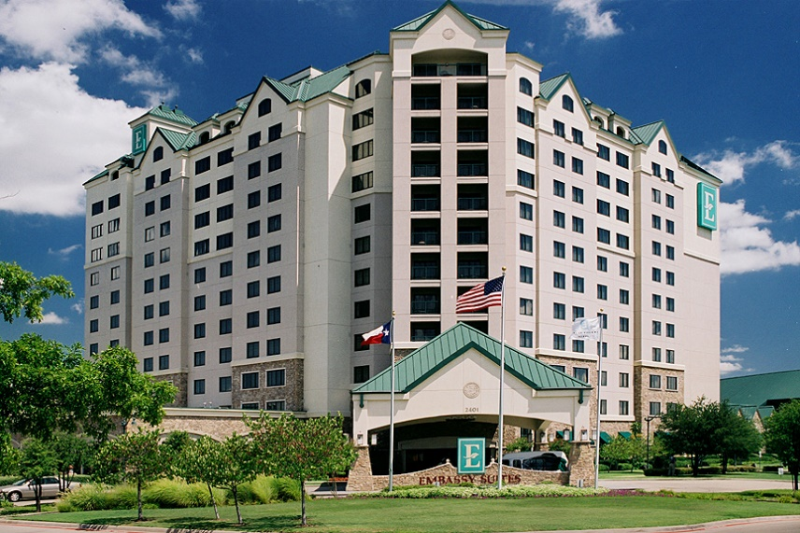

Embassy Suites Outdoor World has 329 suites and 20,000 sq. ft of meeting space.

**Information for the Burgundy Brigade working Embassy Suites….**

**Parking:** Parking is allowed anywhere in the regular parking area. As a courtesy, please leave the spaces that are closest to the hotel open for Embassy Suites’ guests.

**Food Service:** You may bring a lunch and eat in the employee break room. The Grapevine CVB name badge must be visible to the Embassy Suites staff.

**Information for the guests…**

**ATM:** Located on the first floor by the restrooms.

**Business Services:** There is a complete business center, with one computer for hotel guests.

**TRANSPORTATION:** Complimentary 24-hour transportation to and from DFW International Airport every 30 minutes. Complimentary shuttle service to and from Grapevine Mills, based on availability.

**RESTAURANTS:**

**Lobby** – complimentary full made-to-order breakfast during designated hours. Complimentary Manager’s reception during designated hours.

**Sportsman Club** – lunch and dinner Sun. – Thur. 11am – midnight, Fri & Sat. 11am – 2am

**Uncle Buck’s Brewery & Steakhouse** (between Embassy Suites & Bass Pro Shops) - lunch and dinner. 11am-10pm

**Grand Hyatt DFW**

**International Parkway (Terminal D) - DFW Airport, Texas**

**972-973-1234**

[**www.granddfw.hyatt.com**](http://www.granddfw.hyatt.com) **or**

[**http://granddfw.hyatt.com/hyatt/images/hotels/dfwgh/factsheet.pdf**](http://granddfw.hyatt.com/hyatt/images/hotels/dfwgh/factsheet.pdf)

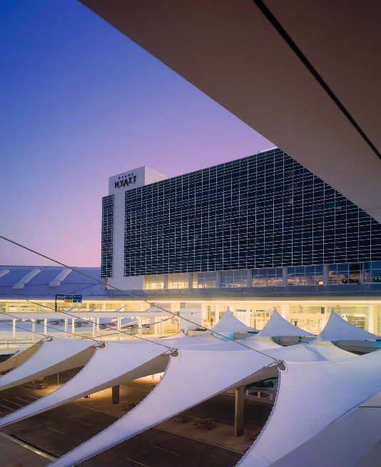

Grand Hyatt has 298 guest rooms and 34,000 square feet of meeting space.

**Information for the Burgundy Brigade….**

**Parking:** Parking is allowed anywhere in the regular parking area. Bring your airport parking ticket to the concierge for validation. Park in long-term parking; watch for the signs.

**Food Service:** work confirmation will state the location.

**Restaurants:**

**Grand Met –** Daily. Breakfast 6:30 – 11:30am, Lunch 11:30am -2pm, Dinner 5:30 – 10:30pm

**Grand Met Lounge-** Daily. 11:30am – midnight

**Sushi Bar –** Mon. – Fri. 5-10pm

**Moka –** Daily. 5am - midnight

**Other Full Service Hotels**

* **Silverlake Crossings: Hilton Garden Inn, Courtyard and TownePlace Suites by Marriott-** 453 rooms

[www.marriottgrapevine.com](http://www.marriottgrapevine.com)

* **Hotel Vin, Autograph Collection-** 120 rooms

[www.hotelvin.com](http://www.hotelvin.com)

**Select Service Hotels/Campgrounds**

* **Residence Inn by Marriott DFW Airport North/Grapevine-**133 rooms

[www.marriott.com/dalgp](http://www.marriott.com/dalgp)

* **Hyatt Place Grapevine**-125 rooms

[www.dallasgrapevine.place.hyatt.com](http://www.dallasgrapevine.place.hyatt.com)

* **SpringHill Suites by Marriott Dallas Airport North/Grapevine**-111 rooms [www.marriott.com/hotels/travel/dalgv-springhill-suites-dallas-dfw-airport-north-grapevine](http://www.marriott.com/hotels/travel/dalgv-springhill-suites-dallas-dfw-airport-north-grapevine)
* **Hilton Garden Inn DFW North/Grapevine-**110 rooms

[www.dfwnorthgrapevine.hgi.com](http://www.dfwnorthgrapevine.hgi.com)

* **Homewood Suites by Hilton DFW Airport North/Grapevine**-105 rooms

[www.dallasgrapevine.homewoodsuites.com](http://www.dallasgrapevine.homewoodsuites.com)

* **Comfort Inn**–SH114 & Main Street -100 rooms

[www.choicehotels.com](http://www.choicehotels.com)

* **Super 8 Hotel Grapevine**-100 rooms

[www.super8grapevine.com](http://www.super8grapevine.com)

* **Comfort Suites DFW North/Grapevine**-SH121 & Bass Pro Dr.-96 rooms

[www.choicehotels.com](http://www.choicehotels.com)

* **Holiday Inn Express Hotel & Suites DFW/Grapevine**-95 rooms

[www.hiexpress.com/grapevinetx](http://www.hiexpress.com/grapevinetx)

* **Hampton Inn & Suites DFW North/Grapevine**-94 rooms

[www.hamptoninn.com](http://www.hamptoninn.com)

* **Minute Suites DFW**-Terminal A38-7 rooms; Terminal D23-10 room

[www.minutesuites.com](http://www.minutesuites.com)

* **Vineyards Campground & Lakefront Cabins**-15 cabins

[www.vineyardscampground.com](http://www.vineyardscampground.com)

**GRAPEVINE INFORMATION**

Vintage Texas®

1M+ sq. ft. of Meeting Space

11,000 Area Hotel Rooms

1,800+ Flights Daily • 200+ Restaurants

Historic Downtown - Grapevine Mills

LEGOLAND® Discovery Center – SEA LIFE Grapevine Aquarium

Grapevine Glockenspiel’s Would-Be Train Robbers

Bass Pro Shops Outdoor World - 81 Holes of Premier Golf

Grapevine Vintage Railroad – Urban Wine Trail

Palace Arts Center

MCj04238700000[1]

**Helpful websites:**

* + [GrapevineTexasUSA.com](http://www.GrapevineTexasUSA.com)
  + [www.grapevinetexas.gov](http://www.grapevinetexas.gov)
  + [www.GrapevineChamber.org](http://www.GrapevineChamber.org)
  + [www.ILoveGrapevineTexas.com](http://www.ILoveGrapevineTexas.com)
  + [www.GrapevineMills.com](http://www.GrapevineMills.com)
  + [www.BassPro.com](http://www.BassPro.com)
  + [www.GrapevineTowneCenter.com](http://www.GrapevineTowneCenter.com)
  + [www.passporthealthtexas.com](http://www.passporthealthtexas.com)
  + [www.dfwairport.com](http://www.dfwairport.com)
  + [www.traveltex.com](http://www.traveltex.com)
  + [www.visitdallas-fortworth.com](http://www.visitdallas-fortworth.com)
  + [www.txwines.org](http://www.txwines.org)
  + [www.dfwconnector.com](http://www.dfwconnector.com)
  + [www.GrapevineToday.com](http://www.GrapevineToday.com)
  + [www.ridetrinitymetro.org](http://www.ridetrinitymetro.org)
  + www.grapevinetexasusa.com/destination-grapevine/